# 2015 Observing Notes

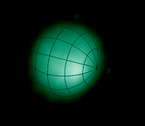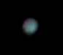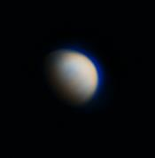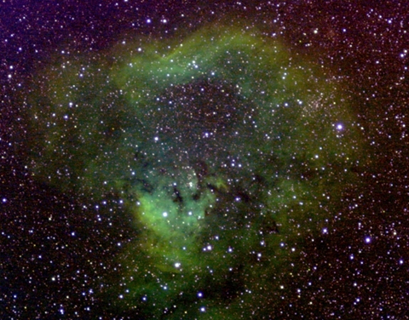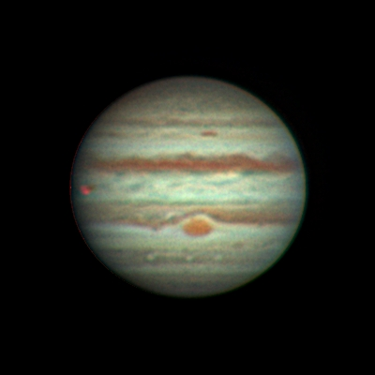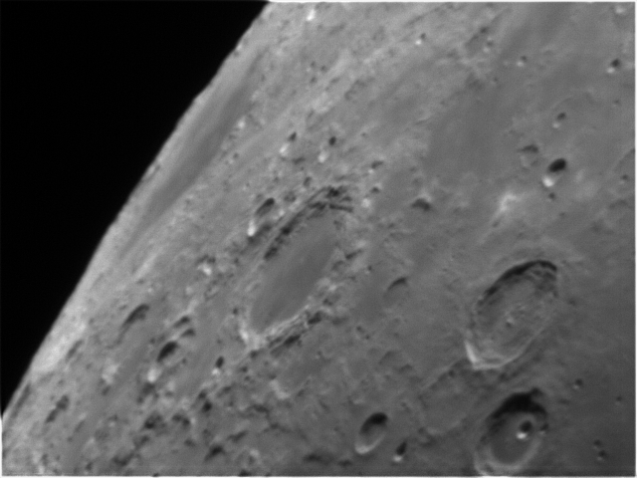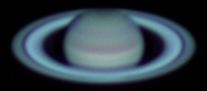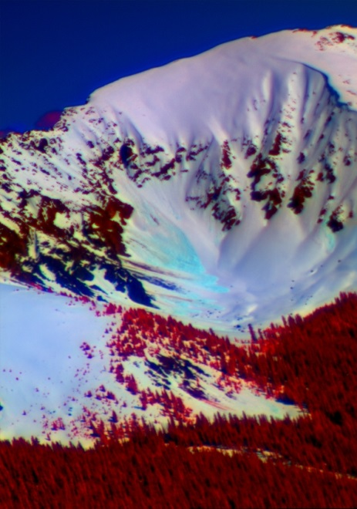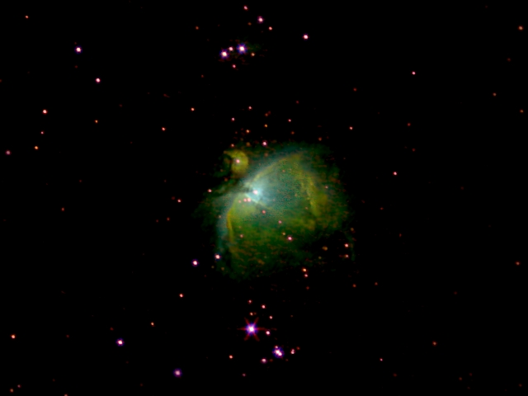

[2015 Observing Notes 1](#_Toc446913880)

[Year in Review 4](#_Toc446913881)

[January 5](#_Toc446913882)

[2015-Jan-15 (Jan-16 UT): Comet Lovejoy (C/2012 Q2) and M42 5](#_Toc446913883)

[2015-Jan-22 (Jan-23 UT): Jupiter and Pollux Spectra 8](#_Toc446913884)

[2015-Jan-25 (Jan-26 UT): C/2014 Q2 (Lovejoy) and Gam Tri Spectra; M42 OIII Wide Field Imaging 10](#_Toc446913885)

[2015-Jan-26 (Jan-27 UT): C/2014 Q2 (Lovejoy) Multiband Wide Field Imaging 12](#_Toc446913886)

[2015-Jan-28 (Jan-29 UT): Uranus Spectrum and M42 SII Wide Field Imaging 14](#_Toc446913887)

[February 17](#_Toc446913888)

[2015-Feb-08 (Feb-09 UT): Jupiter and Regulus Spectrum 17](#_Toc446913889)

[2015-Feb-09 (Feb-10 UT): Jupiter and Pollux Spectrum 18](#_Toc446913890)

[2015-Feb-11 (Feb-12 UT): “Steven Hill” Star and M42 Wide (>742nm) 19](#_Toc446913891)

[2015-Feb-18 (Feb-19 UT): M42 Wide Field >807nm and SII 21](#_Toc446913892)

[March 23](#_Toc446913893)

[2015-Mar-09 (Mar-10 UT): Venus and Jupiter Video 23](#_Toc446913894)

[2015-Mar-10 (Mar-11 UT): Venus, Jupiter and Sirius Video 27](#_Toc446913895)

[2015-Mar-17 (Mar-18 UT): Jupiter Spectra 31](#_Toc446913896)

[2015-Mar-21 (Mar-22 UT): Jupiter Spectra 31](#_Toc446913897)

[2015-Mar-29 (Mar-30 UT): Venus Spectra 32](#_Toc446913898)

[2015-Mar-30 (Mar-31 UT): Jupiter Spectra 33](#_Toc446913899)

[Planning: Spring 34](#_Toc446913900)

[April 35](#_Toc446913901)

[2015-Apr-12 (Apr-13 UT): M82 in [OIII] 35](#_Toc446913902)

[2015-Apr-13 (Apr-14 UT): M82 in [OIII] 36](#_Toc446913903)

[June 38](#_Toc446913904)

[2015-Jun-01 (Jun-01 UT): Backyard Multiband Experiment 38](#_Toc446913905)

[2015-Jun-02 (Jun-02 UT): Loveland Pass Multiband 39](#_Toc446913906)

[2015-Jun-02 (Jun-03 UT): Venus 40](#_Toc446913907)

[2015-Jun-22 (Jun-23 UT): Venus, Jupiter, Moon and Saturn 41](#_Toc446913908)

[Planning: Summer 47](#_Toc446913909)

[September 48](#_Toc446913910)

[2015-Sep-09 (Sep-10 UT): Beta Lyrae and M57 Spectra 48](#_Toc446913911)

[2015-Sep-12 (Sep-13 UT): Vega, Gamma Lyrae and M57 Spectra 49](#_Toc446913912)

[2015-Sep-20 (Sep-21 UT): NGC 7009 Spectra 51](#_Toc446913913)

[2015-Sep-24 (Sep-25 UT): Vega and Beta Lyrae Spectra and Veil Nebula Imaging 53](#_Toc446913914)

[October 55](#_Toc446913915)

[2015-Oct-13 (Oct-14 UT): Vega, Bet Lyr, Sig Aqr and (not-) Neptune Spectra 55](#_Toc446913916)

[2015-Oct-14 (Oct-15 UT): Vega, Bet Lyr, Sig Aqr and Neptune Spectra 59](#_Toc446913917)

[November 63](#_Toc446913918)

[Planning: Fall 63](#_Toc446913919)

[2015-Nov-07 (Nov-08 UT): Sig Aqr and Neptune Spectra 64](#_Toc446913920)

[2015-Nov-08 (Nov-09 UT): Sig Aqr and Neptune Spectra 67](#_Toc446913921)

[2015-Nov-09 (Nov-10 UT): Sig Aqr and Neptune Spectra 70](#_Toc446913922)

[2015-Nov-14 (Nov-15 UT): Sig Aqr, Neptune(?) and Uranus Imaging 72](#_Toc446913923)

[December 77](#_Toc446913924)

[2015-Dec-03 (Dec-04 UT): NGC7822 and Ced 214 Narrow Band Imaging 77](#_Toc446913925)

[2015-Dec-05 (Dec-06 UT): M31 and NGC1499 Narrow Band Imaging 79](#_Toc446913926)

[Planet Analysis 80](#_Toc446913927)

[Venus Analysis 2015 Apparition 80](#_Toc446913928)

[Jupiter Analysis 2015 Apparition 87](#_Toc446913929)

[Saturn Analysis 2015 Apparition 92](#_Toc446913930)

[Uranus Analysis 2015 Apparition 93](#_Toc446913931)

[Neptune Analysis 2015 Apparition 94](#_Toc446913932)

[Analyses: Stars 102](#_Toc446913933)

[Vega (Spectroscopy) 103](#_Toc446913934)

[Beta Lyrae (Spectroscopy) 113](#_Toc446913935)

[Planetary Nebulae Analysis 120](#_Toc446913936)

[Saturn Nebula (NGC7009) Analysis 120](#_Toc446913937)

[Ring Nebula (M57) Analysis 122](#_Toc446913938)

[Nebulae 123](#_Toc446913939)

[Orion Wide Field – M42 and Sword Region 123](#_Toc446913940)

[Galaxies 126](#_Toc446913941)

[M31 Wide Field and Multispectral 126](#_Toc446913942)

[Techniques and Planning 132](#_Toc446913943)

[Data Model for Projects 132](#_Toc446913944)

[Python Resources 133](#_Toc446913945)

[Python Spectral Analysis and Plotting 135](#_Toc446913946)

[Python EW Analysis and Plotting 140](#_Toc446913947)

[SWIR Camera Resources 144](#_Toc446913948)

[Some Thoughts on Additional Narrow-Band Imaging Filters and Spectroscopes 146](#_Toc446913949)

[Some Thoughts on Mounts 149](#_Toc446913950)

[Object Lists 152](#_Toc446913951)

## Year in Review

This year was focused on spectroscopy and planetary science, primarily due to my current observing location in a heavily light polluted city. Highlights include:

* Comet Lovejoy imaging and low resolution spectra
* Jupiter spectroscopic search for rotational modulation
* SAS conference and outer planet methane study
* NUV-VIS-NIR imaging in the mountains of Colorado
* Venus spectrum
* Planetary nebulae spectra (M57 and NGC7009)
* Neptune spectroscopic search for rotational modulation
* Resolution of albedo features on Uranus

## January

### 2015-Jan-15 (Jan-16 UT): Comet Lovejoy (C/2012 Q2) and M42

Last Updated 1/18/2015

I took videos of Comet Lovejoy for lucky imaging using the ASI120MM camera and the C8 at prime focus with the 2x barlow lens. This gives a plate scale of approximately 0.17 arcsec/pix. Videos were taken with the CLR filter with both 1x1 and 2x2 binning. Videos in R, G, B, and >685nm were taken with 2x2 binning. In addition, I took a 2x2 binned image of M42 with the CLR filter.

|  |  |
| --- | --- |
| D:\Astronomy\Projects\Comet Lovejoy 2014 Project\Imaging Data\20150115LT\LJ-CLR-100-100 2015-01-15TXX_XX_XX-Stretch0-120-Stack5-Log-HalfSize.jpg | D:\Astronomy\Projects\Comet Lovejoy 2014 Project\Imaging Data\20150115LT\LJ-CLR-2x2-75-75 2015-01-15T2X_XX_XX-Stretch0-150-Stack9Overlay-Log.jpg |
| LJ-CLR-100-100 2015-01-15TXX\_XX\_XX-Stretch0-120-Stack5-Log-HalfSize.jpg | LJ-CLR-2x2-75-75 2015-01-15T2X\_XX\_XX-Stretch0-150-Stack9Overlay-Log.jpg |
| D:\Astronomy\Projects\Comet Lovejoy 2014 Project\Imaging Data\20150115LT\LJ-685-2x2-90-90-4000ms 2015-01-15T21_17_18-Log.jpg | D:\Astronomy\Projects\Comet Lovejoy 2014 Project\Imaging Data\20150115LT\LJ-RED-2x2-90-90-4000ms 2015-01-15T21_22_59-Log.jpg |
| LJ-685-2x2-90-90-4000ms 2015-01-15T21\_17\_18-Log.jpg | LJ-RED-2x2-90-90-4000ms 2015-01-15T21\_22\_59-Log.jpg |
| D:\Astronomy\Projects\Comet Lovejoy 2014 Project\Imaging Data\20150115LT\LJ-GRN-2x2-90-90-4000ms 2015-01-15T21_28_21-Log.jpg | D:\Astronomy\Projects\Comet Lovejoy 2014 Project\Imaging Data\20150115LT\LJ-BLU-2x2-90-90-4000ms 2015-01-15T21_33_51-Log.jpg |
| LJ-GRN-2x2-90-90-4000ms 2015-01-15T21\_28\_21-Log.jpg | LJ-BLU-2x2-90-90-4000ms 2015-01-15T21\_33\_51-Log.jpg |

What comes next? The RGB, IRG, IGB images on a linear scale? How about on a log scale?

Then definitely need to have individual rotational gradient images, total luminance image, and rotational gradient applied to total luminance. Probably need the master RGB log scale used for the blended direct and rotational gradient image below.

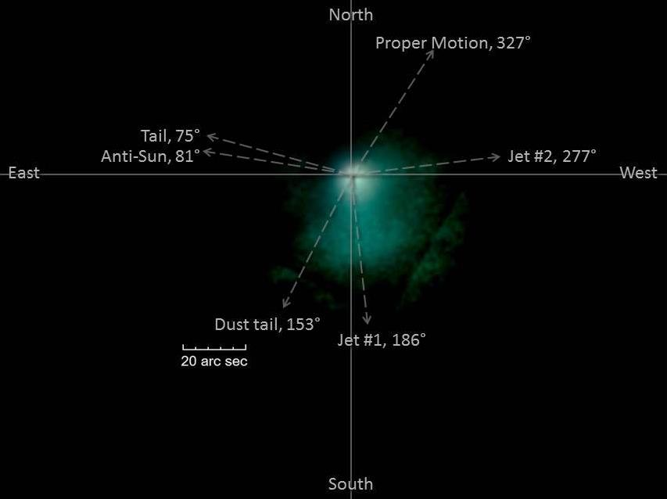

Lovejoy-Angles-Trimmed.jpg

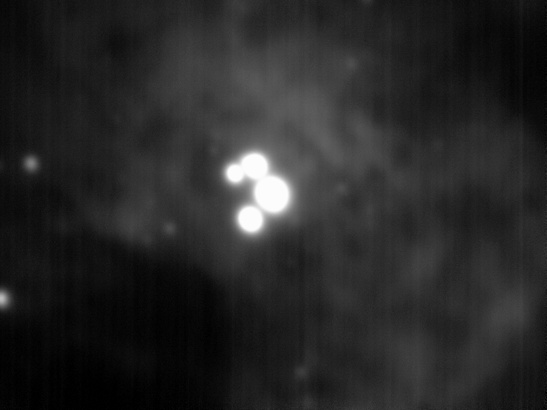

m42-2x2-55GN-100GM-1250ms 2015-01-15T22\_44\_14.jpg

**Data Disposition:** Not sure where raw data is located. Project data is under /Projects/Planets/Comet Lovejoy 2014 and …Nebulae-Diffuse/Orion Nebula (M42)

### 2015-Jan-22 (Jan-23 UT): Jupiter and Pollux Spectra

Last Updated 1/23/2015

I took very deep spectra of Jupiter and used Pollux as a calibration star, which seemed would be at about the same air mass as the integrated Jupiter spectra would. I used the 100 line/mm StarAnalyzer grating at the objective of the 135mm lens along with the ST2000 camera. For Pollux (K0IIIb) I took 2.5 minutes of exposure through the clear (CLR) filter and 5.0 minutes of exposure through the >742nm NIR filter (742).

For Jupiter, the integration times were 50 minutes for CLR and 3 hours 20 minutes for 742. In addition, I took images in HI, SII, and OIII. I wasn’t sure of the filter positions for these three, but they turned out to be mostly correctly labeled (HAL, SIImaybe, and UnK).

The mid-integration time for the Jupiter CLR exposure was 20150123T0741:17UT which would give a CMII of about 339 deg. The start time is 070734UT giving an initial CMII of about 320 deg and an airmass of ~1.1.

The >742nm exposure begins at 08:15:14UT (CMII=0.4), but the mid-exposure computation from MaximDL give the year as 1970, so there is an obvious error there. Since the exposure was 3h20m, the mid-exposure time should be about 10:15:00UT, which allows for overhead between the exposures. This gives a mid-exposure CMII of about 73 deg. At the end of the NIR exposures the CMII would be about 136 deg with an airmass of ~1.7.

So, for Jupiter, the airmass ranges from 1.1 to 1.7. The CLR exposures cover roughly CMII 320 to 358 deg and the NIR exposures cover about 0 to 138 deg.

The Pollux CLR mid-exposure time was 05:53:59UT NIR mid-exposure time was 05:58:45 UT.

**Suggested intervals during the observation - for examination of temporal variations – are 10x5min intervals for the initial CLR filter observations, then 20x10min intervals for the NIR observations. Longer integrations for CLR could be used to improve signal levels, but are probably not necessary.**

|  |
| --- |
| G:\Astronomy\Projects\Jupiter Project 2015\Spectroscopy\Data\Pollux-20150122LT-742-sum5m00s-Rotated-BkgFlt-Cropped-Log-HalfSize.jpg |
| Pollux-20150122LT-742-sum5m00s-Rotated-BkgFlt-Cropped-Log-HalfSize.jpg |
| G:\Astronomy\Projects\Jupiter Project 2015\Spectroscopy\Data\Pollux-20150122LT-CLR-sum2m30s-Rotated-BkgFlt-Cropped-Log-HalfSize.jpg |
| Pollux-20150122LT-CLR-sum2m30s-Rotated-BkgFlt-Cropped-Log-HalfSize.jpg |
| G:\Astronomy\Projects\Jupiter Project 2015\Spectroscopy\Data\JupiterSpectrum-20150122LT-742-sum3h20m-Rotated-Cropped-Log-HalfSize.jpg |
| JupiterSpectrum-20150122LT-742-sum3h20m-Rotated-Cropped-Log-HalfSize.jpg |
| G:\Astronomy\Projects\Jupiter Project 2015\Spectroscopy\Data\JupiterSpectrum-20150122LT-CLR-sum0h50m-Rotated-Cropped-Log-HalfSize.jpg |
| JupiterSpectrum-20150122LT-CLR-sum0h50m-Rotated-Cropped-Log-HalfSize.jpg |

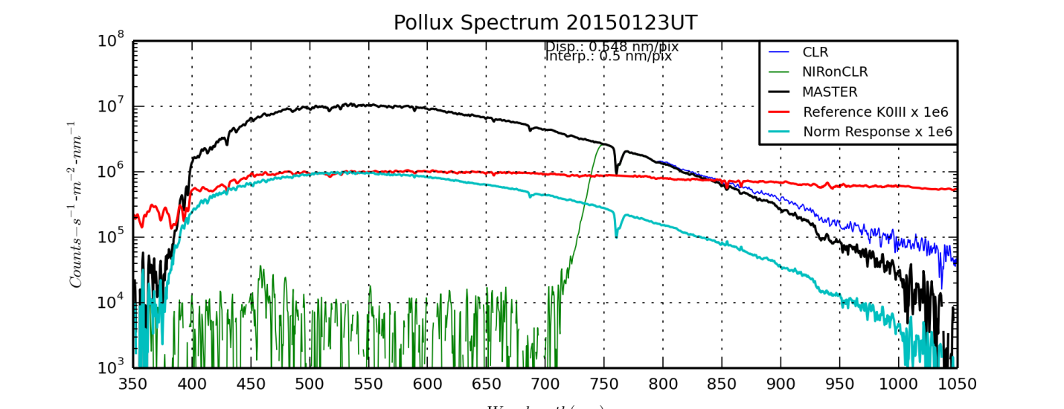

PolluxSpectrum20150123UT.png created by PolluxSpectrum20150123UT.py

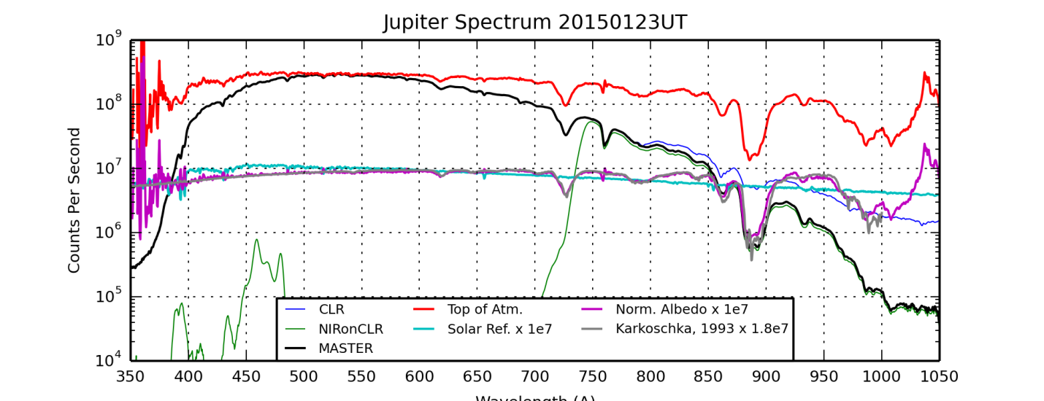

JupiterSpectrum20150123UT.png created by JupiterSpectrum20150123UT.py

Note: On EW’s for the H2O Z band near 820nm, there is contamination from the CaII triplet near 850nm if one is not careful. I’m guessing that it leads to over-estimation of the H2O absorption.

### 2015-Jan-25 (Jan-26 UT): C/2014 Q2 (Lovejoy) and Gam Tri Spectra; M42 OIII Wide Field Imaging

Last Updated 1/27/2015

|  |
| --- |
| G:\Astronomy\Data\2015\01\25\LovejoySpectrum\GamTriSpectrum-20150125LT-742-sum09m00s-Rotated-Cropped-Log-HalfSize.jpg |
| GamTriSpectrum-20150125LT-742-sum09m00s-Rotated-Cropped-Log-HalfSize.jpg |
| G:\Astronomy\Data\2015\01\25\LovejoySpectrum\GamTriSpectrum-20150125LT-CLR-sum05m00s-Rotated-Cropped-Log-HalfSize.jpg |
| GamTriSpectrum-20150125LT-CLR-sum05m00s-Rotated-Cropped-Log-HalfSize.jpg |
| G:\Astronomy\Data\2015\01\25\LovejoySpectrum\LovejoySpectrum-20150125LT-742-sum30m00s-Rotated-Cropped-Log-HalfSize.jpg |
| LovejoySpectrum-20150125LT-742-sum30m00s-Rotated-Cropped-Log-HalfSize.jpg |
| G:\Astronomy\Data\2015\01\25\LovejoySpectrum\LovejoySpectrum-20150125LT-CLR-sum28m00s-Rotated-Cropped-Log-HalfSize.jpg |
| LovejoySpectrum-20150125LT-CLR-sum28m00s-Rotated-Cropped-Log-HalfSize.jpg |

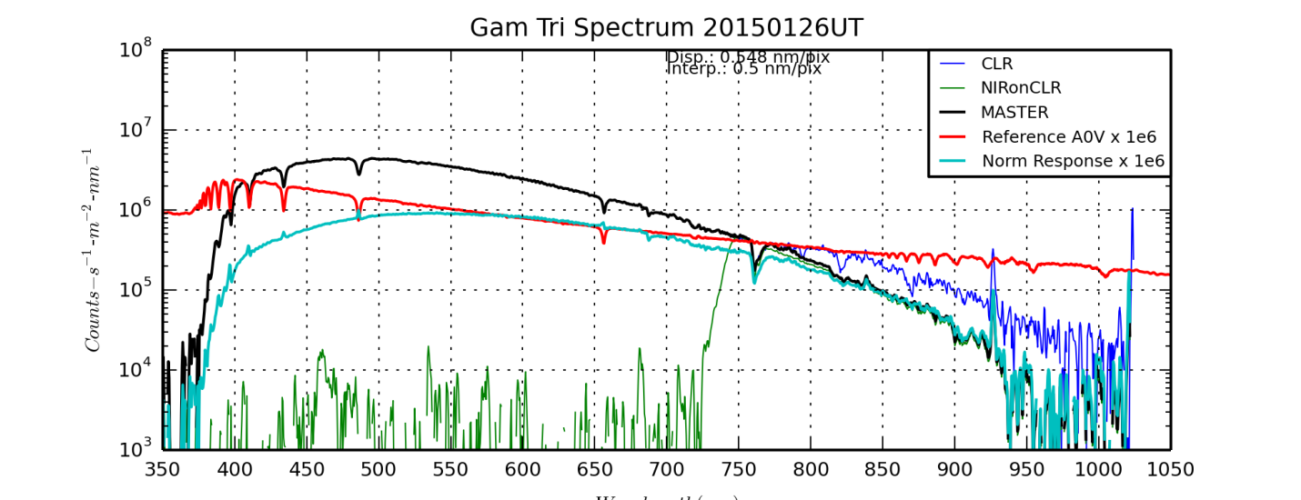

GamTriSpectrum20150126UT.png created by GamTriSpectrum20150126UT.py

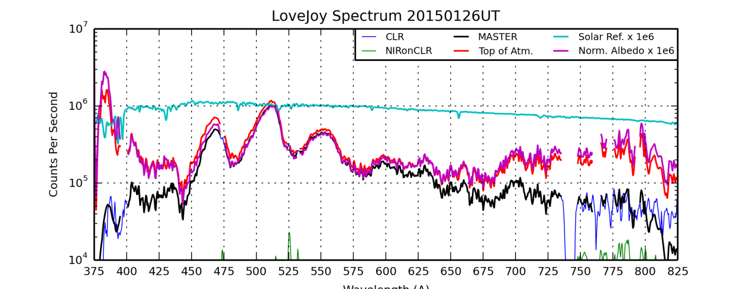

LoveJoySpectrum20150126UT.png created by LoveJoySpectrum20150126UT.png

|  |  |
| --- | --- |
| G:\Astronomy\Data\2015\01\25\M42-Wide-OIII\M42-20150125LT-OIII-sum2h33m-LogLog-HalfSize.jpg | G:\Astronomy\Data\2015\01\25\M42-Wide-OIII\M42-201X01XX-H(H+O)O-Log-Sat150pct-Log-HalfSize.jpg |
| M42-20150125LT-OIII-sum2h33m-LogLog-HalfSize.jpg | M42-201X01XX-H(H+O)O-Log-Sat150pct-Log-HalfSize.jpg |

### 2015-Jan-26 (Jan-27 UT): C/2014 Q2 (Lovejoy) Multiband Wide Field Imaging

Last Updated 2/4/2015

|  |  |
| --- | --- |
| G:\Astronomy\Projects\Comet Lovejoy 2014 Project\Imaging Data\20150127UT\Lovejoy-20150126LT-SII-sum30m00s-CometAligned-Log-HalfSize.jpg | G:\Astronomy\Projects\Comet Lovejoy 2014 Project\Imaging Data\20150127UT\Lovejoy-20150126LT-HAL-sum29m00s-CometAligned-Log-HalfSize.jpg |
| Lovejoy-20150126LT-SII-sum30m00s-CometAligned-Log-HalfSize.jpg | Lovejoy-20150126LT-HAL-sum29m00s-CometAligned-Log-HalfSize.jpg |
| G:\Astronomy\Projects\Comet Lovejoy 2014 Project\Imaging Data\20150127UT\Lovejoy-20150126LT-CLRLPFRED-sum29m00s-CometAligned-Log-HalfSize.jpg | G:\Astronomy\Projects\Comet Lovejoy 2014 Project\Imaging Data\20150127UT\Lovejoy-20150126LT-CLRLPFGRN-sum30m00s-CometAligned-Log-HalfSize.jpg |
| Lovejoy-20150126LT-CLRLPFRED-sum29m00s-CometAligned-Log-HalfSize.jpg | Lovejoy-20150126LT-CLRLPFGRN-sum30m00s-CometAligned-Log-HalfSize.jpg |
| G:\Astronomy\Projects\Comet Lovejoy 2014 Project\Imaging Data\20150127UT\Lovejoy-20150126LT-OIII-sum30m00s-CometAligned-Log-HalfSize.jpg | G:\Astronomy\Projects\Comet Lovejoy 2014 Project\Imaging Data\20150127UT\Lovejoy-20150126LT-CLRLPFBLU-sum29m00s-CometAligned-Log-HalfSize.jpg |
| Lovejoy-20150126LT-OIII-sum30m00s-CometAligned-Log-HalfSize.jpg | Lovejoy-20150126LT-CLRLPFBLU-sum29m00s-CometAligned-Log-HalfSize.jpg |

Plans for imaging C/2014 Q2:

* C2 Swan band ratios:
  + LPF+BLU [455nm to 505nm]
  + LPF+GRN [493nm to 531nm]
  + OIII [~493nm to ~502nm]
* Red Continuum
  + LPF+RED [>642nm]
  + HAL [~653nm to ~659nm]
  + SII [~668nm to ~676nm]

Stacked with SD Mask set to 5 passes, sigma = 0.1 and Normalization=”None”

RGB and multi-color; rotational gradient images; difference/ratio images

**TECHNIQUE TO REMOVE STARS:** <http://www.newastro.com/tutorials/comet_technique.html>

Involves only median filtering in MaximDL, as opposed to the SDMask I tried earlier.

### 2015-Jan-28 (Jan-29 UT): Uranus Spectrum and M42 SII Wide Field Imaging

Last Updated 2/4/2015

I took spectra of Jupiter using the 135mm lens at f/22 and the ST2000 camera. Spectra were taken both with a clear filter and with a >742nm filter for order separation. A single focus was used, as opposed to optimizing focus for each of the two filters. Integration time was 50m for the clear filter and 3h20m for the >742nm filter. A single spectrum of Pollux was used as the transmission reference spectrum. Integration times for Pollux were 2m30s for the clear filter and 5m00s for the >742nm filter.

Initial analysis simply integrated all Jupiter observations, rather integrating shorter time periods to look for temporal variations. The appropriateness of the airmass for Pollux needs to be validated.

|  |
| --- |
| G:\Astronomy\Projects\Uranus Project 2014\Spectral Data\20150129UT\UranusSpectrum-20150128LT-742-sum20min-Rotated-Cropped-RefStar-HalfSize.jpg |
| UranusSpectrum-20150128LT-742-sum20min-Rotated-Cropped-RefStar-HalfSize.jpg |
| G:\Astronomy\Projects\Uranus Project 2014\Spectral Data\20150129UT\UranusSpectrum-20150128LT-CLR-sum22min-Rotated-Cropped-RefStar-HalfSize.jpg |
| UranusSpectrum-20150128LT-CLR-sum22min-Rotated-Cropped-RefStar-HalfSize.jpg |
| G:\Astronomy\Projects\Uranus Project 2014\Spectral Data\20150129UT\UranusSpectrum-20150128LT-742-sum20min-Rotated-Cropped-Uranus-HalfSize.jpg |
| UranusSpectrum-20150128LT-742-sum20min-Rotated-Cropped-Uranus-HalfSize.jpg |
| G:\Astronomy\Projects\Uranus Project 2014\Spectral Data\20150129UT\UranusSpectrum-20150128LT-CLR-sum22min-Rotated-Cropped-Uranus-HalfSize.jpg |
| UranusSpectrum-20150128LT-CLR-sum22min-Rotated-Cropped-Uranus-HalfSize.jpg |

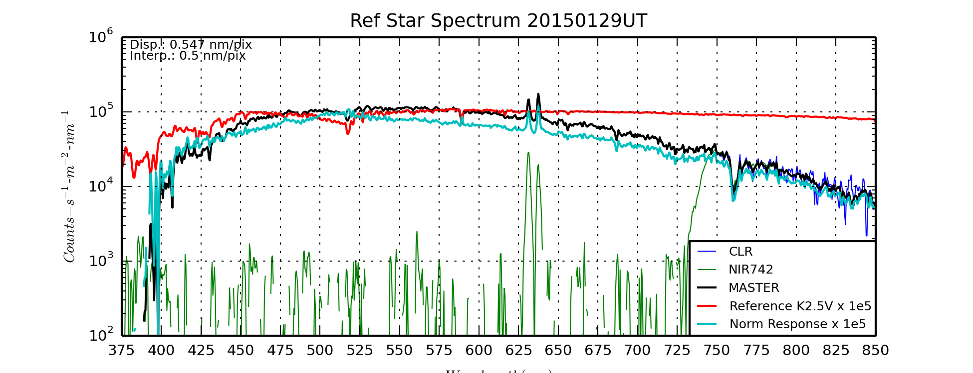

RefStarSpectrum20150129UT.png produced by RefStarSpectrum20150129UT.py

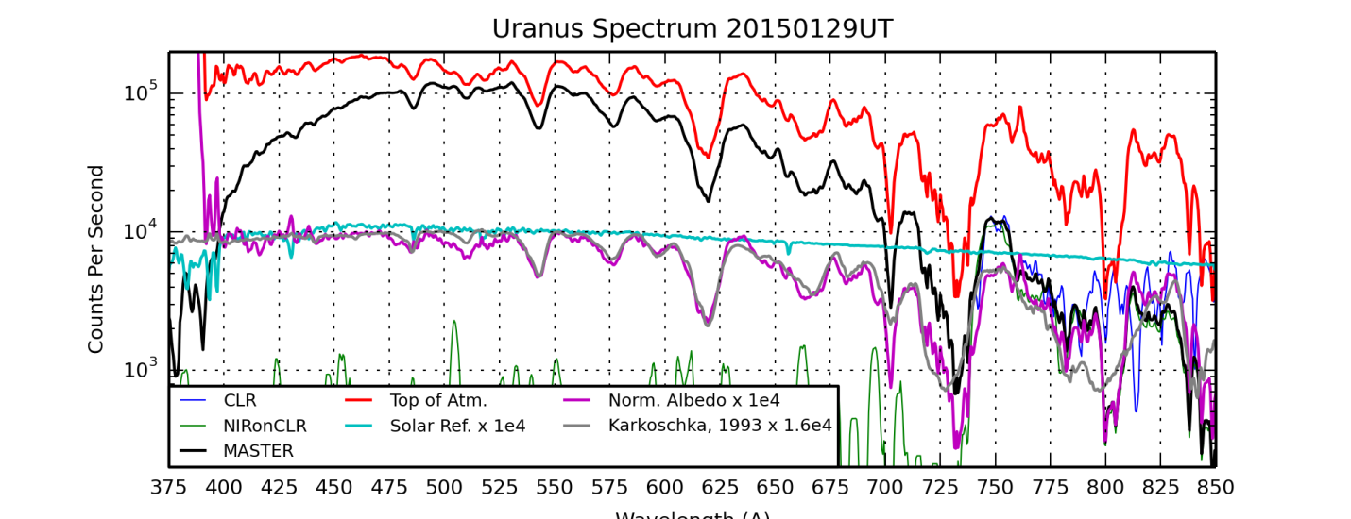

UranusSpectrum20150129UT.png produced by UranusSpectrum20150129UT.py

|  |  |
| --- | --- |
| G:\Astronomy\Projects\OrionWideFieldProject2014\Data\20150129UT-SII-Sword\M42-20150128LT-SII-sum1h25m42s-LogLog-HalfSize.jpg | G:\Astronomy\Projects\OrionWideFieldProject2014\Data\20150129UT-SII-Sword\M42-201X01XX-SHO-ColBal-Log-ColBal-Sat140pct-Wavelets.jpg |
| M42-20150128LT-SII-sum1h25m42s-LogLog-HalfSize.jpg | M42-201X01XX-SHO-ColBal-Log-ColBal-Sat140pct-Wavelets-HalfSize.jpg |



M42-201X01XX-SHO-ColBal-Log-ColBal-Sat140pct-Wavelets-Cropped.jpg

Nice image for clouds in Orion <http://apod.nasa.gov/apod/image/1503/OrionClouds_Andreo_2048.jpg>

## February

### 2015-Feb-08 (Feb-09 UT): Jupiter and Regulus Spectrum

Last Updated 1/18/2015

I took spectra of Jupiter using the 135mm lens at f/22 and the ST2000 camera. Spectra were taken both with a clear filter and with a >742nm filter for order separation. A single focus was used, as opposed to optimizing focus for each of the two filters. Integration time was 36m40s for the clear filter and 1h13m20s for the >742nm filter. A single spectrum of Regulus was used as the transmission reference spectrum. Integration times for Regulus were 2m40s for the clear filter and 5m20s for the >742nm filter. Note that as a B8V star, Regulus provides a relatively low signal level in the near-infrared.

Initial analyzed eleven shorter time intervals (3m20s for clear and 7m40s for >742nm), spaced on roughly 15min centers, to look for temporal variations. The Jupiter observations started just after the GRS transited the center of Jupiter’s disk.

The airmass for the Regulus spectra was ~1.1 whereas the airmass for the Jupiter spectra varied from about 1.1 to about 1.5.

CMII coverage is from 233 to 325 deg, just barely overlapping the beginning observations from Jan 23 UT.

Some details of atmospheric absorption spectra, note especially the close proximity of O2 and H2O bands at 687.5nm (O2) and 695.0nm (H2O) <http://www.astrosurf.com/buil/us/spe2/hresol4.htm>

|  |
| --- |
| D:\Astronomy\Projects\Jupiter Project 2015\Spectroscopy\Data\20150209UT\JupiterSpectrum-20150209TXXXXXXUT-sum4440-742-Aligned-RotCrop.jpg |
| JupiterSpectrum-20150209TXXXXXXUT-sum4440sec-742-Aligned-RotCrop.jpg |
| D:\Astronomy\Projects\Jupiter Project 2015\Spectroscopy\Data\20150209UT\JupiterSpectrum-20150209TXXXXXXUT-sum2220-CLR-Aligned-RotCrop.jpg |
| JupiterSpectrum-20150209TXXXXXXUT-sum2220sec-CLR-Aligned-RotCrop.jpg |

### 2015-Feb-09 (Feb-10 UT): Jupiter and Pollux Spectrum

Last Updated 1/18/2015

Initial exposure began at 20150210043718UT and final exposure ended 20150210093137UT (but have had contamination from power lines). The CMII range would be: 56 to 222 deg and so would include the GRS from the east limb to just past transit. However, the GRS observations would be with the highest airmass and potential contamination. Between the 1/23, 2/9 and 2/10 observations, I have nearly global coverage of Jupiter, but with some limitations in wavelength coverage.

**Suggested intervals during the observation - for examination of temporal variations – are 10 images each for the CLR and NIR. This will give 19 periods on approximately 15min centers.**

**Total observations will consist of 30 intervals from 1/23, 11 intervals from 2/9 and 19 intervals from 2/10UT**

### 2015-Feb-11 (Feb-12 UT): “Steven Hill” Star and M42 Wide (>742nm)

Last Updated 7/8/2015

|  |  |
| --- | --- |
| D:\Astronomy\Data\2015\02\11\StevenHill\StevenHill-20150211LT-742-sum10m00s-LogSmoothed-Annotated-HalfSize.jpg | D:\Astronomy\Data\2015\02\11\StevenHill\StevenHill-20150211LT-742-sum10m00s-LogSmoothed-Annotated-Cropped.jpg |
| StevenHill-20150211LT-742-sum10m00s-LogSmoothed-Annotated-HalfSize.jpg | StevenHill-20150211LT-742-sum10m00s-LogSmoothed-Annotated-Cropped.jpg |

GSC1.2 0072101629

GSC2.2 [N220310317](http://vizier.u-strasbg.fr/viz-bin/VizieR-5?-info=XML&-out.add=.&-source=I/271/out&GSC2.2===N2203103174)

Rmag 12.88 mag Magnitude in F photographic band (red) (Note 6) (phot.mag;em.opt.R)

e\_Rmag 0.29 mag Mean error on Rmag (Note 2) (stat.error)

Bjmag 13.31 mag Magnitude in J photographic band (blue) (Note 6) (phot.mag;em.opt.B)

e\_Bjmag 0.29 mag Mean error on Bjmag (Note 2) (stat.error)

No Visual magnitude available

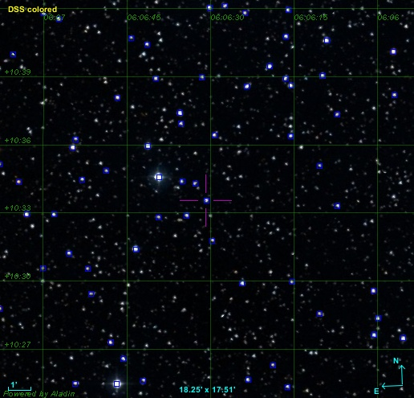

StevenHillAladin.jpg

|  |  |
| --- | --- |
| D:\Astronomy\Data\2015\02\11\M42-742nm\M42-20150211LT-742-sum41m20s-BkgFlt-Log-SmthBkg-HalfSize.jpg | D:\Astronomy\Data\2015\02\11\M42-742nm\M42-20150211LT-742-sum41m20s-BkgFlt-Log-SmthBkg-Cropped.jpg |
| M42-20150211LT-742-sum41m20s-BkgFlt-Log-SmthBkg-HalfSize.jpg | M42-20150211LT-742-sum41m20s-BkgFlt-Log-SmthBkg-Cropped.jpg |

**Data Disposition:** Raw data is zipped on the thumb drive and ready to be moved to the 2TB archive drive. Processed data are in the “StevenHill” and “OrionWideFieldProject2015” folders.

### 2015-Feb-18 (Feb-19 UT): M42 Wide Field >807nm and SII

Last Updated 1/18/2015

|  |  |
| --- | --- |
| G:\Astronomy\Projects\OrionWideFieldProject2015\Data\20150219UT-807+SII-Sword\M42-20150218LT--SII-sum50m40s-Log-HalfSize.jpg | G:\Astronomy\Projects\OrionWideFieldProject2015\Data\20150219UT-807+SII-Sword\M42Wide-201502XX-SII02h15m-FlatBkg-Log-HalfSize.jpg |
| M42-20150218LT--SII-sum50m40s-Log-HalfSize.jpg | M42Wide-201502XX-SII02h15m-FlatBkg-Log-HalfSize.jpg |
| G:\Astronomy\Projects\OrionWideFieldProject2015\Data\20150219UT-807+SII-Sword\M42-20150218LT-807-sum0h58m-Flattened-Log-HalfSize.jpg | G:\Astronomy\Projects\OrionWideFieldProject2015\Data\M42-SHO-Final-Wavelets1x8-Sat-Stretch-HalfSize.jpg |
| M42-20150218LT-807-sum0h58m-Flattened-Log-HalfSize.jpg | M42-SHO-Final-Wavelets1x8-Sat-Stretch-HalfSize.jpg |

|  |
| --- |
| G:\Astronomy\Projects\OrionWideFieldProject2015\Data\M42-SHO-Final-Wavelets1x8-Sat-Stretch-Cropped.jpg |
| M42-SHO-Final-Wavelets1x8-Sat-Stretch-Cropped.jpg |

## March

### 2015-Mar-09 (Mar-10 UT): Venus and Jupiter Video

Last Updated 3/11/2015

|  |
| --- |
| D:\Astronomy\Projects\Venus Project 2015\Imaging\Data\20150310UT\Venus-UV 2015-03-09T19_55_37-Stack200-Wavelets3x4+4x30+5X15+6x4-Cont85pct-RotCrop.jpg |
| Venus-UV 2015-03-09T19\_55\_37-Stack200-Wavelets3x4+4x30+5X15+6x4-Cont85pct-RotCrop.jpg |

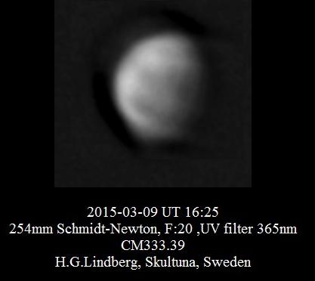

I took a 2 min video of Venus with the ASI120MM and the C8 with a 2x barlow giving a plate scale of about 0.16”/pix. Gamma was set to 50, gain to 84, brightness to 0 and the exposure time was ~262 ms. About a minute into the video Venus fades when it goes behind a pine.

I took a set of videos of Jupiter with the ASI120MM and the C8 with a 2x barlow giving a plate scale of about 0.16”/pixel. The table below shows the camera and video parameters associated with each filter. Unfortunately the signal with the methane filter was so low that it necessitated a gamma well above 50, which I believe is the linear setting for the ASI120mm. (I must experimentally quantify the effects of the ASI120MM camera settings at some time.)

I took a second set of videos of Jupiter with the ASI120MM and the C8 with a 2x barlow giving a plate scale of about 0.16”/pixel to give different longitude coverage of Jupiter. The table above shows the camera and video parameters associated with each filter. Unfortunately the signal with the methane filter was so low that it necessitated a gamma well above 50, which I believe is the linear setting for the ASI120mm. (I must experimentally quantify the effects of the ASI120MM camera settings at some time.)

|  |  |  |  |  |  |
| --- | --- | --- | --- | --- | --- |
| Filter | Gamma | Gain | Brightness | Exposure | 3/11/UT |
| NUV | 50 | 100 | 0 | 935 ms |  |
| BLU | 50 | 50 | 0 | 51 ms | Yes |
| GRN | 50 | 50 | 0 | 51 ms | Yes |
| RED | 50 | 50 | 0 | 91 ms | Yes |
| >685 nm | 50 | 50 | 0 | 122 (or 91?) ms | 91ms Yes |
| CH4 | 95 | 100 | 12 | 4000ms | Yes |

|  |  |
| --- | --- |
| D:\Astronomy\Projects\Jupiter Project 2015\Imaging\Data\20150310UT\2015-03-10-0228_2-Hill-IGB-ReAligned-Wavelets.jpg | D:\Astronomy\Projects\Jupiter Project 2015\Imaging\Data\20150310UT\2015-03-10-0433_8-Hill-IGB-Realigned-Wavelets-ColAdj.jpg |
| 2015-03-10-0228\_2-Hill-IGB-ReAligned-Wavelets.jpg | 2015-03-10-0433\_8-Hill-IGB-Realigned-Wavelets-ColAdj.jpg |
| D:\Astronomy\Projects\Jupiter Project 2015\Imaging\Data\20150310UT\2015-03-10-0227_4-Hill-Jupiter-MGU-ColAdj-Wavelets.jpg | D:\Astronomy\Projects\Jupiter Project 2015\Imaging\Data\20150310UT\2015-03-10-0433_7-Hill-Jupiter-MGU-ColAdj-Wavelets.jpg |
| 2015-03-10-0227\_4-Hill-Jupiter-MGU-ColAdj-Wavelets.jpg | 2015-03-10-0433\_7-Hill-Jupiter-MGU-ColAdj-Wavelets.jpg |
| D:\Astronomy\Projects\Jupiter Project 2015\Imaging\Data\20150310UT\Ganymede-20150310UT-02XX-RED+685-Stack2.jpg | D:\Astronomy\Projects\Jupiter Project 2015\Imaging\Data\20150310UT\Ganymede-20150310UT-04XX-RED+685-Stack3.jpg |
| Ganymede-20150310UT-02XX-RED+685-Stack2.jpg | Ganymede-20150310UT-04XX-RED+685-Stack3.jpg |

**Ganymede!**

|  |  |  |  |  |  |
| --- | --- | --- | --- | --- | --- |
| G:\Astronomy\Projects\Jupiter Project 2015\Imaging\Data\20150310UT\2015-03-11-0329_5-Hill-Ganymede-CH4-Stack6-Cropped4x.jpg | G:\Astronomy\Projects\Jupiter Project 2015\Imaging\Data\20150310UT\2015-03-10-0221.6-Hill-Ganymede-685-Stack1-Cropped4x.jpg | G:\Astronomy\Projects\Jupiter Project 2015\Imaging\Data\20150310UT\2015-03-10-0224.8-Hill-Jupiter-RED-Stack1-Cropped4x.jpg | G:\Astronomy\Projects\Jupiter Project 2015\Imaging\Data\20150310UT\2015-03-10-0229.4-Hill-Ganymede-GRN-Stack1-Cropped4x.jpg | G:\Astronomy\Projects\Jupiter Project 2015\Imaging\Data\20150310UT\2015-03-10-0233.6-Hill-Ganymede-BLU-Stack1-Cropped4x.jpg | G:\Astronomy\Projects\Jupiter Project 2015\Imaging\Data\20150310UT\2015-03-10-0331_0-Hill-Ganymede-NUV-Stack4-Cropped4x.jpg |
| 2015-03-11-0329\_5-Hill-Ganymede-CH4-Stack6-Cropped4x.jpg | 2015-03-10-0221.6-Hill-Ganymede-685-Stack1-Cropped4x.jpg | 2015-03-10-0224.8-Hill-Jupiter-RED-Stack1-Cropped4x.jpg | 2015-03-10-0229.4-Hill-Ganymede-GRN-Stack1-Cropped4x.jpg | 2015-03-10-0233.6-Hill-Ganymede-BLU-Stack1-Cropped4x.jpg | 2015-03-10-0331\_0-Hill-Ganymede-NUV-Stack4-Cropped4x.jpg |
|  | G:\Astronomy\Projects\Jupiter Project 2015\Imaging\Data\20150310UT\2015-03-11-0352_9-Hill-Ganymede-685-Stack3-Cropped4x.jpg | G:\Astronomy\Projects\Jupiter Project 2015\Imaging\Data\20150310UT\2015-03-11-0330_4-Hill-Ganymede-RED-Stack2-Cropped4x.jpg | G:\Astronomy\Projects\Jupiter Project 2015\Imaging\Data\20150310UT\2015-03-11-0331_0-Hill-Ganymede-GRN-Stack2-Cropped4x.jpg | G:\Astronomy\Projects\Jupiter Project 2015\Imaging\Data\20150310UT\2015-03-10-0332_0-Hill-Ganymede-BLU-Stack2-Cropped4x.jpg |  |
|  | 2015-03-11-0352\_9-Hill-Ganymede-685-Stack3-Cropped4x.jpg | 2015-03-11-0330\_4-Hill-Ganymede-RED-Stack2-Cropped4x.jpg | 2015-03-11-0331\_0-Hill-Ganymede-GRN-Stack2-Cropped4x.jpg | 2015-03-10-0332\_0-Hill-Ganymede-BLU-Stack2-Cropped4x.jpg |  |

**Io!**

|  |  |  |  |  |  |
| --- | --- | --- | --- | --- | --- |
| G:\Astronomy\Projects\Jupiter Project 2015\Imaging\Data\20150310UT\2015-03-11-0444_4-Hill-Io-CH4-Stack3-Cropped4x.jpg | G:\Astronomy\Projects\Jupiter Project 2015\Imaging\Data\20150310UT\2015-03-11-0352_9-Hill-Io-685-Stack3-Cropped4x.jpg | G:\Astronomy\Projects\Jupiter Project 2015\Imaging\Data\20150310UT\2015-03-11-0330_4-Hill-Io-RED-Stack2-Cropped4x.jpg | G:\Astronomy\Projects\Jupiter Project 2015\Imaging\Data\20150310UT\2015-03-10-0432.6-Hill-Io-GRN-Stack1-Cropped4x.jpg | G:\Astronomy\Projects\Jupiter Project 2015\Imaging\Data\20150310UT\2015-03-10-0332_0-Hill-Io-BLU-Stack2-Cropped4x.jpg | G:\Astronomy\Projects\Jupiter Project 2015\Imaging\Data\20150310UT\2015-03-10-0424_0-Hill-Io-NUV-Stack2-Cropped4x.jpg |
| 2015-03-11-0444\_4-Hill-Io-CH4-Stack3-Cropped4x.jpg | 2015-03-11-0352\_9-Hill-Io-685-Stack3-Cropped4x.jpg | 2015-03-11-0330\_4-Hill-Io-RED-Stack2-Cropped4x.jpg | 2015-03-10-0432.6-Hill-Io-GRN-Stack1-Cropped4x.jpg | 2015-03-10-0332\_0-Hill-Io-BLU-Stack2-Cropped4x.jpg | 2015-03-10-0424\_0-Hill-Io-NUV-Stack2-Cropped4x.jpg |

Record durations of videos above...also put processing statuses and archive disposition

**Data Disposition:**

Jupiter and Venus data are zipped and archived on the 2TB Archive Drive. Processed data is contained in their respective 2015 project folders.

### 2015-Mar-10 (Mar-11 UT): Venus, Jupiter and Sirius Video

Last Updated 3/11/2015

I took three videos of Venus with the C8 (2x Barlow) and ASI120MM (NUV, >685, CH4).

Venus

|  |  |  |  |  |  |
| --- | --- | --- | --- | --- | --- |
| Filter | Gamma | Gain | Brightness | Exposure | Duration |
| NUV | 50 | 84 | 0 | 91 ms | 2x1min |
| CH4 | 50 | 84 | 0 | 51 ms | 1min |
| 685 | 50 | 0 | 0 | 16ms |  |

|  |  |  |  |
| --- | --- | --- | --- |
| D:\Astronomy\Projects\Venus Project 2015\Imaging\Data\20150311UT\Venus-20150311UT-NUV 2015-03-10T18_57_01-Stack300-Wavelets3x6+4x20+5x6-Cont60pct.jpg | D:\Astronomy\Projects\Venus Project 2015\Imaging\Data\20150311UT\Venus-20150311UT-685 2015-03-10T19_12_18-Stack375-Wavelets3x6+4x20+5x6-Cont60pct-Wavelets1x2+2x6+3x2.jpg | | D:\Astronomy\Projects\Venus Project 2015\Imaging\Data\20150311UT\Venus-20150311UT-CH4 2015-03-10T19_07_15_Stack300-Wavelets2x6+3x20+4x6-Cont80pct.jpg |
| Venus-20150311UT-NUV 2015-03-10T18\_57\_01-Stack300-Wavelets3x6+4x20+5x6-Cont60pct.jpg | Venus-20150311UT-685 2015-03-10T19\_12\_18-Stack375-Wavelets3x6+4x20+5x6-Cont60pct-Wavelets1x2+2x6+3x2.jpg | | Venus-20150311UT-CH4 2015-03-10T19\_07\_15\_Stack300-Wavelets2x6+3x20+4x6-Cont80pct.jpg |
| D:\Astronomy\Projects\Venus Project 2015\Imaging\Data\20150311UT\2015-03-11-0XXX.X-Hill-Venus-RGB-685-(685NUV)-NUV-Sat150pct.jpg | | D:\Astronomy\Projects\Venus Project 2015\Imaging\Data\20150311UT\2015-03-11-0XXX.X-Hill-Venus-RGB-CH4-685-NUV.jpg | |
| 2015-03-11-0XXX.X-Hill-Venus-RGB-685-(685NUV)-NUV-Sat150pct.jpg | | 2015-03-11-0XXX.X-Hill-Venus-RGB-CH4-685-NUV.jpg | |

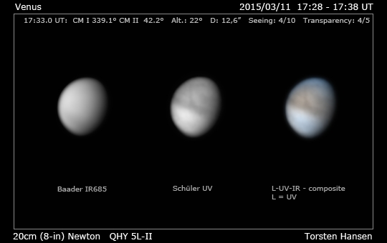

Jupiter 3/11

|  |  |  |  |  |  |
| --- | --- | --- | --- | --- | --- |
| Filter | Gamma | Gain | Brightness | Exposure |  |
| NUV | 50 | 100 | 0 | 935 ms |  |
| BLU | 50 | 50 | 0 | 51 ms |  |
| GRN | 50 | 50 | 0 | 51 ms |  |
| RED | 50 | 50 | 0 | 91 ms |  |
| >685 nm | 50 | 50 | 0 | 91 ms |  |
| CH4 | 95 | 100 | 12 | 4000ms |  |

Sirius

|  |  |  |  |  |  |
| --- | --- | --- | --- | --- | --- |
| Filter | Gamma | Gain | Brightness | Exposure | Duration |
| NUV | 100 | 100 | 0 | 91 ms |  |
| 685 | 100 | 58 | 0 | 3.7ms |  |
| 685 | 100 | 58 | 0 | 91ms |  |

Record durations of videos above...also put processing statuses and archive disposition

The following morning, March 11 at 5:59 am MST, I saw a very bright meteor/fireball. It was travelling north to south about 10-15 degrees above the western horizon. I viewed it from my car while commuting to Boulder. It was much slower moving compared to most meteors I’ve seen. I estimate the brightness to be about -5 to -6 visual magnitude. It trailed a tail that must have been 0.5-1.0 degree. There was no trail evident after the meteors passage, but that could be due to interference from streetlights and headlights. At peak brightness the core of the head was bright white, maybe even with a tinge of blue. The tail was yellow as was the head for most of the observed time. Total duration of the flight was probably 5-10 seconds. visibility spanned probably >90 degrees in azimuth with the meteor fading into the distance in the south as it’s angular rate decreased almost seemingly to zero due to the foreshortening of the viewing geometry. I began driving from home at about 5:38am MST. I can probably use that to estimate my location on the highway when I saw the meteor. Roughly, it was Broomfield.

Put AMS link here: <http://www.amsmeteors.org/members/imo_view/browse_reports> The event was #638.

Note that ASI120MM Gamma setting of 50 ***is*** the linear gamma setting per this website <http://www.zwoptical.com/eng/Cameras/ASI120/software_basic.asp> (near the bottom of the page).

|  |  |
| --- | --- |
| D:\Astronomy\Projects\Jupiter Project 2015\Imaging\Data\20150311UT\2015-03-11-0217_5-Hill-Jupiter-IGB-ReAligned-Wavelets.jpg | D:\Astronomy\Projects\Jupiter Project 2015\Imaging\Data\20150311UT\2015-03-11-0452_8-Hill-Jupiter-IGB-Realigned-Wavelets.jpg |
| 2015-03-11-0217\_5-Hill-Jupiter-IGB-ReAligned-Wavelets.jpg | 2015-03-11-0452\_8-Hill-Jupiter-IGB-Realigned-Wavelets.jpg |
| G:\Astronomy\Projects\Jupiter Project 2015\Imaging\Data\20150311UT\2015-03-11-0214_7-Hill-Jupiter-MGU-RealignedColAdj-Wavelets.jpg | D:\Astronomy\Projects\Jupiter Project 2015\Imaging\Data\20150311UT\2015-03-11-0450_8-Hill-Jupiter-MGU-Realigned-Wavelets.jpg |
| 2015-03-11-0214\_7-Hill-Jupiter-MGU-RealignedColAdj-Wavelets.jpg | 2015-03-11-0450\_8-Hill-Jupiter-MGU-Realigned-Wavelets.jpg |

|  |  |  |  |  |
| --- | --- | --- | --- | --- |
| D:\Astronomy\Projects\Jupiter Project 2015\Imaging\Data\20150311UT\2015-03-11-0327_0-Hill-Io-CH4-Stack4-Cropped4x.jpg | D:\Astronomy\Projects\Jupiter Project 2015\Imaging\Data\20150311UT\2015-03-11-0412_0-Hill-Io-685-Stack4-Cropped4x.jpg | D:\Astronomy\Projects\Jupiter Project 2015\Imaging\Data\20150311UT\2015-03-11-0327_4-Hill-Io-RED-Stack2-Cropped4x.jpg | D:\Astronomy\Projects\Jupiter Project 2015\Imaging\Data\20150311UT\2015-03-11-0403_4-Hill-Io-BLU-Stack3-Cropped4x.jpg | D:\Astronomy\Projects\Jupiter Project 2015\Imaging\Data\20150311UT\2015-03-11-0224.9-Hill-Io-NUV-Stack1-Cropped4x.jpg |
| 2015-03-11-0327\_0-Hill-Io-CH4-Stack4-Cropped4x.jpg | 2015-03-11-0412\_0-Hill-Io-685-Stack4-Cropped4x.jpg | 2015-03-11-0327\_4-Hill-Io-RED-Stack2-Cropped4x.jpg | 2015-03-11-0403\_4-Hill-Io-BLU-Stack3-Cropped4x.jpg | 2015-03-11-0224.9-Hill-Io-NUV-Stack1-Cropped4x.jpg |

|  |  |  |  |  |
| --- | --- | --- | --- | --- |
| D:\Astronomy\Projects\Jupiter Project 2015\Imaging\Data\20150311UT\2015-03-11-0454.1-Hill-Europa-CH4-Cropped4x.jpg | D:\Astronomy\Projects\Jupiter Project 2015\Imaging\Data\20150311UT\2015-03-11-0436.3-Hill-Europa-685-Cropped4x.jpg | D:\Astronomy\Projects\Jupiter Project 2015\Imaging\Data\20150311UT\2015-03-11-0439.2-Hill-Europa-RED-Cropped4x.jpg | D:\Astronomy\Projects\Jupiter Project 2015\Imaging\Data\20150311UT\2015-03-11-0441.4-Hill-Europa-GRN-Cropped4x.jpg | D:\Astronomy\Projects\Jupiter Project 2015\Imaging\Data\20150311UT\2015-03-11-0443.9-Hill-Europa-BLU-Cropped4x.jpg |
| 2015-03-11-0454.1-Hill-Europa-CH4-Cropped4x.jpg | 5-03-11-0436.3-Hill-Europa-685-Cropped4x.jpg | 2015-03-11-0439.2-Hill-Europa-RED-Cropped4x.jpg | 2015-03-11-0441.4-Hill-Europa-GRN-Cropped4x.jpg | 2015-03-11-0443.9-Hill-Europa-BLU-Cropped4x.jpg |

4x and then 81% scaling

**Data Disposition:**

Venus...raw data may have been accidentally deleted! Still have processed/stacked images under “Venus Project 2015” directory.

Jupiter and Sirius data are zipped and archived on the 2TB Archive Drive. Processed data is contained in their respective 2015 project folders.

### 2015-Mar-17 (Mar-18 UT): Jupiter Spectra

Last Updated 3/11/2015

Problems with filter wheel interference from 135mm lens forced only taking >742nm spectra

Upon initial analysis found a small contaminating star right next to the 889nm band!!!! MUST BE VERY CAREFUL!!!

### 2015-Mar-21 (Mar-22 UT): Jupiter Spectra

Last Updated 3/11/2015

Only taking >742nm spectra

### 2015-Mar-29 (Mar-30 UT): Venus Spectra

Last Updated 3/11/2015

A good solar atlas online. It’s basically a scanned version of I can’t recall which definitive spectral atlas… <http://www.astrosurf.com/spectrohelio/atlas-en.php>

I took spectra of Venus using the StarAnalyzer 100 as an objective grating with the 135mm lens in two bands (CLR, >742nm).

|  |
| --- |
| D:\Astronomy\Projects\Venus Project 2015\Spectral Data\20150330UT\VenusSpectra-20150330UT-742-sum5m00s-RotCrop-Flat-Log_HalfSize.jpg |
| VenusSpectra-20150330UT-742-sum5m00s-RotCrop-Flat-Log\_HalfSize.jpg |
| D:\Astronomy\Projects\Venus Project 2015\Spectral Data\20150330UT\VenusSpectra-20150330UT-CLR-sum5m00s-RotCrop-Flat-Log-HalfSize.jpg |
| VenusSpectra-20150330UT-CLR-sum5m00s-RotCrop-Flat-Log-HalfSize.jpg |

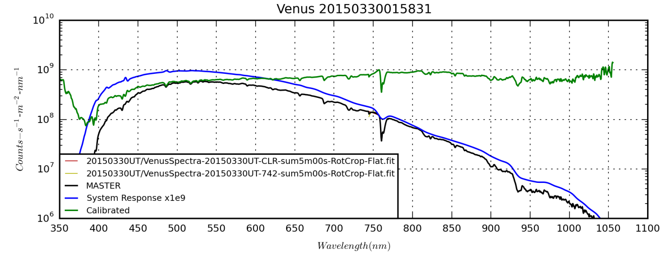

**Data Disposition:** Raw data was *accidentally* *deleted* from the Astronomy2 thumb drive. Processed FITS files and 1-D spectra are under the /Venus Project 2015 directory on the Astronomy2 thumb drive.

### 2015-Mar-30 (Mar-31 UT): Jupiter Spectra

Last Updated 3/11/2015

Only taking >742nm spectra

**Data Disposition:** Raw data is zipped and archived on the 2TB archive drive. Processed data is stored on the Astronomy thumb drive under the Jupiter Project 2014

### Planning: Spring

Last Updated 1/18/2015

* Double Stars
  + Xi Uma
  + Zet Cnc
  + Castor
  + Eta Cass
  + Iota Cass
  + Sigma Cass
* Jupiter
  + Full Longitudinal video mapping
  + Spectroscopic variability due to GRS and moons
* Venus
  + Multiband video
  + Spectroscopy including looking for SWIR variations near 1 micron due to surface features
* Planetary Nebulae
  + Eskimo high resolution and/or narrow band
  + Eskimo spectra
* Galaxies
  + M81 multiband imaging in NUV, NIR and narrow band (HI, SII, OIII)
  + M82 multiband imaging in NUV, NIR and narrow band (HI, SII, OIII)

## April

### 2015-Apr-12 (Apr-13 UT): M82 in [OIII]

Last Updated 7/7/1/2015

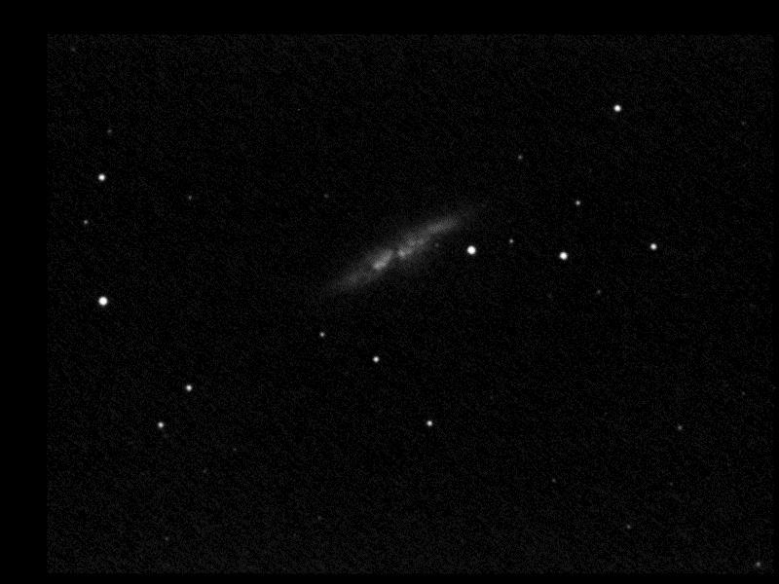

M82-20150413UT-OIII-sum39m19s-SmoothLog-HalfSize.jpg

I tried to take a 5 hour series of [OIII] images of M82 through the C8 at 1260mm (f/6.3) with the ST2000 camera. I had multiple problems:

1. Saw that both X and Y axes had secular drifts despite having a very good star to guide on. I later realized that for some reason I had the guiding graph set to camera coordinates rather than mount coordinates. So, it was actually only the Y-axis that had the uncorrected drift. I set the anti-sticktion to off – just blindly trying anything – and that seemed to restore guiding to ~1.0 pixel. However, after about 10-15 minutes it started to drift again. I ended up shutting off one direction of the Y-axes guiding commands at a time and found that one seemed not to work. I shut down guiding and gave manual commands to move in Y and one direction worked while the other did not. In fact, upon pressing the button for the commanded direction, it immediately popped back up on the console without appearing to pause to give the 5-7 second correction it should have. The pause happened for each of the other three command directions. And, for each of those other directions I could hear the relay clicks. I ended up shortening my individual exposures to 30 seconds to minimize drift. It appeared – from visual examination of images – that later, guiding seemed better. This seems like a classic failure of the relay box system, including the fact that one Y-axis light on the cable system never lit at all. However, the response of MaximDL upon manual commanding seems weird.
2. When I checked on the system in the morning, MaximDL had frozen at exposure number 62 when I had planned 150 exposures followed by calibration frames. I’ve never seen this type of problem before. There were no disk full problems and I had turned off wifi so that there should have been no forced system patches or updates.

**Data Disposition:** Raw data zipped and stored on 2TB archive drive. Processed data in *\M82 Project 2015* directory

### 2015-Apr-13 (Apr-14 UT): M82 in [OIII]

Last Updated 5/19/2015

I tried again, with little more success. Taking short exposures to ensure minimal drift only served to let the read noise completely dominate the image data.

|  |  |
| --- | --- |
| D:\Astronomy\Projects\M82 Project 2015\20150413LT\M82-20150414TXXXXXXUT-sum4h34m00s-OIII-Log-HalfSize.jpg | D:\Astronomy\Projects\M82 Project 2015\20150413LT\M82-2015041XTXXXXXXUT-sum5h13m19s-OIII-58-42weighted-ExpNorm-Log-HalfSize.jpg |
| M82-20150414TXXXXXXUT-sum4h34m00s-OIII-Log-HalfSize.jpg | M82-2015041XTXXXXXXUT-sum5h13m19s-OIII-58-42weighted-ExpNorm-Log-HalfSize.jpg |

|  |  |
| --- | --- |
| G:\Astronomy\Projects\M82 Project 2015\20150413LT\M82-HaHaOIII-Log-Cropped-HalfSize.jpg | G:\Astronomy\Projects\M82 Project 2015\20150413LT\M82_HaLog-minus-OIIILog-Cropped-HalfSize.jpg |
| M82-HaHaOIII-Log-Cropped-HalfSize.jpg | M82\_HaLog-minus-OIIILog-Cropped-HalfSize.jpg |
| G:\Astronomy\Projects\M82 Project 2015\20150413LT\M82-HaHaOIII-Log-Cropped-Inverse-HalfSize.jpg | G:\Astronomy\Projects\M82 Project 2015\20150413LT\M82_HaLog-minus-OIIILog-Cropped-Inverse-HalfSize.jpg |
| M82-HaHaOIII-Log-Cropped-Inverse-HalfSize.jpg | M82\_HaLog-minus-OIIILog-Cropped-Inverse-HalfSize.jpg |

**Data Disposition:** Raw data zipped and stored on 2TB archive drive. Processed data in *\M82 Project 2015* directory

## June

### 2015-Jun-01 (Jun-01 UT): Backyard Multiband Experiment

Last Updated 3/11/2015

**Data Disposition:** Raw and processed data only exist in “Earth Project 2015” directory.

### 2015-Jun-02 (Jun-02 UT): Loveland Pass Multiband

Last Updated 3/11/2015

Filter 1 is NUV

Filter 2 is NIR (not sure if 685, 742 or 807)

Filter 3 is Red

Filter 4 is Green

Filter 5 is Blue

|  |  |  |
| --- | --- | --- |
| G:\Astronomy\Data\2015\06\01UT\Loveland-Mosaic-StackX-AlignedScaled-345-RGB-Gam60pct-Sat150pct-HalfSize.jpg | G:\Astronomy\Data\2015\06\01UT\Loveland-Mosaic-StackX-AlignedScaled-241-IGU-Gam60pct-Sat150pct-HalfSize.jpg | G:\Astronomy\Data\2015\06\01UT\Loveland-Mosaic-StackX-AlignedScaled-23451-IRGBU-WhiteBal-Sat200pct-HalfSize.jpg |
| Loveland-Mosaic-StackX-AlignedScaled-345-RGB-Gam60pct-Sat150pct-HalfSize.jpg | Loveland-Mosaic-StackX-AlignedScaled-241-IGU-Gam60pct-Sat150pct-HalfSize.jpg | Loveland-Mosaic-StackX-AlignedScaled-23451-IRGBU-WhiteBal-Sat200pct-HalfSize.jpg |
| G:\Astronomy\Data\2015\06\01UT\Loveland-Mosaic-StackX-AlignedScaled-345-RGB-Gam60pct-Sat150pct-Gam200pct+Sat200pct-HalfSize.jpg | G:\Astronomy\Data\2015\06\01UT\Loveland-Mosaic-StackX-AlignedScaled-241-IGU-Gam60pct-Sat150pct-Gamma150+Sat200-HalfSize.jpg | G:\Astronomy\Data\2015\06\01UT\Loveland-Mosaic-StackX-AlignedScaled-23451-IRGBU-WhiteBal-Gamma200pct+Sat200pct-HalfSize.jpg |
| Loveland-Mosaic-StackX-AlignedScaled-345-RGB-Gam60pct-Sat150pct-Gam200pct+Sat200pct-HalfSize.jpg | Loveland-Mosaic-StackX-AlignedScaled-241-IGU-Gam60pct-Sat150pct-Gamma150+Sat200-HalfSize.jpg | Loveland-Mosaic-StackX-AlignedScaled-23451-IRGBU-WhiteBal-Gamma200pct+Sat200pct-HalfSize.jpg |

**Data Disposition:** Raw and processed data only exist in “Earth Project 2015” directory. JPG files also posted to Flickr.com.

### 2015-Jun-02 (Jun-03 UT): Venus

Last Updated 1029/2015

|  |  |  |  |
| --- | --- | --- | --- |
| G:\Astronomy\Projects\Venus Project 2015\Imaging\Data\20150603UT\Venus-NUV 2015-06-02T21_04_33-Rot-Crop.jpg | G:\Astronomy\Projects\Venus Project 2015\Imaging\Data\20150603UT\Venus-685 2015-06-02T20_51_10-Rot-Crop.jpg | G:\Astronomy\Projects\Venus Project 2015\Imaging\Data\20150603UT\Venus-807 2015-06-02T21_10_35-Rot-Crop.jpg | G:\Astronomy\Projects\Venus Project 2015\Imaging\Data\20150603UT\Venus-889 2015-06-02T20_54_17-Rot-Crop.jpg |
| Venus-NUV 2015-06-02T21\_04\_33-Rot-Crop.jpg | Venus-685 2015-06-02T20\_51\_10-Rot-Crop.jpg | Venus-807 2015-06-02T21\_10\_35-Rot-Crop.jpg | Venus-889 2015-06-02T20\_54\_17-Rot-Crop.jpg |
| G:\Astronomy\Projects\Venus Project 2015\Imaging\Data\20150603UT\Venus-NUVminus889.jpg | G:\Astronomy\Projects\Venus Project 2015\Imaging\Data\20150603UT\Venus-685+807+889 2015-06-02T-Rot-Crop.jpg | G:\Astronomy\Projects\Venus Project 2015\Imaging\Data\20150603UT\Venus-RGB-889-807-NUV-Wavelets-ColAdj.jpg |  |
| Venus-NUVminus889.jpg | Venus-685+807+889 2015-06-02T-Rot-Crop.jpg | Venus-RGB-889-807-NUV-Wavelets-ColAdj.jpg |  |

Referring back to this set of observations (10/29/2015), there is a very confusing set of processed images. It appears that filter labeling was not correct and that after the fact I made an attempt to correct it. There are references to four different filters: >685nm, >807nm, 889nm and NUV. In addition, no record of the video times (other than the time stamps in the processed file names) is immediately available.

|  |  |  |
| --- | --- | --- |
| Date Time | Initial Filter Label | “Really” Filter Label |
| 2015-06-02T20\_51\_10 | 685 |  |
| 2015-06-02T21\_10\_35 | 807-Really |  |
| 2015-06-02T20\_54\_17 | NUV | NUVbutreally889 |
| 2015-06-02T21\_04\_33 | NUV-Really |  |

**Data Disposition:** Raw data zipped and stored on 2TB archive drive. Processed data in “Venus Project 2015” directory

### 2015-Jun-22 (Jun-23 UT): Venus, Jupiter, Moon and Saturn

Last Updated 3/11/2015

**Venus**

|  |  |  |
| --- | --- | --- |
| G:\Astronomy\Projects\Venus Project 2015\Imaging\Data\20150623UT\Venus-20150622-NUV 2015-06-22T20_53_27-Stack600-Wavelets2x5+3x10+4x5-Hist128-Wavelets1x0+2x4+3x4-Aligned-Crop.jpg | G:\Astronomy\Projects\Venus Project 2015\Imaging\Data\20150623UT\Venus-20150622-685 2015-06-22T20_48_09-Stack400-Wavelets2x8+3x15+4x8-Hist192-Aligned-Crop.jpg | G:\Astronomy\Projects\Venus Project 2015\Imaging\Data\20150623UT\Venus-20150622-807 2015-06-22T20_44_13-Stack700-Wavelets2x10+3x20+4x10-Aligned-Crop.jpg |
| Venus-20150622-NUV 2015-06-22T20\_53\_27-Stack600-Wavelets2x5+3x10+4x5-Hist128-Wavelets1x0+2x4+3x4-Aligned-Crop.jpg | Venus-20150622-685 2015-06-22T20\_48\_09-Stack400-Wavelets2x8+3x15+4x8-Hist192-Aligned-Crop.jpg | Venus-20150622-807 2015-06-22T20\_44\_13-Stack700-Wavelets2x10+3x20+4x10-Aligned-Crop.jpg |
| G:\Astronomy\Projects\Venus Project 2015\Imaging\Data\20150623UT\Venus-20150622-NUVminus807-Crop.jpg | G:\Astronomy\Projects\Venus Project 2015\Imaging\Data\20150623UT\Venus-20150622-807-685-NUV-Crop.jpg | G:\Astronomy\Projects\Venus Project 2015\Imaging\Data\20150623UT\Venus-20150622-807-685-NUV-Rev2-Crop.jpg |
| Venus-20150622-NUVminus807-Crop.jpg | Venus-20150622-807-685-NUV-Crop.jpg | Venus-20150622-807-685-NUV-Rev2-Crop.jpg |

**Jupiter**

|  |  |  |  |
| --- | --- | --- | --- |
| D:\Astronomy\Projects\Jupiter Project 2015\Imaging\Data\20150623UT\Jupiter-20150622-RED 2015-06-22T21_11_43-Stack300-Wavelets2x10+3x20+4x10-Hist128RotCrop.jpg | D:\Astronomy\Projects\Jupiter Project 2015\Imaging\Data\20150623UT\Jupiter-20150622-GRN 2015-06-22T21_09_43-Stack400-Wavelets2x10+3x20+4x10RotCrop.jpg | D:\Astronomy\Projects\Jupiter Project 2015\Imaging\Data\20150623UT\Jupiter-20150622-BLU 2015-06-22T21_07_05-Stack300-Wavelets2x10+3x20+4x10RotCrop.jpg | D:\Astronomy\Projects\Jupiter Project 2015\Imaging\Data\20150623UT\Jupiter-20150622T21_09_30-RGB-Wavelets2x3+3x3+4x3-Hist192RotCrop.jpg |
| Jupiter-20150622-RED 2015-06-22T21\_11\_43-Stack300-Wavelets2x10+3x20+4x10-Hist128RotCrop.jpg | Jupiter-20150622-GRN 2015-06-22T21\_09\_43-Stack400-Wavelets2x10+3x20+4x10RotCrop.jpg | Jupiter-20150622-BLU 2015-06-22T21\_07\_05-Stack300-Wavelets2x10+3x20+4x10RotCrop.jpg | Jupiter-20150622T21\_09\_30-RGB-Wavelets2x3+3x3+4x3-Hist192RotCrop.jpg |

**Saturn**

|  |  |  |
| --- | --- | --- |
| G:\Astronomy\Projects\Saturn Project 2015\Imaging\20150623UT\Saturn-20150622-CH4 2015-06-22T22_41_12-DarkStack201-Wavelets3x3+4x5+5x3-Hist64-Wavelets3x3+4x5+5x3-AlignedRot-CropTight.jpg | G:\Astronomy\Projects\Saturn Project 2015\Imaging\20150623UT\Saturn-20150622-807 2015-06-22T22_25_52-Stack100-Wavelets2x6+3x12+4x6-Hist64-AlignedRot-CropTight.jpg | G:\Astronomy\Projects\Saturn Project 2015\Imaging\20150623UT\Saturn-20150622-685 2015-06-22T22_22_36-Stack450-Wavelets1x8+2x15+3x8-Hist64-AlignedRot-CropTight.jpg |
| Saturn-20150622-CH4 2015-06-22T22\_41\_12-DarkStack201-Wavelets3x3+4x5+5x3-Hist64-Wavelets3x3+4x5+5x3-AlignedRot-CropTight.jpg | Saturn-20150622-807 2015-06-22T22\_25\_52-Stack100-Wavelets2x6+3x12+4x6-Hist64-AlignedRot-CropTight.jpg | Saturn-20150622-685 2015-06-22T22\_22\_36-Stack450-Wavelets1x8+2x15+3x8-Hist64-AlignedRot-CropTight.jpg |
| G:\Astronomy\Projects\Saturn Project 2015\Imaging\20150623UT\Saturn-20150622-RED 2015-06-22T22_29_32-Stack200-Wavelets1x8+2x15+3x8-Hist128-AlignedRot-CropTight.jpg | G:\Astronomy\Projects\Saturn Project 2015\Imaging\20150623UT\Saturn-20150622-GRN 2015-06-22T22_32_07-Stack350-Wavelets1x10+2x20+3x10-Hist128-AlignedRot-CropTight.jpg | G:\Astronomy\Projects\Saturn Project 2015\Imaging\20150623UT\Saturn-20150622-BLU 2015-06-22T22_36_00-Stack200-Wavelets1x8+2x15+3x8-Hist128-AlignedRot-CropTight.jpg |
| Saturn-20150622-RED 2015-06-22T22\_29\_32-Stack200-Wavelets1x8+2x15+3x8-Hist128-AlignedRot-CropTight.jpg | Saturn-20150622-GRN 2015-06-22T22\_32\_07-Stack350-Wavelets1x10+2x20+3x10-Hist128-AlignedRot-CropTight.jpg | Saturn-20150622-BLU 2015-06-22T22\_36\_00-Stack200-Wavelets1x8+2x15+3x8-Hist128-AlignedRot-CropTight.jpg |
| G:\Astronomy\Projects\Saturn Project 2015\Imaging\20150623UT\Saturn-20150622-NUV 2015-06-22T22_54_18-DarkStack87-Wavelets5x4+6x4-Stretch-AlignedRot-CropTight.jpg | G:\Astronomy\Projects\Saturn Project 2015\Imaging\20150623UT\Saturn-20150622T22_26_00-807-685-RED-Crop.jpg | G:\Astronomy\Projects\Saturn Project 2015\Imaging\20150623UT\Saturn-20150622T22_36_26-CH4-GRN-BLU-Crop.jpg |
| Saturn-20150622-NUV 2015-06-22T22\_54\_18-DarkStack87-Wavelets5x4+6x4-Stretch-AlignedRot-CropTight.jpg | Saturn-20150622T22\_26\_00-807-685-RED-Crop.jpg | Saturn-20150622T22\_36\_26-CH4-GRN-BLU-Crop.jpg |
| G:\Astronomy\Projects\Saturn Project 2015\Imaging\20150623UT\Saturn-20150622T22_36_26-CH4-GRN-BLU-Rev2-Crop.jpg | G:\Astronomy\Projects\Saturn Project 2015\Imaging\20150623UT\Saturn-20150622T22_37_26-807-GRN-NUV-Crop.jpg | G:\Astronomy\Projects\Saturn Project 2015\Imaging\20150623UT\Saturn-20150622T22_32_33-RGB-Crop.jpg |
| Saturn-20150622T22\_36\_26-CH4-GRN-BLU-Rev2-Crop.jpg | Saturn-20150622T22\_37\_26-807-GRN-NUV-Crop.jpg | Saturn-20150622T22\_32\_33-RGB-Crop.jpg |

**Saturnian Moons**

Table 1: Resolved Moon Observations (ToUCam or ASI120MM)

|  |  |  |  |  |  |  |  |  |  |  |
| --- | --- | --- | --- | --- | --- | --- | --- | --- | --- | --- |
| **Date (UT)** | **Moon** | **Camera** | **NUV** | **BLU** | **GRN** | **RED** | **>685** | **>807** | **CH4** | **\*** |
| 2015-06-23 | Dione | ASI120MM | - | 04:36.0 | - | - | 04:22.6 | 04:25.9 | - |  |
| 2015-06-23 | Dione | ASI120MM | - | - | - | - | **05:07.9** | - | - | 1 |
| 2015-06-23 | Enceladus | ASI120MM | - | 04:36.0 | 04:32.1 | 04:29.5 | - | - | - |  |
| 2015-06-23 | Enceladus | ASI120MM | - | - | - | - | **05:07.9** | - | - | 1 |
| 2015-06-23 | Hyperion | ASI120MM | - | - | - | - | 05:16.1 | - | - | 2 |
| 2015-06-23 | Mimas | ASI120MM | - | - | 04:32.1 | 04:29.5 | - | - | - |  |
| 2015-06-23 | Rhea | ASI120MM | - | - | - | - | **05:07.9** | - | - | 1 |
| 2015-06-23 | Tethys | ASI120MM | - | 04:36.0 | 04:32.1 | 04:29.5 | 04:22.6 | 04:25.9 | - |  |
| 2015-06-23 | Tethys | ASI120MM | - | - | - | - | **05:07.9** | - | - | 1 |
| 2015-06-23 | Titan | ASI120MM | - | - | - | - | 05:16.1 | - | - |  |

2015MoonPhotemetry.xlsx

[1] Should these exposures be stacked with the 3-sec exposure videos at 05:13.5 and the offset 05:16.1 and treated as a single observation? I *don’t* think so. I don’t recall if these use linear gamma, but that should be testable by applying aperture photometry to moons of different brightnesses.

[2] Hyperion detection needs to be tested. Given that Mimas detections seem pretty clear, I suspect the Hyperion one is real. However, the SNR is very low.

Note that in general, I believe all videos were taken with gain and gamma both set to 50 and brightness set to zero. That should give linear brightness scaling. Only the CH4 videos used non-linear gamma. So, this could be a good chance to experiment with photometry using an 8-bit CMOS camera.

Finally, note that the 05:13.5 image file name indicates that histogram scaling was not done, but checking the net signal on Dione, it is within 5% of the 05:16.1 image, which does indicate a 0 to 64 histogram stretch.

|  |  |
| --- | --- |
| E:\Astronomy\Projects\Saturn Project 2015\Imaging\20150623UT\Moons-20150622-685-Gam100 2015-06-22T23_14_22-Mosaic-Mask-Hist64-Strtch-Annotated.jpg | E:\Astronomy\Projects\Saturn Project 2015\Imaging\20150623UT\Moons-20150622-685-Gam100 2015-06-22T23_14_22-Mosaic-Mask-Hist64-Strtch-Hyperion-Smooth-Annotated.jpg |
| Moons-20150622-685-Gam100 2015-06-22T23\_14\_22-Mosaic-Mask-Hist64-Strtch-Annotated.jpg | Moons-20150622-685-Gam100 2015-06-22T23\_14\_22-Mosaic-Mask-Hist64-Strtch-Hyperion-Smooth-Annotated.jpg |
| E:\Astronomy\Projects\Saturn Project 2015\Imaging\20150623UT\Saturn-Red-Gree-Composite with Mimas Smooth Stretch-Annotated-Cropped.jpg | |
| Saturn-Red-Gree-Composite with Mimas Smooth Stretch-Annotated-Cropped.jpg | |

**Moon**

|  |  |
| --- | --- |
| E:\Astronomy\Projects\Moon Project 2015\Images\20150623UT\Limb2-20150622-685 2015-06-22T21_21_17_Stack100-SinglePoint-Wavelets1x5+2x15+3x8-Hist128-HalfSize.jpg | E:\Astronomy\Projects\Moon Project 2015\Images\20150623UT\Limb1-20150622-685 2015-06-22T21_18_35_Stack300-SinglePoint-Wavelets1x15+2x20+3x15-Hist192-HalfSize.jpg |
| Limb2-20150622-685 2015-06-22T21\_21\_17\_Stack100-SinglePoint-Wavelets1x5+2x15+3x8-Hist128-HalfSize.jpg | Limb1-20150622-685 2015-06-22T21\_18\_35\_Stack300-SinglePoint-Wavelets1x15+2x20+3x15-Hist192-HalfSize.jpg |
| E:\Astronomy\Projects\Moon Project 2015\Images\20150623UT\Poseidonus-20150622-685 2015-06-22T21_16_24_Stack222-MultiPoint-RGSTX6-Wavelets1x15+2x20-Gam60pct-Wavelets-HalfSize.jpg | |
| Poseidonus-20150622-685 2015-06-22T21\_16\_24\_Stack222-MultiPoint-RGSTX6-Wavelets1x15+2x20-Gam60pct-Wavelets-HalfSize.jpg | |

**Data Disposition:** Venus, Jupiter and Saturn raw data zipped and stored on 2TB archive drive under the “video” directory. Processed data is in “Venus/Jupiter/Saturn Project 2015” directory. Moon raw data is zipped and stored on the 2TB archive drive under the “data” directory**.** Processed Moon data is in “Moon Project 2015” folder.

### Planning: Summer

Last Updated 11/6/2015

* Saturn
  + High resolution and multiband imaging
  + Titan spectra
  + Vesta, Ceres
* Stars
  + Vega Spectra 200 lines/mm C8 prime focus – Needed for calibration
  + Zet Her
  + BU 648
  + Bet Lyr Spectra 200 lines/mm objective grating! (Maybe for an entire 12-day cycle?)
* Planetary Nebulae
  + Saturn Nebula NGC7009
    - Spectra – 200 lines/mm C8 prime focus
  + Cat’s Eye NGC6543
    - Spectra – 200 lines/mm objective grating
    - Spectra – 200 lines/mm C8 prime focus
    - High resolution multiband
    - Deep narrow band
  + **M27 – narrow band**
  + M57 – narrow band
  + Helix – narrow band
  + Blinking
* Emission Nebulae
  + M8 - Lagoon
  + M20 – Trifid
  + Eagle
  + Swan
  + Veil
  + Cygnus stuff, Cocoon?
  + Scorpius stuff?
* Galaxies
  + Draco groups, narrow band or IR/UV?
  + Hercules Cluster, narrow band or IR/UV?

## September

### 2015-Sep-09 (Sep-10 UT): Beta Lyrae and M57 Spectra

Last Updated 9/17/2015

|  |
| --- |
| D:\Astronomy\Projects\M57 Project 2015\Spectral Data\20150910UT\M57-20150910UT-CLR-sum30m00s-Flattened-Rotated-Cropped-ReFlat-Log-HalfSize.jpg |
| M57-20150910UT-CLR-sum30m00s-Flattened-Rotated-Cropped-ReFlat-Log-HalfSize.jpg |
| D:\Astronomy\Projects\Stellar Spectra Project 2015\BetLyr\20150910UT\BetLyr-20150909LT-CLR-FocusHAL-Rotated-Cropped-HalfSize.jpg |
| BetLyr-20150909LT-CLR-FocusHAL-Rotated-Cropped-HalfSize.jpg |

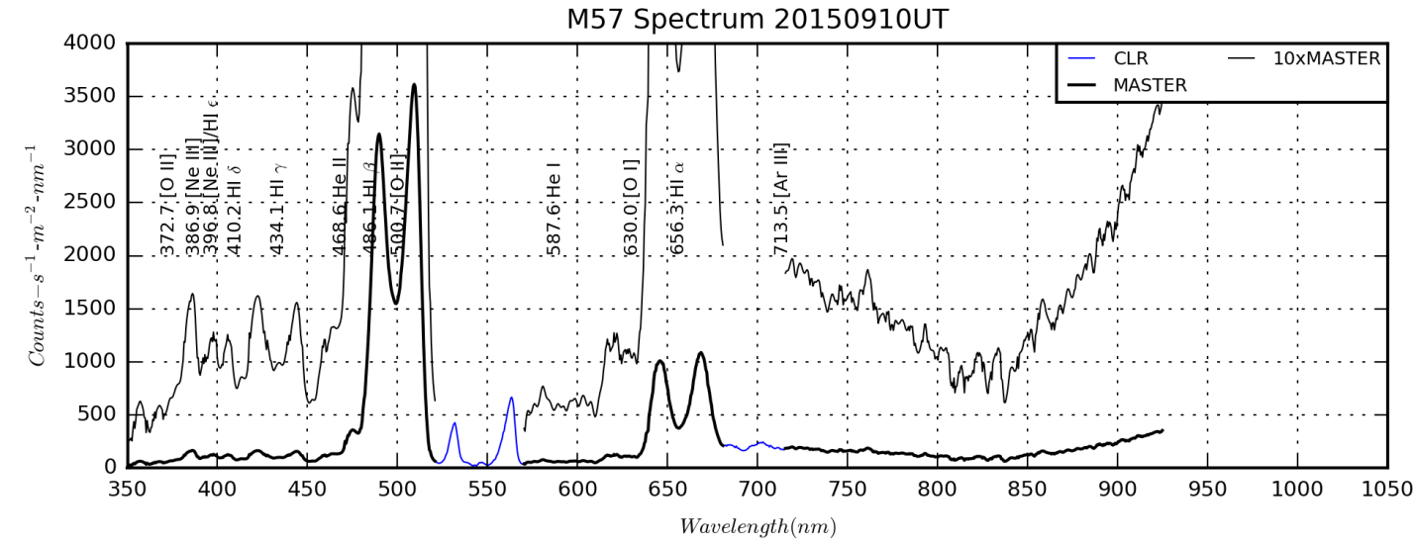

M57Spectrum20150910UT.png from M57Spectrum20150910UT.py

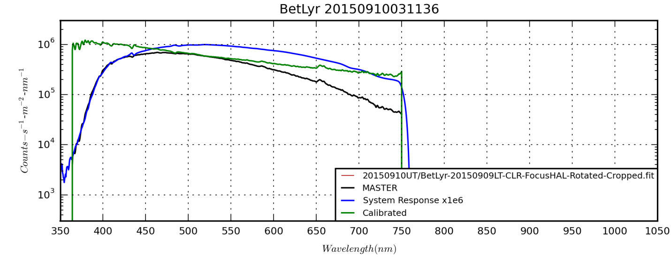

BetLyr\_20150910031136\_1D.png

**Data Disposition:** Raw data is zipped and stored on the 2TB archive drive under the “video” directory.

### 2015-Sep-12 (Sep-13 UT): Vega, Gamma Lyrae and M57 Spectra

Last Updated 9/17/2015

|  |
| --- |
| D:\Astronomy\Projects\Stellar Spectra Project 2015\Vega\20150913UT\Vega-20150912-CLR-Rotated-Cropped-Log-HalfSize.jpg |
| Vega-20150912-CLR-Rotated-Cropped-Log-HalfSize.jpg |
| D:\Astronomy\Data\2015\09\12\Beta Lyra\BetLyr-20150913UT-CLR-sum25s-Rotated-Cropped-Log-HalfSize.jpg |
| BetLyr-20150913UT-CLR-sum25s-Rotated-Cropped-Log-HalfSize.jpg |

|  |
| --- |
| D:\Astronomy\Projects\M57 Project 2015\Spectral Data\20150913UT\M57-20150913UT-CLR-sum20m00s-Flattened-Rotated-Cropped-Log-HalfSize.jpg |
| M57-20150913UT-CLR-sum20m00s-Flattened-Rotated-Cropped-Log-HalfSize.jpg |
| D:\Astronomy\Projects\M57 Project 2015\Spectral Data\20150913UT\M57-20150913UT-CLR-sum30m00s-Flattened-Rotated-Cropped-Log-HalfSize.jpg |
| M57-20150913UT-CLR-sum30m00s-Flattened-Rotated-Cropped-Log-HalfSize.jpg |
| D:\Astronomy\Projects\M57 Project 2015\Spectral Data\20150913UT\M57-20150913UT-CLR-sum46m00s-Flattened-Rotated-Cropped-Log-HalfSize.jpg |
| M57-20150913UT-CLR-sum46m00s-Flattened-Rotated-Cropped-Log-HalfSize.jpg |

**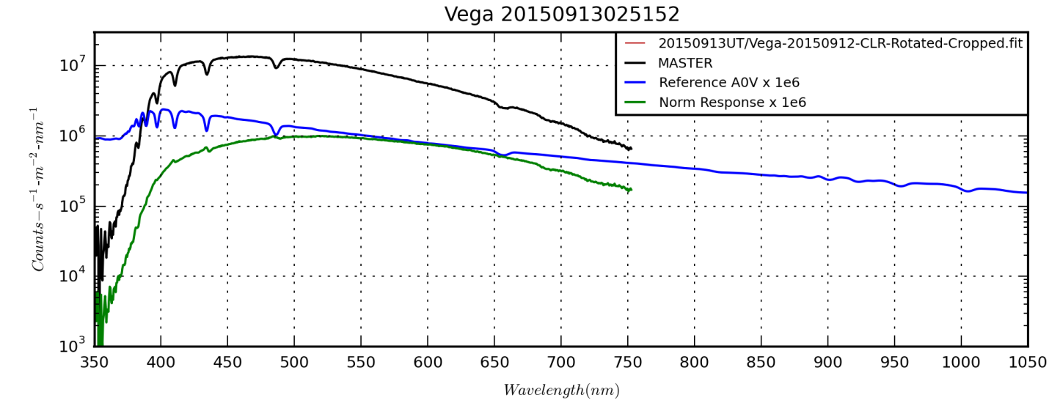**

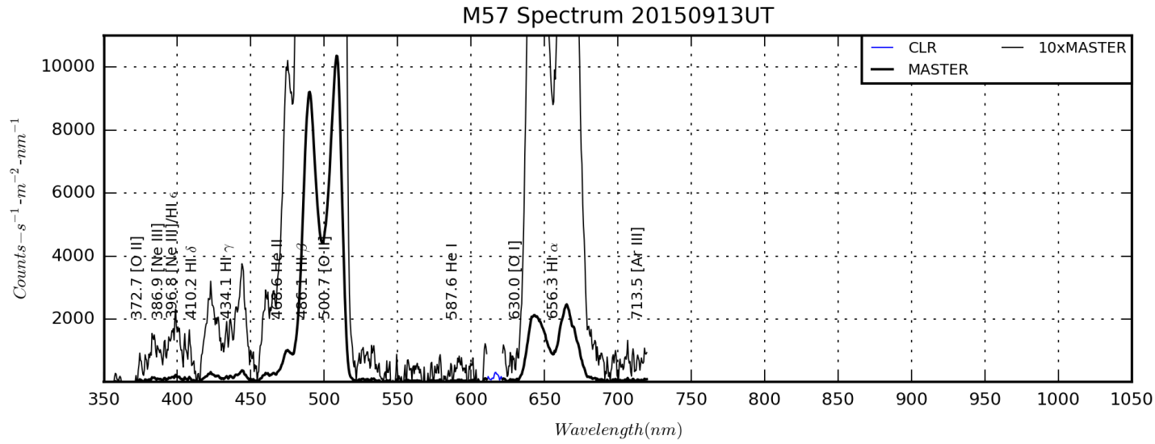

M57Spectrum20150913UT.png from M57Spectrum20150913UT.py

**Data Disposition:** I believe the raw data is zipped on the work computer.

### 2015-Sep-20 (Sep-21 UT): NGC 7009 Spectra

Last Updated 9/21/2015

I took spectra of Vega, Beta Lyrae and NGC 7009 using the 200/mm Star Analyzer grating, the C8 and the ST2000. Unfortunately I discovered that when the Vega and Beta Lyrae spectra were taken, there was icing on the detector at -10C. This essentially ruined the spectra for any quantitative purposes. The Vega spectra were supposed to be the first coverage I have both in the VIS and NIR ranges for calibration purposes. I’ve permanently deleted all the Vega and Beta Lyrae files.

I raised the temperature to 0C to clear the ice and then reset to -5C for the NGC 7009 spectra. Note that I accidentally set the file name to NGC 6543 for the images, but this is corrected for the stacked images.

|  |
| --- |
| G:\Astronomy\Projects\NGC7009 Project\Data\Spectra\20150921UT\NGC6543-20150921UT-CLR-sum04m00s-Rotated-Cropped-Flattened-Log-HalfSize.jpg |
| NGC6543-20150921UT-CLR-sum04m00s-Rotated-Cropped-Flattened-Log-HalfSize.jpg |
| G:\Astronomy\Projects\NGC7009 Project\Data\Spectra\20150921UT\NGC6543-RedFocus-20150921UT-CLR-sum04m00s-Rotated-Cropped-Flattened-Log-HalfSize.jpg |
| NGC6543-RedFocus-20150921UT-CLR-sum04m00s-Rotated-Cropped-Flattened-Log-HalfSize.jpg |
| G:\Astronomy\Projects\NGC7009 Project\Data\Spectra\20150921UT\NGC6543-RedFocus-20150921UT-742-sum01m40s-Rotated-Cropped-Flattened-Log-HalfSize.jpg |
| NGC6543-RedFocus-20150921UT-742-sum01m40s-Rotated-Cropped-Flattened-Log-HalfSize.jpg |
| G:\Astronomy\Projects\NGC7009 Project\Data\Spectra\20150921UT\NGC6543-RedFocus-20150921UT-CLRa-sum04m00s-Rotated-Cropped-Flattened-Log-HalfSize.jpg |
| NGC6543-RedFocus-20150921UT-CLRa-sum04m00s-Rotated-Cropped-Flattened-Log-HalfSize.jpg |

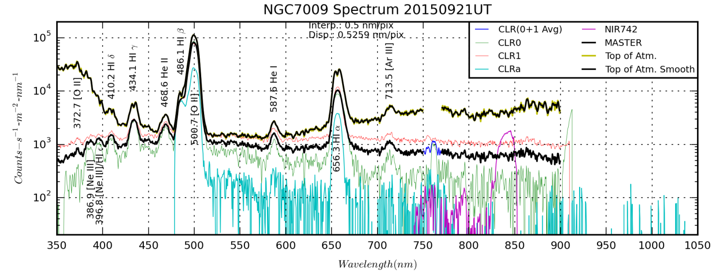

NGC7009-Spectrum20150921UT.png created by NGC7009-Spectrum20150921UT.py

**Data Disposition:** Raw data are zipped and stored on the 2TB archive drive under the “data” directory.

### 2015-Sep-24 (Sep-25 UT): Vega and Beta Lyrae Spectra and Veil Nebula Imaging

Last Updated 9/25/2015

|  |  |
| --- | --- |
| G:\Astronomy\Data\2015\09\24\Veil\Veil-20150921UT-RGB-Log-ColSmth-Crop-HalfSize.jpg | G:\Astronomy\Data\2015\09\24\Veil\Veil-20150921UT-RGB-Log-ColSmth-Stretch-Smooth-Crop-HalfSize.jpg |
| Veil-20150921UT-RGB-Log-ColSmth-Crop-HalfSize.jpg | Veil-20150921UT-RGB-Log-ColSmth-Stretch-Smooth-Crop-HalfSize.jpg |

|  |
| --- |
| G:\Astronomy\Projects\Stellar Spectra Project 2015\Vega\20150925UT\Vega-20150925UT-NIR-sum02m00s-Rotated-Crop-Log-HalfSize.jpg |
| Vega-20150925UT-NIR-sum02m00s-Rotated-Crop-Log-HalfSize.jpg |
| G:\Astronomy\Projects\Stellar Spectra Project 2015\Vega\20150925UT\Vega-20150925UT-CLR-sum00m06s-Rotated-Crop-Log-HalfSize.jpg |
| Vega-20150925UT-CLR-sum00m06s-Rotated-Crop-Log-HalfSize.jpg |

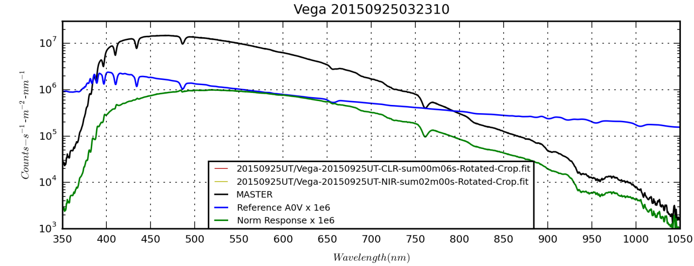

|  |
| --- |
| E:\Astronomy\Projects\Stellar Spectra Project 2015\BetLyr\20150925UT\BetLyr-20150921UT-742-sum04m00s-Rotated-Crop-Log-HalfSize.jpg |
| BetLyr-20150921UT-742-sum04m00s-Rotated-Crop-Log-HalfSize.jpg |
| E:\Astronomy\Projects\Stellar Spectra Project 2015\BetLyr\20150925UT\BetLyr-20150921UT-CLR-sum02m00s-Rotated-Crop-Flat-Log-HalfSize.jpg |
| BetLyr-20150921UT-CLR-sum02m00s-Rotated-Crop-Flat-Log-HalfSize.jpg |

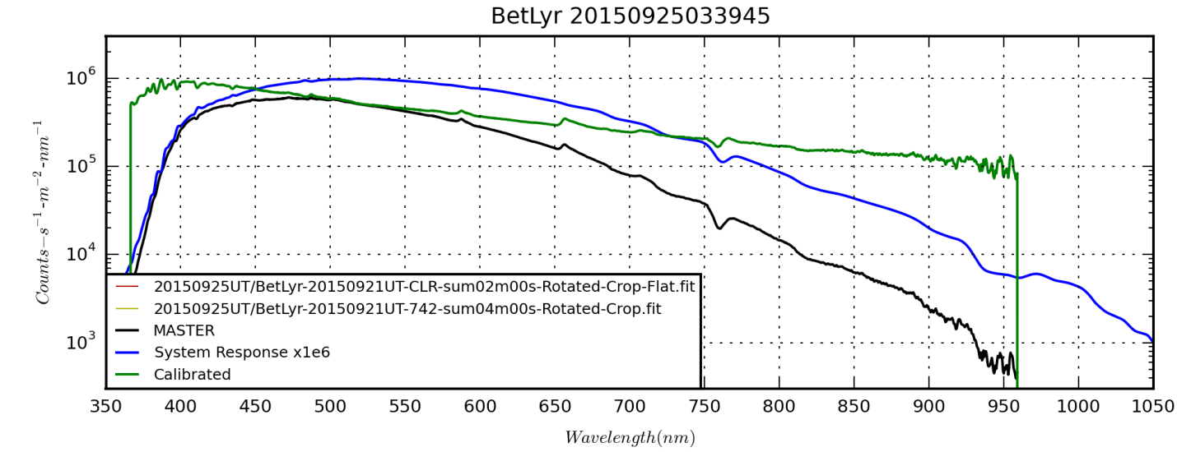

**Data Disposition:** All raw data zipped and on 2TB archive drive under the “data directory.” Processed data for spectra under the “Stellar Spectra 2015 Project” directory on the thumb drive.

## October

### 2015-Oct-13 (Oct-14 UT): Vega, Bet Lyr, Sig Aqr and (not-) Neptune Spectra

Last Updated 11/12/2015

Tonight was my first attempt this season to take a spectrum of Neptune. I used the 200 line/mm grating and the C8 at 1260mm with the ST-2000XM. However, with Neptune relatively low above the horizon, it was challenging to find. I mistook a nearby K?? star as Neptune because of its deep molecular absorption bands.

**Vega**

|  |
| --- |
| G:\Astronomy\Projects\Stellar Spectra Project 2015\Vega\20151014UT\Vega-20151014UT-NIR-sum01m40s-RotCrop-Log-HalfSize.jpg |
| Vega-20151014UT-NIR-sum01m40s-RotCrop-Log-HalfSize.jpg |
| G:\Astronomy\Projects\Stellar Spectra Project 2015\Vega\20151014UT\Vega-20151014UT-CLR-sum1500ms-RotCrop-Log-HalfSize.jpg |
| Vega-20151014UT-CLR-sum1500ms-RotCrop-Log-HalfSize.jpg |

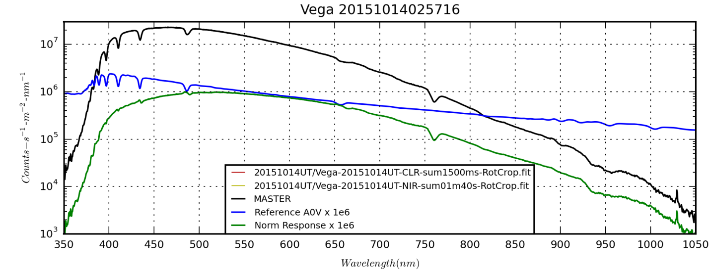

**Bet Lyr**

|  |
| --- |
| G:\Astronomy\Projects\Stellar Spectra Project 2015\BetLyr\20151014UT\BetLyr-20151014UT-742-sum03m20s-Rot-Cropped-Log-HalfSize.jpg |
| BetLyr-20151014UT-742-sum03m20s-Rot-Cropped-Log-HalfSize.jpg |
| G:\Astronomy\Projects\Stellar Spectra Project 2015\BetLyr\20151014UT\BetLyr-20151014UT-CLR-sum00m50s-Rot-Cropped-Flat-Log-HalfSize.jpg |
| BetLyr-20151014UT-CLR-sum00m50s-Rot-Cropped-Flat-Log-HalfSize.jpg |

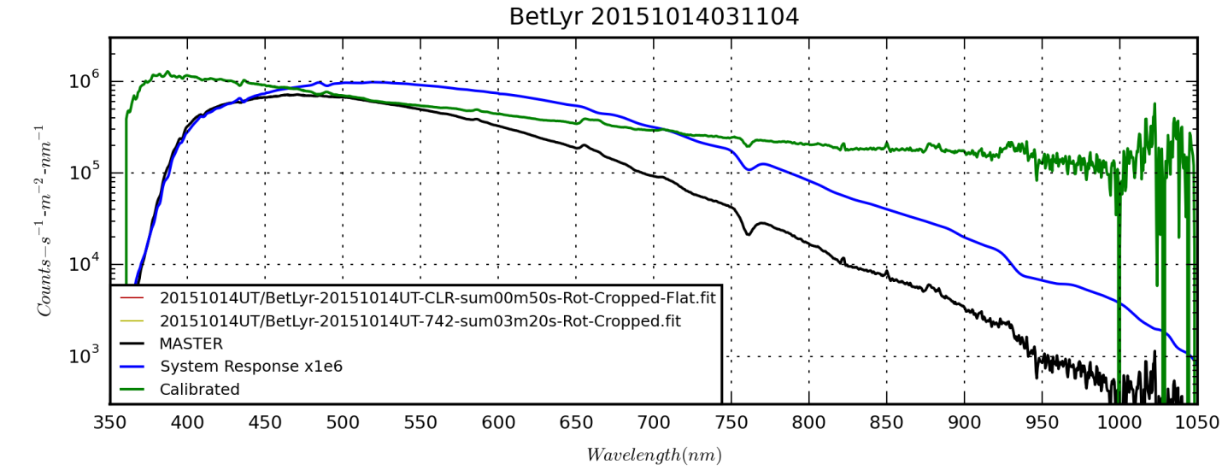

**Sig Aqr**

|  |
| --- |
| E:\Astronomy\Projects\Stellar Spectra Project 2015\SigAqr\20151014UT\SigAqr-20151014UT-742-sum03m20s-Rot-Crop-Log-HalfSize.jpg |
| SigAqr-20151014UT-742-sum03m20s-Rot-Crop-Log-HalfSize.jpg |
| E:\Astronomy\Projects\Stellar Spectra Project 2015\SigAqr\20151014UT\SigAqr-20151014UT-CLR-sum01m40s-Rot-Aligned-Crop-Flat-Log-HalfSize.jpg |
| 20151014UT-CLR-sum01m40s-Rot-Aligned-Crop-Flat-Log-HalfSize.jpg |

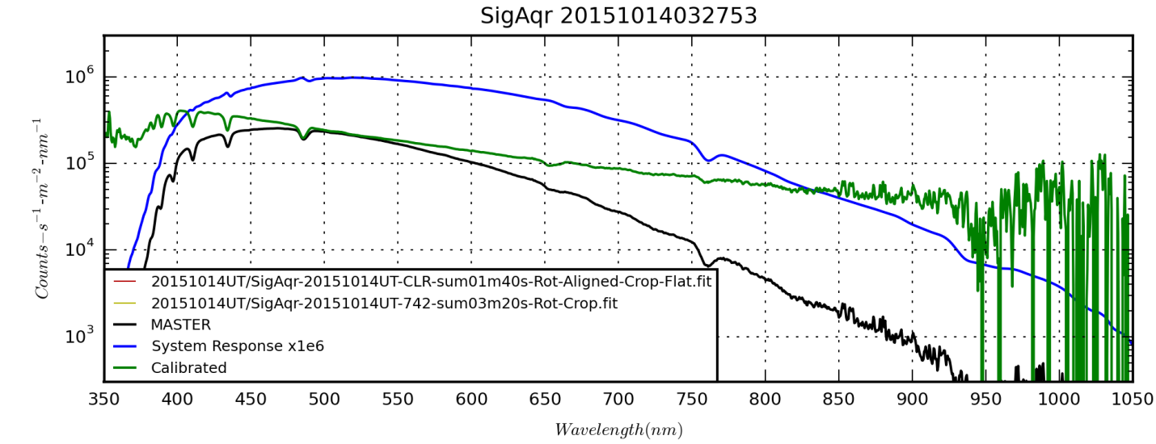

**NotNeptune** (below). Most likely guess is HD213563 as an M1/2 III star. Nearby is probably 58 Aqr, an A9/F0 IV star showing Balmer lines along with possibly some cooler lines.

|  |
| --- |
| E:\Astronomy\Projects\Stellar Spectra Project 2015\NotNeptune\20151014UT\NotNeptune-20151014UT-742-sum20m00s-RotCrop-Log-HalfSize.jpg |
| NotNeptune-20151014UT-742-sum20m00s-RotCrop-Log-HalfSize.jpg |
| E:\Astronomy\Projects\Stellar Spectra Project 2015\NotNeptune\20151014UT\NotNeptune-20151014UT-CLR-sum10m00s-RotCropFlat-Log-HalfSize.jpg |
| NotNeptune-20151014UT-CLR-sum10m00s-RotCropFlat-Log-HalfSize.jpg |

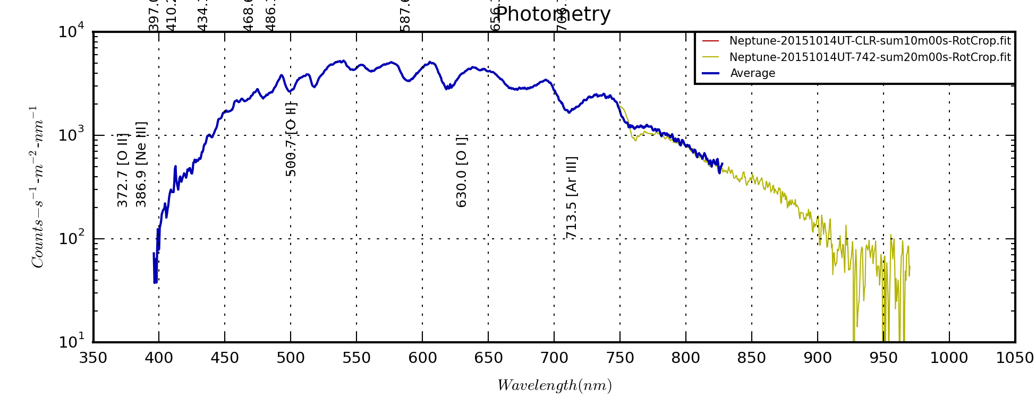Poor wavelength calibration above because I was trying to use methane bands.

**Data Disposition:** All raw data is zipped and on the 2TB archive drive. Processed data are under the Stellar Spectra Project 2015 folder on the astronomy thumb drive.

### 2015-Oct-14 (Oct-15 UT): Vega, Bet Lyr, Sig Aqr and Neptune Spectra

Last Updated 10/16/2015

**Vega**

|  |
| --- |
| G:\Astronomy\Projects\Stellar Spectra Project 2015\Vega\20151015UT\Vega-20151015UT-NIR-sum01m40s-Rot-Crop-Log-HalfSize.jpg |
| Vega-20151015UT-NIR-sum01m40s-Rot-Crop-Log-HalfSize.jpg |
| G:\Astronomy\Projects\Stellar Spectra Project 2015\Vega\20151015UT\Vega-20151015UT-CLR-sum1500ms-Rot-Crop-Log-HalfSize.jpg |
| Vega-20151015UT-CLR-sum1500ms-Rot-Crop-Log-HalfSize.jpg |

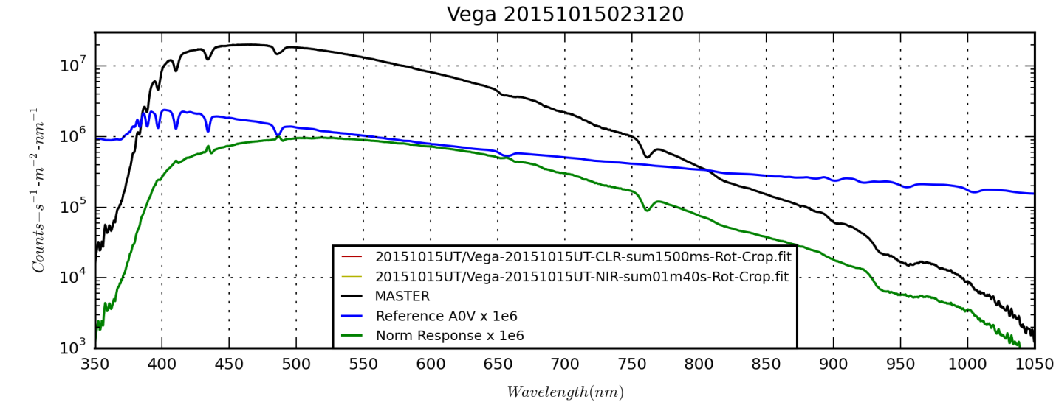

**Beta Lyrae**

|  |
| --- |
| G:\Astronomy\Projects\Stellar Spectra Project 2015\BetLyr\20151015UT\BetLyr-20151015UT-742-sum03m20s-Rot-Crop-Log-HalfSize.jpg |
| BetLyr-20151015UT-742-sum03m20s-Rot-Crop-Log-HalfSize.jpg |
| G:\Astronomy\Projects\Stellar Spectra Project 2015\BetLyr\20151015UT\BetLyr-20151015UT-CLR-sum00m50s-Rot-Crop-Flat-Log-HalfSize.jpg |
| BetLyr-20151015UT-CLR-sum00m50s-Rot-Crop-Flat-Log-HalfSize.jpg |

**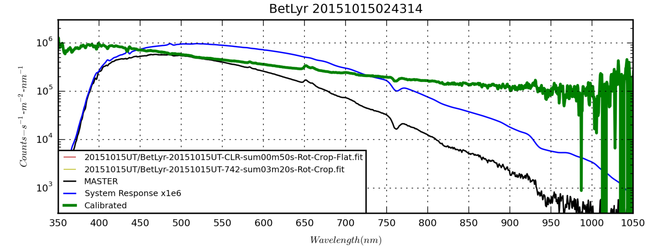**

**Neptune**

The below spectra of Neptune were taken with a mean CM of 180.1 deg according to WinJUPOS. They are calibrated against Vega as of 10/27/2015, but I may change that to Sig Aqr since it matches the air mass better. Unfortunately there’s a contaminating signal from a star right in the 725nm CH4 band, so I lose that one.

|  |
| --- |
| G:\Astronomy\Projects\Stellar Spectra Project 2015\Neptune\20151015UT\Neptune-20151015UT-742-sum19m40s-Rot-Cropped-Log-HalfSize.jpg |
| Neptune-20151015UT-742-sum19m40s-Rot-Cropped-Log-HalfSize.jpg |
| G:\Astronomy\Projects\Stellar Spectra Project 2015\Neptune\20151015UT\Neptune-20151015UT-CLR-sum10m00s-Rot-Cropped-Flat-Log-HalfSize.jpg |
| Neptune-20151015UT-CLR-sum10m00s-Rot-Cropped-Flat-Log-HalfSize.jpg |

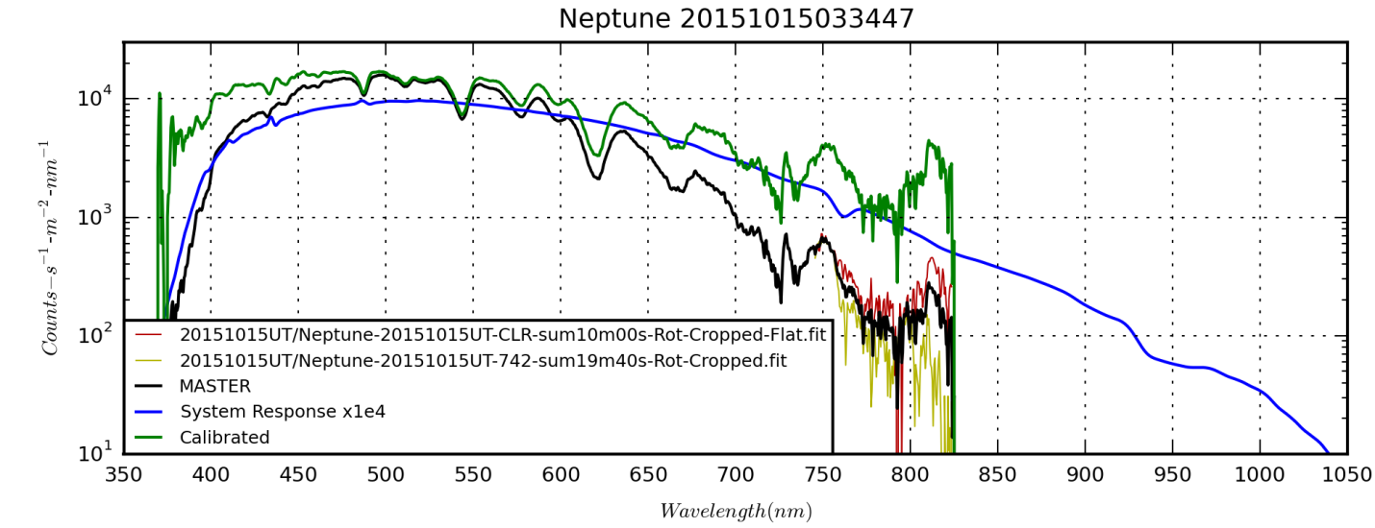

**Sig Aqr**

|  |
| --- |
| E:\Astronomy\Projects\Stellar Spectra Project 2015\SigAqr\20151015UT\SigAqr-20151015UT-742-sum03m20s-RotCrop-Log-HalfSize.jpg |
| SigAqr-20151015UT-742-sum03m20s-RotCrop-Log-HalfSize.jpg |
| E:\Astronomy\Projects\Stellar Spectra Project 2015\SigAqr\20151015UT\SigAqr-20151015UT-CLR-sum01m40s-RotCropFlat-Log-HalfSize.jpg |
| SigAqr-20151015UT-CLR-sum01m40s-RotCropFlat-Log-HalfSize.jpg |

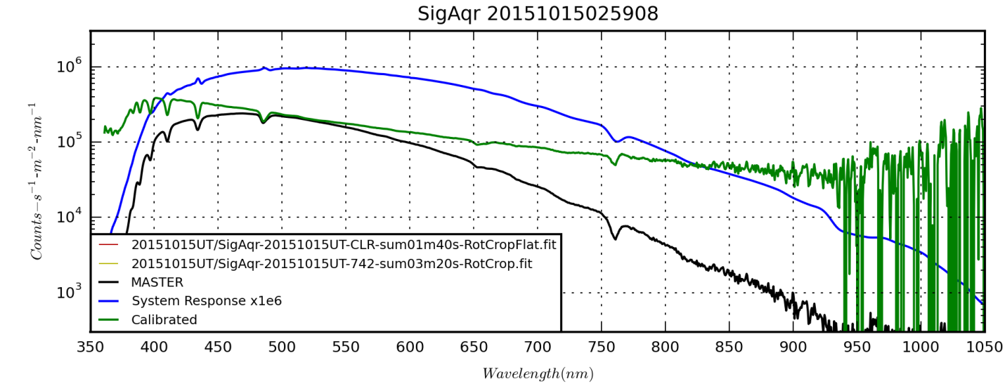

## November

### Planning: Fall

Last Updated 11/6/2015

* Planets
  + Neptune
    - High resolution NIR imaging
    - Spectra showing rotational modulation spectra
  + Uranus
    - High resolution NIR imaging
    - Spectra showing rotational modulation spectra
* Stars
  + Any bright Be Stars to play with for spectra to try with 135 mm lens and 200 line/mm grating?
* Emission Nebulae
  + Crab Nebula M1
    - 1260 mm multi band imaging, including both emission lines and NUV/NIR
    - 135 mm lens spectra?
* Star Clusters
  + M45
    - 1260 mm imaging of regions in NUV and NIR?
    - 1260 mm imaging in emission lines?
  + Auriga clusters?
* Galaxies
  + 1260 mm images of M31 in NIR, NUV or emission lines?
  + 1260 mm images of M33 in NIR, NUV or emission lines?

### 2015-Nov-07 (Nov-08 UT): Sig Aqr and Neptune Spectra

Last Updated 11/16/2015

|  |
| --- |
| G:\Astronomy\Projects\Neptune Project 2015\Spectral Data\20151108UT\Neptune-20151108T034314UT-sum01h39m00s-CLR-RotCropFlat-Log-HalfSize.jpg |
| Neptune-20151108T034314UT-sum01h39m00s-CLR-RotCropFlat-Log-HalfSize.jpg |
| G:\Astronomy\Projects\Stellar Spectra Project 2015\SigAqr\20151108UT\SigAqr-20151108UT-CLR-sum05m40s-RotCropFlat-Log-HalfSize.jpg |
| SigAqr-20151108UT-CLR-sum05m40s-RotCropFlat-Log-HalfSize.jpg |

Note that the calibration of the FITS files *includes* median and hot pixel filtering.

Note the significant *slant* in the Sig Aqr spectrum. Right now my code does not correct for slant.

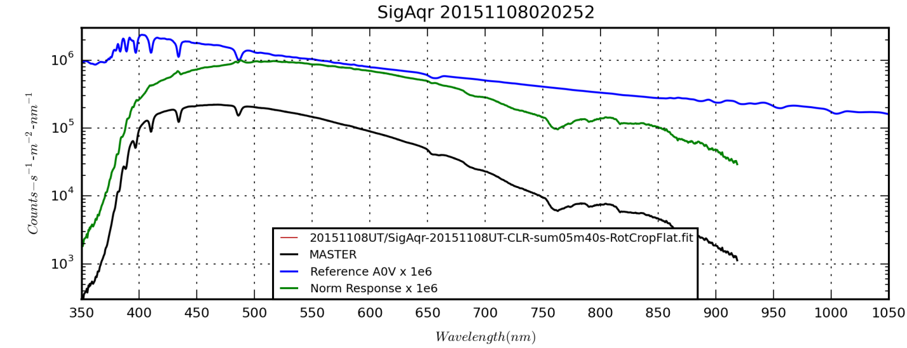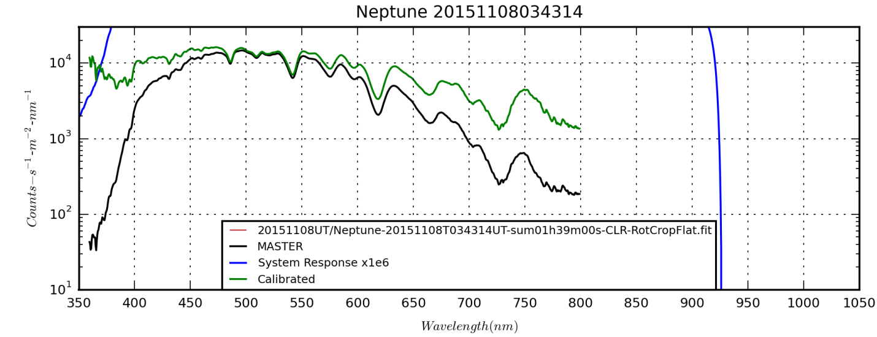

Volume in drive G is ASTROTHUMB

Volume Serial Number is 789B-F8E5

Directory of G:\Astronomy\Projects\Neptune Project 2015\Spectral Data\20151108UT

11/16/2015 09:56 AM 823,680 Neptune-20151108T024047UT-sum09m20s-CLR-RotCropFlat.fit

11/16/2015 09:56 AM 823,680 Neptune-20151108T025422UT-sum10m00s-CLR-RotCropFlat.fit

11/16/2015 09:56 AM 823,680 Neptune-20151108T030817UT-sum10m00s-CLR-RotCropFlat.fit

11/16/2015 09:57 AM 823,680 Neptune-20151108T032212UT-sum10m00s-CLR-RotCropFlat.fit

11/16/2015 09:57 AM 823,680 Neptune-20151108T033607UT-sum10m00s-CLR-RotCropFlat.fit

11/16/2015 01:24 PM 826,560 Neptune-20151108T034314UT-sum01h39m00s-CLR-RotCropFlat.fit

11/16/2015 09:57 AM 823,680 Neptune-20151108T035002UT-sum10m00s-CLR-RotCropFlat.fit

11/16/2015 09:57 AM 823,680 Neptune-20151108T040357UT-sum10m00s-CLR-RotCropFlat.fit

11/16/2015 09:57 AM 823,680 Neptune-20151108T041753UT-sum09m40s-CLR-RotCropFlat.fit

11/16/2015 09:58 AM 823,680 Neptune-20151108T043147UT-sum09m40s-CLR-RotCropFlat.fit

11/16/2015 09:56 AM 823,680 Neptune-20151108T044542UT-sum10m00s-CLR-RotCropFlat.fit

11 File(s) 9,063,360 bytes

0 Dir(s) 1,472,430,080 bytes free

|  |  |
| --- | --- |
| F:\Astronomy\Projects\Planets\Neptune\Spectral Data\1D Spectra\Neptune_20151108024047_1D.png | F:\Astronomy\Projects\Planets\Neptune\Spectral Data\1D Spectra\Neptune_20151108035002_1D.png |
| F:\Astronomy\Projects\Planets\Neptune\Spectral Data\1D Spectra\Neptune_20151108025422_1D.png | F:\Astronomy\Projects\Planets\Neptune\Spectral Data\1D Spectra\Neptune_20151108040357_1D.png |
| F:\Astronomy\Projects\Planets\Neptune\Spectral Data\1D Spectra\Neptune_20151108030817_1D.png | F:\Astronomy\Projects\Planets\Neptune\Spectral Data\1D Spectra\Neptune_20151108041753_1D.png |
| F:\Astronomy\Projects\Planets\Neptune\Spectral Data\1D Spectra\Neptune_20151108032212_1D.png | F:\Astronomy\Projects\Planets\Neptune\Spectral Data\1D Spectra\Neptune_20151108043147_1D.png |
| F:\Astronomy\Projects\Planets\Neptune\Spectral Data\1D Spectra\Neptune_20151108033607_1D.png | F:\Astronomy\Projects\Planets\Neptune\Spectral Data\1D Spectra\Neptune_20151108044542_1D.png |

testhdr.append(('APERTURE',0.0351))

testhdr.append(('DATAROW1',97))

testhdr.append(('DATAROW2',111))

testhdr.append(('BKG1ROW1',46))

testhdr.append(('BKG1ROW2',87))

testhdr.append(('BKG2ROW1',114))

testhdr.append(('BKG2ROW2',155))

testhdr.append(('PIXEL1',126.0))

testhdr.append(('WAVE1',393.4))

testhdr.append(('PIXEL2',561.0))

testhdr.append(('WAVE2',619.0))

testhdr.append(('XPIX1',60))

testhdr.append(('XPIX2',910))

**Data Disposition:** All raw data are – not sure where they are. Not on the archive drive. The processed data are under the Projects/Planets/Neptune directory on the Astronomy2 thumb drive.

### 2015-Nov-08 (Nov-09 UT): Sig Aqr and Neptune Spectra

Last Updated 12/28/2015

|  |
| --- |
| D:\Astronomy\Projects\Planets\Neptune\Spectral Data\20151109UT\NoHeaderUpdates\Neptune-20151109T033424UT-CLR-sum01h55m00s-RotCropFlat-Log-HalfSize.jpg |
| Neptune-20151109T033424UT-CLR-sum01h55m00s-RotCropFlat-Log-HalfSize.jpg |
| D:\Astronomy\Projects\Stars\SigAqr\Spectral Data\20151109UT\SiqAqr-20151109UT-CLR-sum10m00s-RotCrop-Log-HalfSize.jpg |
| SiqAqr-20151109UT-CLR-sum10m00s-RotCrop-Log-HalfSize.jpg |

testhdr.append(('APERTURE',0.0351))

testhdr.append(('DATAROW1',71))

testhdr.append(('DATAROW2',85))

testhdr.append(('BKG1ROW1',0))

testhdr.append(('BKG1ROW2',54))

testhdr.append(('BKG2ROW1',134))

testhdr.append(('BKG2ROW2',158))

testhdr.append(('PIXEL1',147.0))

testhdr.append(('WAVE1',393.4))

testhdr.append(('PIXEL2',581.0))

testhdr.append(('WAVE2',619.0))

testhdr.append(('XPIX1',78))

testhdr.append(('XPIX2',850))

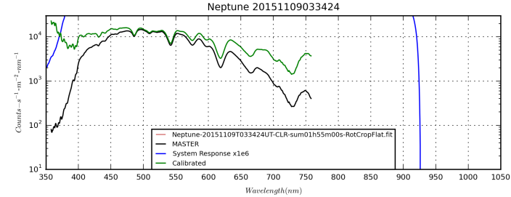

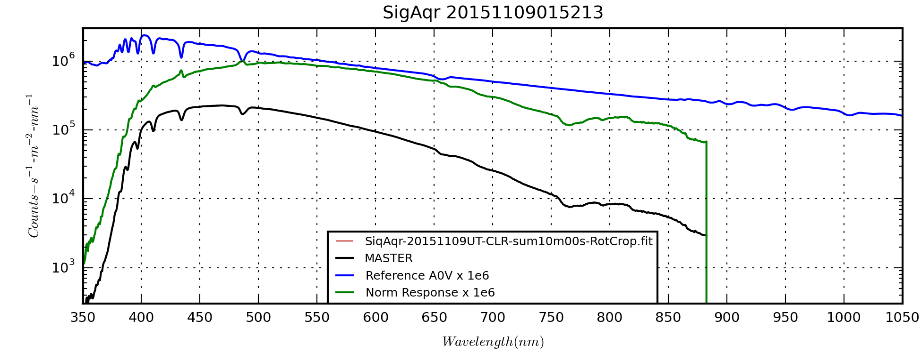

Volume in drive D is ASTROTHUMB2

Volume Serial Number is 88CF-7FE5

Directory of D:\Astronomy\Projects\Planets\Neptune\Spectral Data\20151109UT

11/22/2015 08:10 PM <DIR> .

11/22/2015 08:10 PM <DIR> ..

12/24/2015 10:38 AM 731,520 Neptune-20151109T021801UT-CLR-sum09m40s-RotCrop.fit

12/24/2015 10:39 AM 734,400 Neptune-20151109T023207UT-CLR-sum09m00s-RotCrop.fit

12/24/2015 10:38 AM 734,400 Neptune-20151109T024558UT-CLR-sum10m00s-RotCrop.fit

12/24/2015 10:39 AM 734,400 Neptune-20151109T025953UT-CLR-sum10m00s-RotCrop.fit

12/24/2015 10:39 AM 734,400 Neptune-20151109T031405UT-CLR-sum09m20s-RotCrop.fit

12/24/2015 10:39 AM 734,400 Neptune-20151109T032740UT-CLR-sum10m00s-RotCrop.fit

12/24/2015 10:38 AM 734,400 Neptune-20151109T034124UT-CLR-sum10m00s-RotCrop.fit

12/24/2015 10:38 AM 734,400 Neptune-20151109T035519UT-CLR-sum10m00s-RotCrop.fit

12/24/2015 10:38 AM 734,400 Neptune-20151109T040847UT-CLR-sum09m20s-RotCrop.fit

12/24/2015 10:38 AM 734,400 Neptune-20151109T042310UT-CLR-sum09m20s-RotCrop.fit

12/24/2015 10:38 AM 734,400 Neptune-20151109T043705UT-CLR-sum10m00s-RotCrop.fit

12/24/2015 10:38 AM 734,400 Neptune-20151109T044923UT-CLR-sum07m40s-RotCrop.fit

12/24/2015 08:24 AM <DIR> NoHeaderUpdates

12/28/2015 08:08 PM 0 Temp.txt

13 File(s) 8,809,920 bytes

3 Dir(s) 1,262,256,128 bytes free

|  |  |
| --- | --- |
| D:\Astronomy\Projects\Planets\Neptune\Spectral Data\1D Spectra\Neptune_20151109021801_1D.png | D:\Astronomy\Projects\Planets\Neptune\Spectral Data\1D Spectra\Neptune_20151109034124_1D.png |
| D:\Astronomy\Projects\Planets\Neptune\Spectral Data\1D Spectra\Neptune_20151109023207_1D.png | D:\Astronomy\Projects\Planets\Neptune\Spectral Data\1D Spectra\Neptune_20151109035519_1D.png |
| D:\Astronomy\Projects\Planets\Neptune\Spectral Data\1D Spectra\Neptune_20151109024558_1D.png | D:\Astronomy\Projects\Planets\Neptune\Spectral Data\1D Spectra\Neptune_20151109040847_1D.png |
| D:\Astronomy\Projects\Planets\Neptune\Spectral Data\1D Spectra\Neptune_20151109025953_1D.png | D:\Astronomy\Projects\Planets\Neptune\Spectral Data\1D Spectra\Neptune_20151109042310_1D.png |
| D:\Astronomy\Projects\Planets\Neptune\Spectral Data\1D Spectra\Neptune_20151109031405_1D.png | D:\Astronomy\Projects\Planets\Neptune\Spectral Data\1D Spectra\Neptune_20151109043705_1D.png |
| D:\Astronomy\Projects\Planets\Neptune\Spectral Data\1D Spectra\Neptune_20151109032740_1D.png | D:\Astronomy\Projects\Planets\Neptune\Spectral Data\1D Spectra\Neptune_20151109044923_1D.png |

**Data Disposition:** All raw data are zipped and on the 2TB archive drive. The processed data are under the Projects/Planets/Neptune directory on the Astronomy2 thumb drive.

### 2015-Nov-09 (Nov-10 UT): Sig Aqr and Neptune Spectra

Last Updated 11/16/2015

|  |
| --- |
| D:\Astronomy\Projects\Planets\Neptune\Spectral Data\20151110UT\Neptune-20151110T04XXXUT-CLR-sum34m00s-RotCropFlat-LogHalfSize.jpg |
| Neptune-20151110T04XXXUT-CLR-sum34m00s-RotCropFlat-LogHalfSize.jpg |
| D:\Astronomy\Projects\Stars\SigAqr\Spectral Data\20151110UT\SigAqrA-20151110UT-CLR-sum10m00s-RotCropFlat-LogHalfSize.jpg |
| SiqAqr-20151109UT-CLR-sum10m00s-RotCrop-Log-HalfSize.jpg |

testhdr.append(('APERTURE',0.0351))

testhdr.append(('DATAROW1',65))

testhdr.append(('DATAROW2',81))

testhdr.append(('BKG1ROW1',46))

testhdr.append(('BKG1ROW2',62))

testhdr.append(('BKG2ROW1',84))

testhdr.append(('BKG2ROW2',109))

testhdr.append(('PIXEL1',114.0))

testhdr.append(('WAVE1',393.4))

testhdr.append(('PIXEL2',545.0))

testhdr.append(('WAVE2',619.0))

testhdr.append(('XPIX1',50))

testhdr.append(('XPIX2',900))

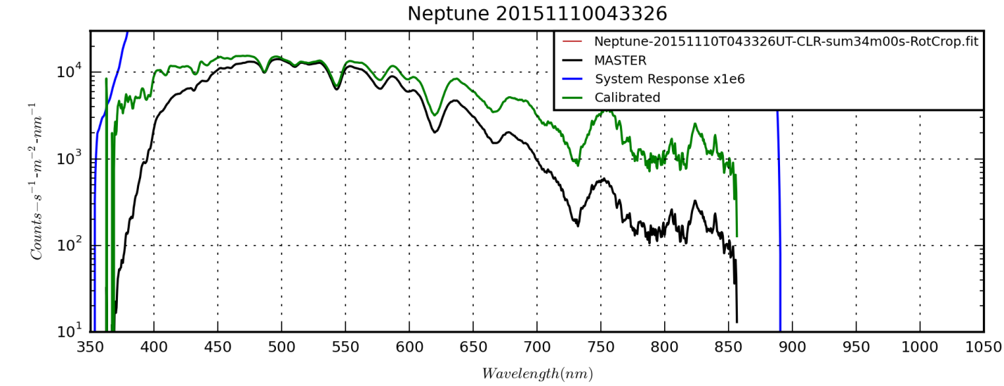

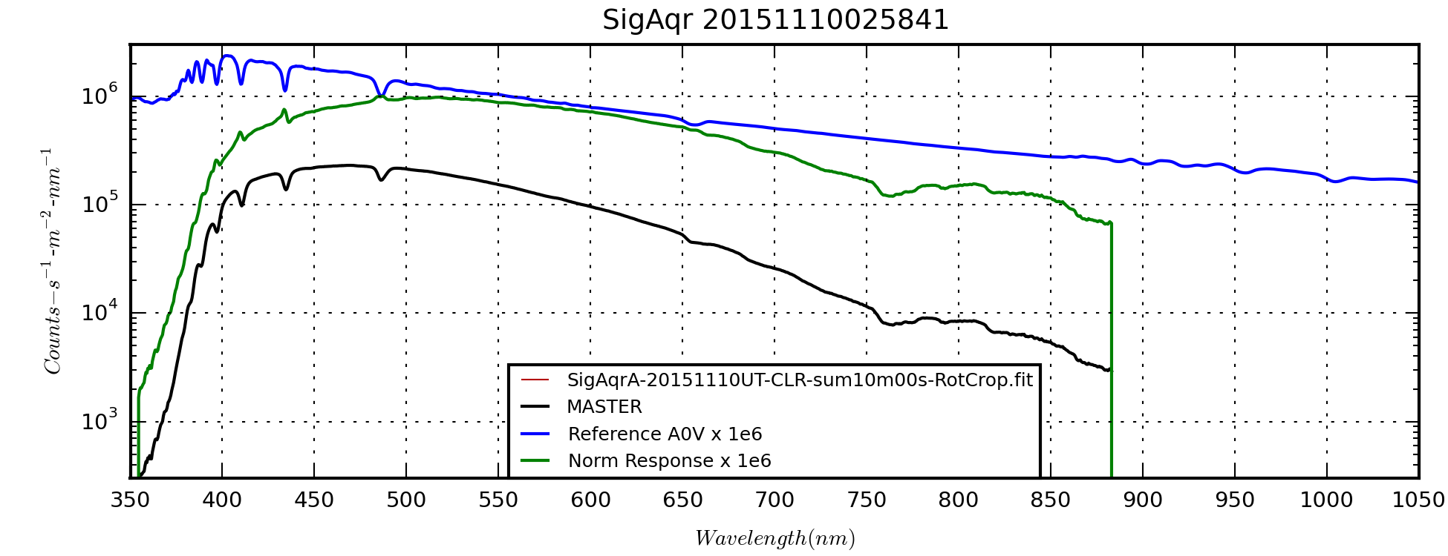

|  |  |
| --- | --- |
| D:\Astronomy\Projects\Planets\Neptune\Spectral Data\1D Spectra\Neptune_20151110041334_1D.png | D:\Astronomy\Projects\Planets\Neptune\Spectral Data\1D Spectra\Neptune_20151110044126_1D.png |
| D:\Astronomy\Projects\Planets\Neptune\Spectral Data\1D Spectra\Neptune_20151110042730_1D.png | D:\Astronomy\Projects\Planets\Neptune\Spectral Data\1D Spectra\Neptune_20151110045112_1D.png |

Volume in drive D is ASTROTHUMB2

Volume Serial Number is 88CF-7FE5

Directory of D:\Astronomy\Projects\Planets\Neptune\Spectral Data\20151110UT

11/22/2015 08:10 PM <DIR> .

11/22/2015 08:10 PM <DIR> ..

01/15/2016 03:04 PM 642,240 Neptune-20151110T041334UT-CLR-sum10m00s-RotCrop.fit

01/15/2016 02:50 PM 645,120 Neptune-20151110T042730UT-CLR-sum10m00s-RotCrop.fit

01/17/2016 05:37 PM 642,240 Neptune-20151110T043326UT-CLR-sum34m00s-RotCrop.fit

01/17/2016 10:57 AM 645,120 Neptune-20151110T043326UT-CLR-sum34m00s-RotCropFlat.fit

01/17/2016 11:01 AM 9,138 Neptune-20151110T043326UT-CLR-sum34m00s-RotCropFlat-LogHalfSize.jpg

01/15/2016 02:50 PM 645,120 Neptune-20151110T044126UT-CLR-sum10m00s-RotCrop.fit

01/15/2016 02:50 PM 645,120 Neptune-20151110T045112UT-CLR-sum04m00s-RotCrop.fit

01/15/2016 02:44 PM <DIR> NoHeaderUpdates

01/17/2016 08:41 PM 0 temp.txt

8 File(s) 3,874,098 bytes

3 Dir(s) 4,338,057,216 bytes free

**Data Disposition:** All raw data are zipped and on the 2TB archive drive. The processed data are under the Projects/Planets/Neptune directory on the Astronomy2 thumbdrive.

### 2015-Nov-14 (Nov-15 UT): Sig Aqr, Neptune(?) and Uranus Imaging

Last Updated 11/16/2015

I reconfigured the observing rig tonight for high resolution imaging with the hope of resolving Neptune and perhaps its major storm. The ST2000 is now mounted on top of the C8 for wide field imaging (and objective grating spectroscopy). I swapped filters so that now the ST2000 filter wheel has three narrow band filters (HI, SII, and OIII) along with an open position (*not* clear) and the NUV filter. Note that the OIII filter is the new replacement filter for the old one that created halo artifacts. The new one arrived today. **(I think I may have put the CH4 filter in rather than leaving an open position???)**

The ASI120MM camera was mounted to the C8 with the 2x barlow lens and SX filter wheel giving a plate scale of ~0.16” per pixel. The filter wheel was configured with the following filters in ascending position order from 1 to 7: >807, >742, >685, Red, Green, Blue and Clear.

When I connected the systems to the laptop I had some trouble with keeping all devices running simultaneously, as I have had in the past. Now, despite initially starting, the ASI120MM stopped and could not be found by the laptop. After trouble shooting, I replaced the short grey USB cable with the long one and was trouble free. I routed the ST2000 and SX filter wheel USB cables through the USB hub at the telescope.

All this took significant time and I got a late start looking for Neptune. When I went out to star hop to Neptune, I found a new problem. The neighbor to the south had installed new backyard lighting fixtures which caused a significant increase in the light trespass into my yard. I though of trying to build an quick light shield, but it was already late so I lived with it. However, it made positive identification of Neptune all but impossible. I was able to star hop to Sig Aqr and see 58 Aqr and took video of Sig Aqr. (I did initial finder alignment and C8 focusing on Vega.) However, the star HD213780 (6.55mV), which was my final hop to Neptune for the past few sessions under moonless skies, was invisible. Thus, I simply referenced off where I thought it would be and got ‘lucky’ with a star on the ASI120MM detector. Now, it’s impossible to confirm whether it was Neptune or HD213780. Possibly I can do checking by looking at the signal level and PSF compared to Sig Aqr and Uranus.

I did a refocusing that clearly was an improvement prior to the Uranus >685 video that started at 0709UT. In general I used a gamma of 50, which should give linear response, along with pretty appropriate contrast. Gain was set to 100 for most videos. There were a few exceptions such as deep exposures of Neptune and the initial calibration video of Siq Aqr.

I took dark frame videos for most of the configurations, but not all. And, some of the dark frame videos had exposure durations that only approximated the exposure durations of the data videos they calibrated, e.g., 1.0 sec versus 1.027 sec. I also took a drift image in which I commanded the mount in the +X and +Y directions. I believe the “swap X” option was checked in MaximDL. Also, the signal is faint because Uranus was passing behind a telephone poll, unknown to me at the time. Unfortunately, I don’t appear to have a dark frame for the image to help the SNR. Since the drift was commanded, I don’t have a way to get plate scale independently, but the position angle should be identifiable within a few degrees.

In the stacked >685 image (consisting of the six videos, excluding the first one that was taken prior to refocusing), there is clear evidence of detail being recorded after sharpening is applied. However, to be validated the orientation of the Uranus needs to be confirmed and the detail compared to contemporaneous images of higher quality posted on ALPO-Japan.

With the data obtained, I should be able to do spatial response analysis and some 8-bit photometry. As for sky conditions, transparency was >4/5. Seeing was very good, say 4/5, judging by the Sig Aqr stacked image. However, the forecast had Denver being in the lowest 300mb wind bin on the GFS map, suggesting extremely good seeing. I don’t think that level of quality was reached.

I should note one more equipment problem. When I found Uranus and was just preparing to take video, I got a blue screen of death (BSOD) on the laptop and it rebooted. I’ve seen this before, but only while running the three USB devices. Therefore I’ve attributed it to some sort of contention between the devices.

The sequences of videos taken are listed in the subsections for each target, starting with the calibration videos.

**Calibration**

Volume in drive C is OS

Volume Serial Number is 62AB-AA8D

Directory of C:\Astronomy\Data\2015\11\15UT\Calibration

11/15/2015 12:28 AM 9,297,920 20151115T072755UT-Dark-Gain100-Gam50-Exp1027ms.avi

11/15/2015 12:31 AM 9,606,144 20151115T073044UT-Dark-Gain100-Gam50-Exp2000ms.avi

11/15/2015 12:33 AM 4,989,952 20151115T073227UT-Dark-Gain100-Gam50-Exp4200ms.avi

11/15/2015 12:35 AM 55,764,992 20151115T073447UT-Dark-Gain100-Gam50-Exp0316ms.avi

11/15/2015 12:37 AM 159,777,280 20151115T073624UT-Dark-Gain100-Gam50-Exp0114ms.avi

11/15/2015 12:39 AM 18,529,792 20151115T073857UT-DarkGain100-Gam100-Exp1000ms.avi

11/15/2015 12:42 AM 9,297,920 20151116T074122UT-Dark-Gain100-Gam100-Exp2000ms.avi

11/15/2015 01:02 AM 297,563,648 20151115T075903-Uranus-CLR-Gain100-Gam100-Exp2000ms-DRIFT.avi

8 File(s) 564,827,648 bytes

0 Dir(s) 21,066,932,224 bytes free

|  |
| --- |
| D:\Astronomy\Data\2015\11\15UT\Calibration\Drive-140-241stack-Smoothed-HalfSize.jpg |
| Drive-140-241stack-Smoothed-HalfSize.jpg |

Within measurement error, i.e., ±1 deg., it appears that the camera was aligned perfectly with the X-Y axis matching the N-S axes. The sign convention was confirmed by the detection of two moons of Uranus, Titania and Oberon. Thus, up is North and left is East on the image. The plate scale from the Uranus moons data indicates about 0.099 arcsec-pixel-1.

**Sig Aqr**

Volume in drive C is OS

Volume Serial Number is 62AB-AA8D

Directory of C:\Astronomy\Data\2015\11\15UT\SigAqr

11/14/2015 08:58 PM 88,999,936 20151115T035703-SigAqr-685.avi

11/14/2015 09:34 PM 92,384,768 20151115T042930UT-SigAqr-CLR-Gam100-Gain063-Exp1000ms.avi

2 File(s) 181,384,704 bytes

0 Dir(s) 21,066,936,320 bytes free

|  |  |
| --- | --- |
| D:\Astronomy\Data\2015\11\15UT\SigAqr\20151115T035703UT-SigAqr-685-DarkStack100-Wavelets2x3+3x4+4x3-Crop.jpg | 20151115T035703UT-SigAqr-685-DarkStack100-Wavelets2x3+3x4+4x3-Crop.jpg |
| D:\Astronomy\Data\2015\11\15UT\SigAqr\20151115T042930UT-SigAqr-CLR-Gam100-Gain063-Exp1000ms-DarkStack40-Wavelets2x3+3x4+4x3-Crop.jpg | 20151115T042930UT-SigAqr-CLR-Gam100-Gain063-Exp1000ms-DarkStack40-Wavelets2x3+3x4+4x3-Crop.jpg |

After noticing how blurry Neptune seemed compared to the initial Sig Aqr image in the >685nm band, I took another video of Sig Aqr at lower gain and longer exposure. This image should help characterize what portion of the Neptune point spread is due to the planet’s finite apparent diameter versus simply and effect of seeing and longer exposures.

**Neptune**

Volume in drive C is OS

Volume Serial Number is 62AB-AA8D

Directory of C:\Astronomy\Data\2015\11\15UT\Neptune

11/14/2015 09:11 PM 46,225,408 20151115T040649UT-Neptune-685-Gam100-Gain100-Exp2000ms.avi

11/14/2015 09:18 PM 92,384,768 20151115T041330UT-Neptune-CLR-Gam100-Gain100-Exp1000ms.avi

2 File(s) 138,610,176 bytes

0 Dir(s) 21,066,936,320 bytes free

Note that Neptune is 7.9mV and Sig Aqr is 4.82mV. Thus, the flux ratio is 1/16.8 ~ 0.0595. This fact may help confirm that the identities of my Neptune images are indeed Neptune. However, I need to retrieve the Sig Aqr exposure details.

|  |  |  |  |
| --- | --- | --- | --- |
| D:\Astronomy\Data\2015\11\15UT\Neptune\20151115T040649UT-Neptune-685-Gam100-Gain100-Exp2000ms-DarkStack150-Str0-128-Wavelets2x3+3x4+4x3-Cropped.jpg | 20151115T040649UT-Neptune-685-Gam100-Gain100-Exp2000ms-DarkStack150-Str0-128-Wavelets2x3+3x4+4x3-Cropped.jpg | D:\Astronomy\Data\2015\11\15UT\Neptune\20151115T041330UT-Neptune-CLR-Gam100-Gain100-Exp1000ms-DarkStack150-Wavelest2x3+3x4+4x3-Crop.jpg | 20151115T041330UT-Neptune-CLR-Gam100-Gain100-Exp1000ms-DarkStack150-Wavelest2x3+3x4+4x3-Crop.jpg |

Having determined the plate scale and plate position angle, I unsuccessfully searched for Neptune’s moon Triton, which is 13.5mV. Since I could detect Titania and Oberon at Uranus (13.9mV and 14.1mV), it seemed pretty reasonable to detect Triton. Two facts need to be considered, though. First, Uranus was imaged specifically to detect its moons by using long exposure, CLR filter images. Second, The Uranus images were taken at the end of the session when I had sharpened the focus of the telescope.

Interestingly, it looks like similar parameters were used for the CLR video used for Uranus’s moons and the CLR video for Neptune. However, the Uranus video was a full 1280x960 whereas the Neptune video was 640x480. BUT, the file size ratio is 2 not 4 as expected, even though the videos are of the same duration!

**Uranus**

Volume in drive C is OS

Volume Serial Number is 62AB-AA8D

Directory of C:\Astronomy\Data\2015\11\15UT\Uranus

11/14/2015 10:53 PM 805,698,048 20151115T054814UT-Uranus-CLR-Gain100-Gam50-Exp114ms.avi

11/14/2015 11:00 PM 91,153,920 20151115T055538UT-Uranus-685-Gain100-Gam50-Exp1015ms.avi

11/14/2015 11:08 PM 291,484,672 20151115T060347UT-Uranus-BLU-Gain100-Gam50-Exp316ms.avi

11/14/2015 11:14 PM 291,484,672 20151115T060931UT-Uranus-GRN-Gain100-Gam50-Exp316ms.avi

11/14/2015 11:21 PM 90,846,208 20151115T061644UT-Uranus-RED-Gain100-Gam50-Exp1015ms.avi

11/14/2015 11:29 PM 90,846,208 20151115T062444UT-Uranus-685-Gain100-Gam50-Exp1015ms.avi

11/14/2015 11:35 PM 90,846,208 20151115T063009UT-Uranus-685-Gain100-Gam50-Exp1015ms.avi

11/14/2015 11:41 PM 90,846,208 20151115T063617UT-Uranus-685-Gain100-Gam50-Exp1015ms.avi

11/14/2015 11:48 PM 46,840,832 20151115T064324UT-Uranus-742-Gain100-Gam50-Exp2000ms.avi

11/14/2015 11:54 PM 46,533,120 20151115T064903UT-Uranus-742-Gain100-Gam50-Exp2000ms.avi

11/15/2015 12:01 AM 24,376,832 20151115T065610UT-Uranus-807-Gain100-Gam50-Exp4200ms.avi

11/15/2015 12:07 AM 24,069,120 20151115T070217UT-Uranus-807-Gain100-Gam50-Exp4200ms.avi

11/15/2015 12:14 AM 45,609,984 20151115T070901UT-Uranus-685-Gain100-Gam50-Exp1027ms.avi

11/15/2015 12:19 AM 45,302,272 20151115T071422UT-Uranus-685-Gain100-Gam50-Exp1027ms.avi

11/15/2015 12:25 AM 45,609,984 20151115T072013UT-Uranus-685-Gain100-Gam50-Exp1027ms.avi

11/15/2015 12:52 AM 36,945,920 20151115T075135UT-Uranus-CLR-Gain100-Gam100-Exp2000ms.avi

11/15/2015 12:58 AM 184,465,408 20151115T075310UT-Uranus-CLR-Gain100-Gam100-Exp2000ms.avi

17 File(s) 2,342,959,616 bytes

0 Dir(s) 21,066,977,280 bytes free

The entire observation period for Uranus spans about two hours. This span is long enough to result in up to 1.2 arcsec of smearing at the sub-Earth point. Since I’ve achieved certainly as good as and perhaps better than 1.0 arcsecond resolution before, I need to be carefully aware of this smearing when stacking images.

|  |  |  |  |
| --- | --- | --- | --- |
|  | 15T065610UT-Uranus-807-Gain100-Gam50-Exp4200ms-Stack2-Wavelets3x3+4x3-AlignedCrop.bmp |  | 20151115T061644UT-Uranus-RED-Gain100-Gam50-Exp1015ms-DarkStack150-Wavelets2x3+3x4+4x3-AlignedCrop.bmp |
|  | 20151115T064324UT-Uranus-742-Gain100-Gam50-Exp2000ms-Stack2-Wavelets2x3+3x4+4x3-BRTminus10-AlignedCrop.bmp |  | 20151115T060931UT-Uranus-GRN-Gain100-Gam50-Exp316ms-DarkStack150-Wavelets2x3+3x4+4x3-BRTminus25-AlignedCrop.bmp |
|  | 20151115T062444UT-Uranus-685-Gain100-Gam50-Exp1015ms-Stack6-Wavelets1x5+2x10+3x10+4x5-AlignedCrop.bmp |  | 20151115T060347UT-Uranus-BLU-Gain100-Gam50-Exp316ms-DarkStack150-Wavelets2x3+3x4+4x3-BRTminus10-AlignedCrop.bmp |
| F:\Astronomy\Data\2015\11\15UT\Uranus\20151115T06XXXXUT-Uranus-807+742+685-Wavelets2x3+3x3.bmp | 20151115T06XXXXUT-Uranus-807+742+685-Wavelets2x3+3x3.bmp |  | 20151115T06XXXXUT-Uranus-RGB.bmp |
|  |  |  |  |

|  |  |  |  |
| --- | --- | --- | --- |
|  | 20151115T054814UT-Uranus-CLR-Gain100-Gam50-Exp114ms-DarkStack1000-Wavelets2x3+3x4+4x3-AlignedCrop.bmp |  |  |

|  |  |
| --- | --- |
| F:\Astronomy\Data\2015\11\15UT\Uranus\20151115T075135UT-Uranus-CLR-Gain100-Gam100-Exp2000ms-Stack155-Wavelets30x10Hist-Cropped.jpg | F:\Astronomy\Data\2015\11\15UT\Uranus\UranusWinJUPOS201511150753.2-AlignmentVerificationAnnotated.jpg |
| 20151115T075135UT-Uranus-CLR-Gain100-Gam100-Exp2000ms-Stack155-Wavelets30x10Hist-Cropped.jpg | UranusWinJUPOS201511150753.2-AlignmentVerificationAnnotated.jpg |

Long exposure clear stack is smoothed with a long pass filter then sharpened with a 10-pixel wavelets filter.

|  |  |
| --- | --- |
|  |  |
| 685 Stack 6 screen cap from WinJUPOS | 685+742+807 screen cap from WinJUPOS |

**Data Disposition:** All raw data are zipped and on the 2TB archive drive. The processed data are under the Projects/Planets/Neptune directory on the Astronomy2 thumbdrive.

## December

### 2015-Dec-03 (Dec-04 UT): NGC7822 and Ced 214 Narrow Band Imaging

Last Updated 12/04/2015

|  |  |  |  |  |  |  |  |  |  |
| --- | --- | --- | --- | --- | --- | --- | --- | --- | --- |
| **Date** | **NGC** | **Other ID** | **Type** | **Size1/Mag1** | **Size2/Mag2** | **Obs** | **Photo** | **Comments** | **Update** |
| 2015 Dec 03 | 7822 |  | GN | 20.0 | 4.0 | 0 | 1 | Imaging: Took 3hr16m SII-HI-OIII image (60:60:76) through 135mm lens (f/2.5). Image also includes nebula Ced 214 and open clusters NGC7762. Tccd=0C. Seeing 3/5. Transparency 4/5. **Note that flat-field images for SII and HI have file names and FITS header filter keywords swapped, e.g., SII is really HI and visa versa.** | 2015 Dec 04 |
| 2015 Dec 03 |  | Ced 214 | GN | 50.0 | 40.0 | 0 | 1 | Imaging: See entry for NGC7822 | 2015 Dec 04 |

|  |  |
| --- | --- |
| F:\Astronomy\Data\2015\12\04UT\NGC7822\NGC7822-20151204UT-Log-SHO-SOGam50pct-Cropped-Gam75pct-R.jpg | F:\Astronomy\Data\2015\12\04UT\NGC7822\NGC7822-20151204UT-Log-SHO-SOGam50pct-Cropped-Gam75pct-G.jpg |
| NGC7822-20151204UT-Log-SHO-SOGam50pct-Cropped-Gam75pct-R.jpg | NGC7822-20151204UT-Log-SHO-SOGam50pct-Cropped-Gam75pct-G.jpg |
| F:\Astronomy\Data\2015\12\04UT\NGC7822\NGC7822-20151204UT-Log-SHO-SOGam50pct-Cropped-Gam75pct-B.jpg | F:\Astronomy\Data\2015\12\04UT\NGC7822\NGC7822-20151204UT-Log-SHO-SOGam50pct-Cropped-Gam75pct.jpg |
| NGC7822-20151204UT-Log-SHO-SOGam50pct-Cropped-Gam75pct-B.jpg | NGC7822-20151204UT-Log-SHO-SOGam50pct-Cropped-Gam75pct.jpg |

### 2015-Dec-05 (Dec-06 UT): M31 and NGC1499 Narrow Band Imaging

Last Updated 12/07/2015

|  |  |
| --- | --- |
| F:\Astronomy\Projects\M31 Multispectral Project\Source Files\672-SII\20151206UT\M31-20151206UT-SII-sum01h30m-Flattened-LogLog-HalfSize.jpg | F:\Astronomy\Projects\M31 Multispectral Project\Source Files\501-OIII\20151206UT\M31-20151206UT-OIII-sum01h14m-Flattened-LogLog-HalfSize.jpg |
| M31 672-SII  M31-20151206UT-SII-sum01h30m-Flattened-LogLog-HalfSize.jpg | M31 501-OIII  M31-20151206UT-OIII-sum01h14m-Flattened-LogLog-HalfSize.jpg |

|  |
| --- |
| D:\Astronomy\Projects\NGC1499 Project\Source Files\OIII\NGC1499-20151206UT-OIII-sum03h38m-Flattened-LogLog-HalfSize.jpg |
| NGC1499-20151206UT-OIII-sum03h38m-Flattened-LogLog-HalfSize.jpg |

## Planet Analysis

### Venus Analysis 2015 Apparition

Last Updated 11/30/2015

The 2015 apparition was very favorable, but unfortunately the spring was *very* wet and rainy this spring. So, there are observations from March and from June, but none in between. A major goal was to obtain NUV images of Venus cloud structures with higher resolution and contrast using my ASI120MM camera, which I’d not previously used for Venus imaging. Given the limited days available for imaging, the seeing could not be counted on to be favorable. Thus, despite the new camera, the NUV images are somewhat disappointing.

However, looking at ALPO-Japan images from March and June (some March images are posted in the chapters for those observations), it is clear that there was much more prominent cloud structure on Venus in March than in June. In June the disk is almost uniform, but in March there are some rather dramatic features.

In addition, I was able to capture one UV-Vis-IR spectrum of Venus using the 100 line/mm grating and the 135mm lens. It was a challenge due to the bright sky, but Venus was bright enough and the focus sharp enough to show a bunch of spectral details.

Circle fitting for possible band-dependent radius determination:

<http://scipy.github.io/old-wiki/pages/Cookbook/Least_Squares_Circle>

<http://scipy-cookbook.readthedocs.org/items/Least_Squares_Circle.html>

And here are some edge detector references:

<http://scikit-image.org/docs/dev/auto_examples/plot_canny.html>

<http://docs.scipy.org/doc/scipy-0.15.1/reference/generated/scipy.ndimage.filters.sobel.html>

Looks like a good overall introduction to image processing in Python:

<http://www.scipy-lectures.org/advanced/image_processing/>

**Observations**

|  |  |  |  |  |  |  |  |  |  |  |  |
| --- | --- | --- | --- | --- | --- | --- | --- | --- | --- | --- | --- |
| **Date (UT)** | **Ill Frac.** | **Size 1** | **Size 2** | **Mag.** | **mag/as2** | **Elevation** | **Seeing** | **Visual** | **Photo** | **Comments** | **Update** |
| 2015-Mar-10 01:55 | 0.843 | 12.5 | 10.5 | -4.0 | 1.3 | 19.0 |  | 0 | 1 | Imaging: I took a 2 min NUV video of Venus with the ASI120MM and the C8 with a 2x barlow giving a plate scale of about 0.16”/pix. Gamma was set to 50, gain to 84, brightness to 0 and the exposure time was ~262 ms. About a minute into the video Venus fades when it goes behind a pine. I have no recorded notes on seeing, but images from Jupiter on the same evening suggest 3/5 or better. | 2015-Nov-30 |
| 2015-Mar-11 01:05 | 0.840 | 12.5 | 10.5 | -4.0 | 1.3 | 29.0 |  | 0 | 3 | Imaging: I took videos of Venus with the C8 (2x Barlow) and ASI120MM in three filters (NUV, >685, CH4). The individual times were 00:57:01, 01:12:18 and 01:07:15. I have no recorded notes on seeing, but images from Jupiter on the same evening suggest 3/5 or better. | 2015-Nov-30 |
| 2015-Mar-30 01:58 | 0.787 | 13.7 | 10.8 | -4.0 | 1.4 | 27.0 |  | 0 | 2 | Spectra: I took spectra of Venus using the StarAnalyzer 100 as an objective grating with the 135mm lens in two bands (CLR, >742nm). Individual images had mid-times at: 2:06:44 and 1:50:19. | 2015-Nov-30 |
| 2015-Jun-03 03:00 | 0.518 | 22.6 | 11.7 | -4.3 | 1.8 | 29.0 |  | 0 | 4 | Imaging: I took videos of Venus with the C8 (2x Barlow) and ASI120MM in four filters (NUV, >685, >807nm and CH4). The individual times were 03:04:33, 02:51:10, 03:10:35 and 02:54:17. I have no recorded notes on seeing or transparency. | 2015-Dec-01 |
| 2015-Jun-23 02:48 | 0.396 | 28.9 | 11.4 | -4.4 | 1.9 | 27.0 |  | 0 | 3 | Imaging: I took videos of Venus with the C8 (2x Barlow) and ASI120MM in three filters (NUV, >685 and >807nm). The individual times were 02:53:27, 02:48:09 and 02:44:13. I have no recorded notes on seeing or transparency. | 2015-Dec-01 |

**Imaging – Clouds and Mapping**

NUV contrast really seemed limited. Some features seem apparent in NIR images (clouds)?

Temporal coverage and cadence insufficient to track cloud motion.

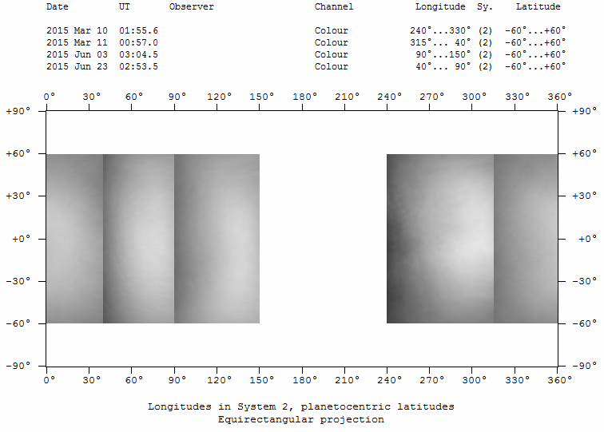

2015-Hill-Venus-NUV.png

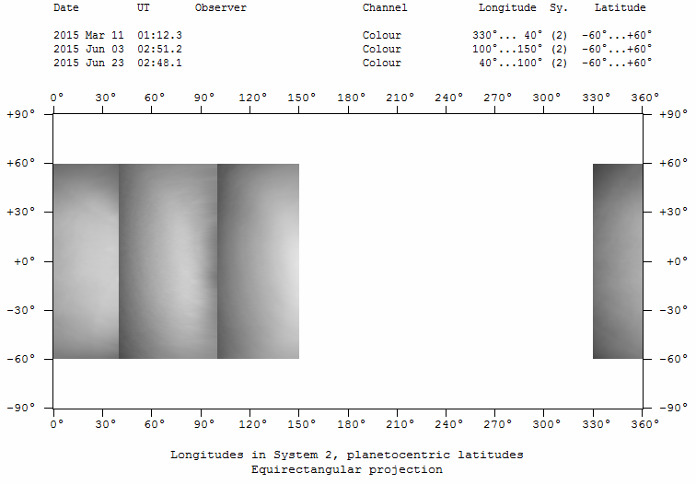

2015-Hill-Venus-685.png

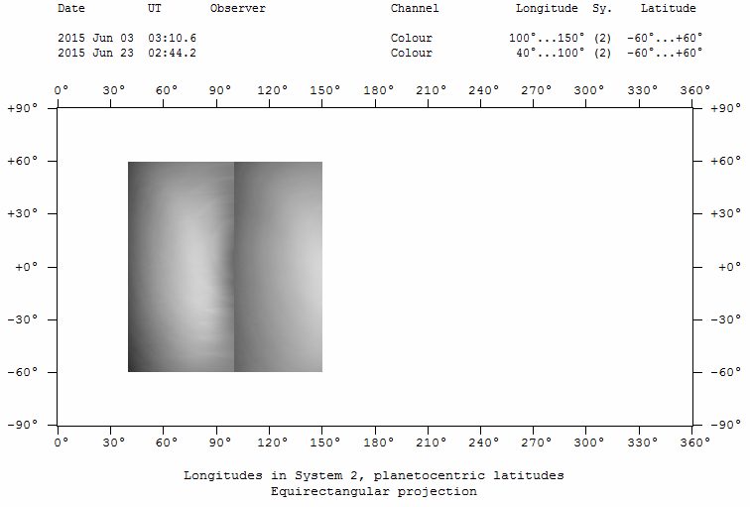

2015-Hill-Venus-807.png

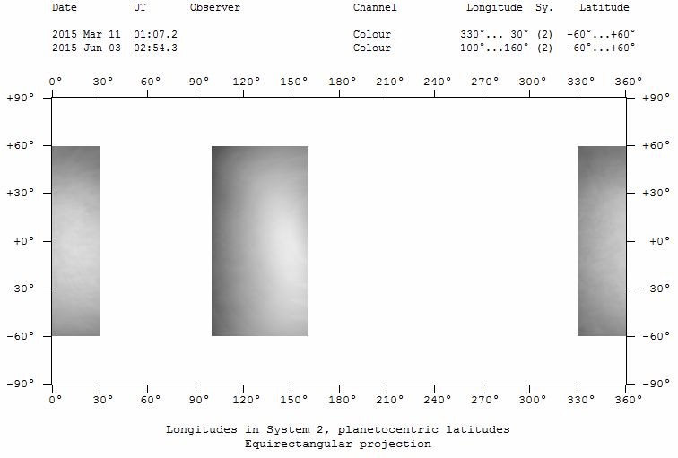

2015-Hill-Venus-889.png

**Spectroscopy**

Single spectrum. No calibration star available because it was taken with a bright sky, which also creates background correction challenges.

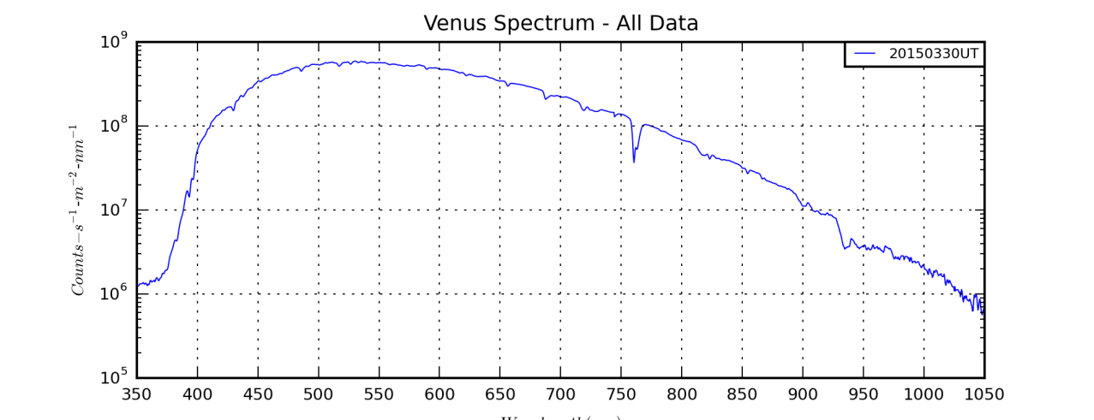

Error in RSPEC motivated me to more fully develop my Python codes to read directly from FITS spectral image data.

Spectrum flux calibration (approx.)

Spectrum spline normalized with line identification (probably no CO2 bands detectable, but we can say where to look)

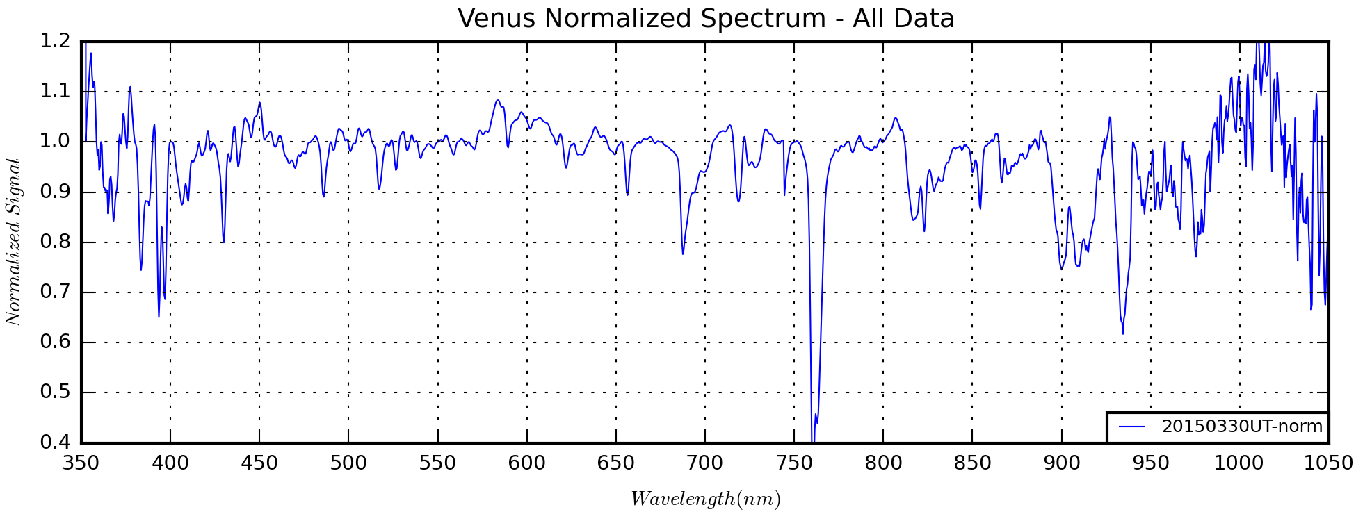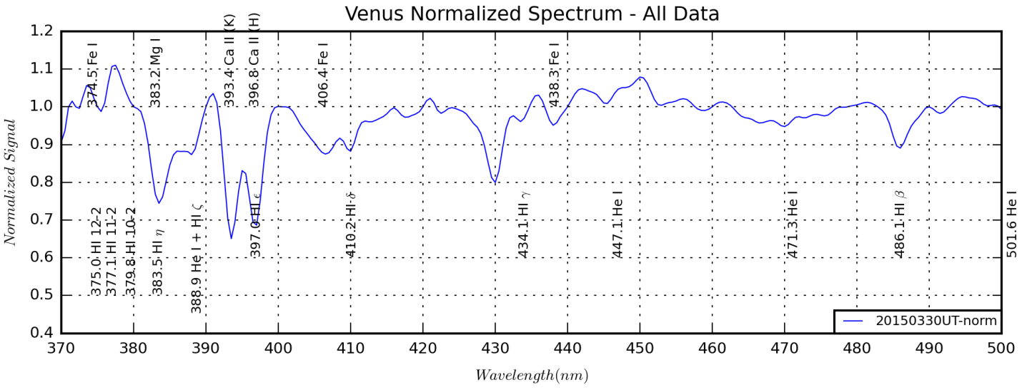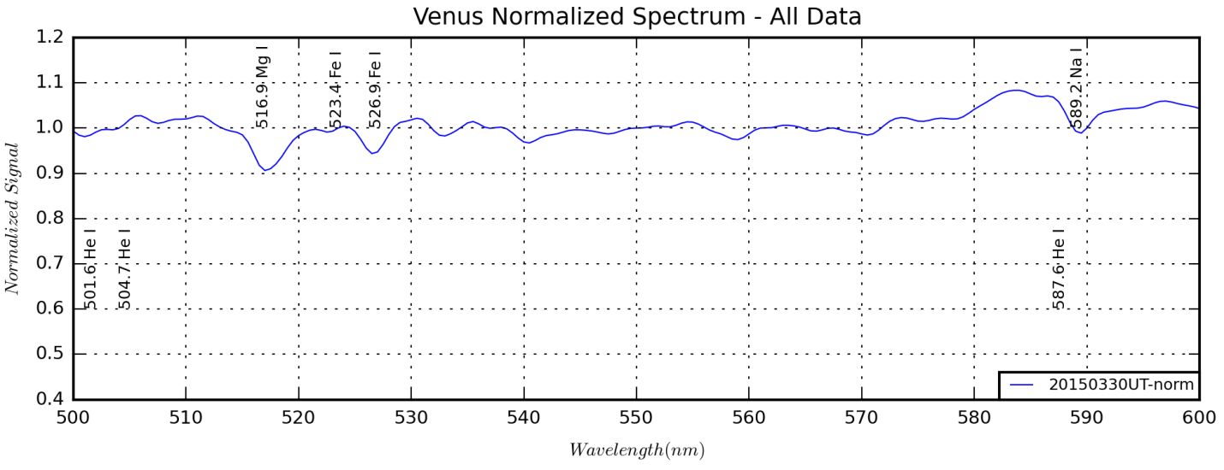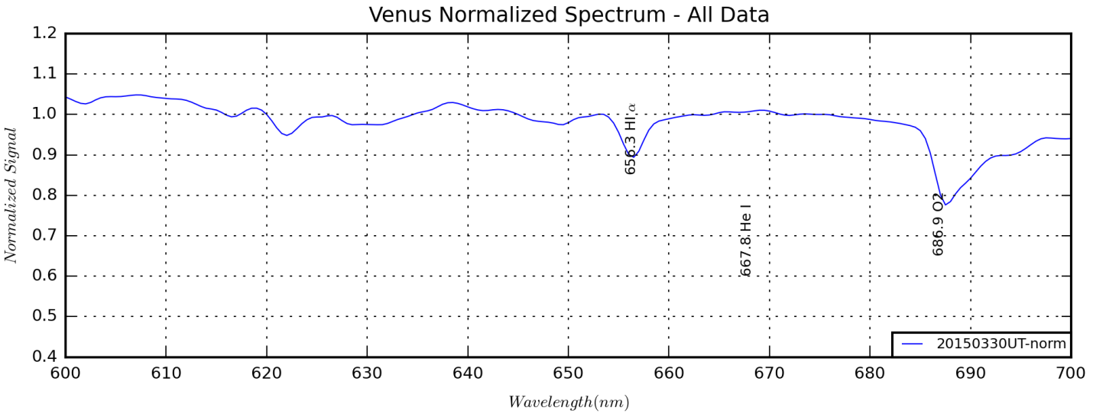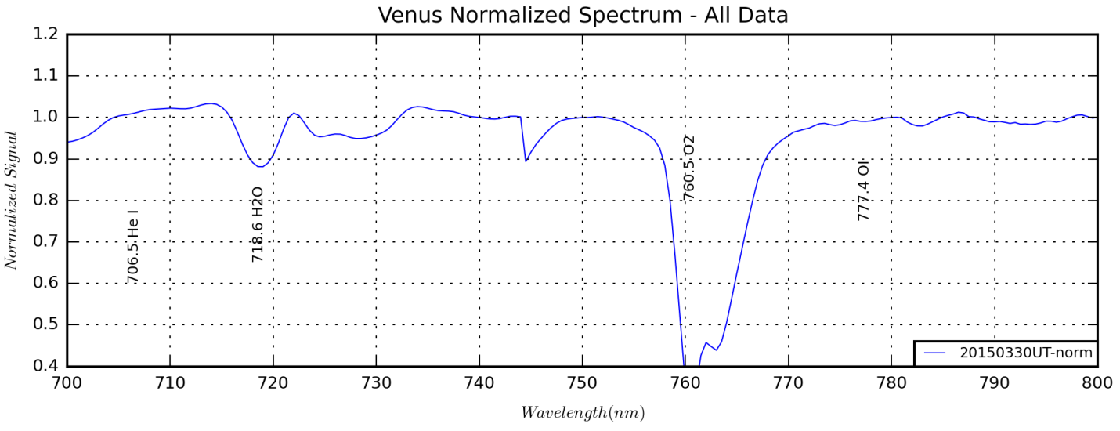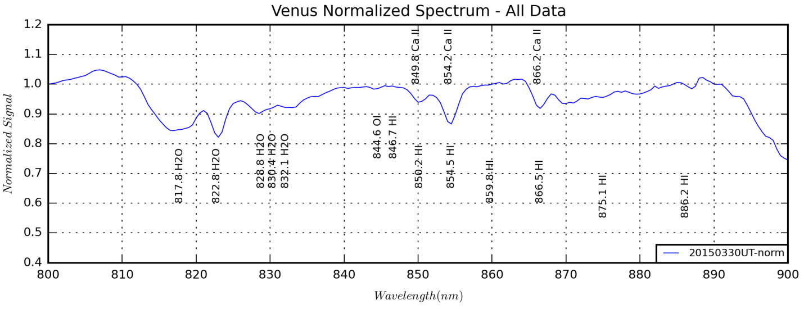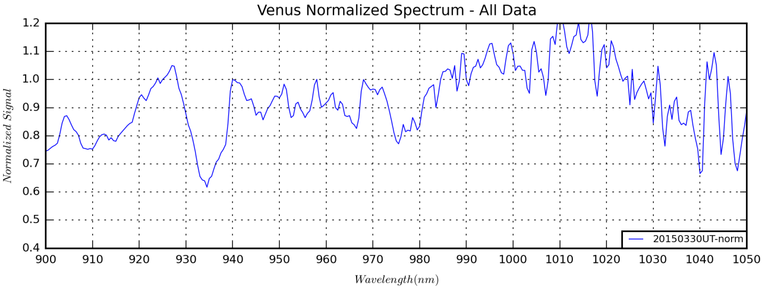

I need to compute the EWs of solar lines, telluric bands and possibly Venusian bands.

+---Venus

| +---Imaging Data

| | +---20150310UT

| | +---20150623UT

| | +---20150603UT

| | +---20150311UT

| | \---Mapping

| +---Spectral Data

| | +---20150330UT

| | +---Configuration Files

| | +---EWs

| | \---1D Spectra

| +---References

| \---Reports

### Jupiter Analysis 2015 Apparition

Last Updated 12/1/2015

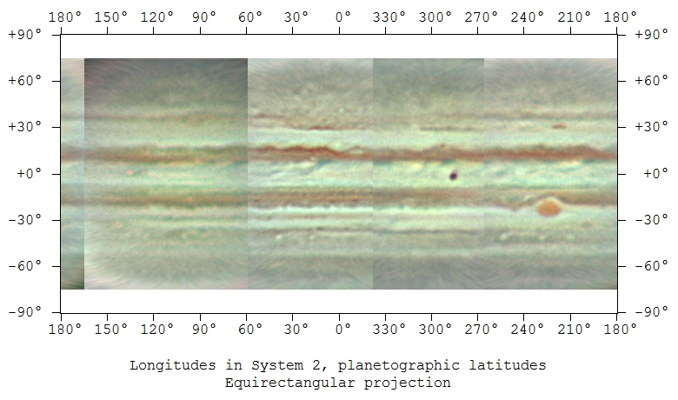

2015-03-10-XXXX.X-Hill-Jupiter-IGB.jpg

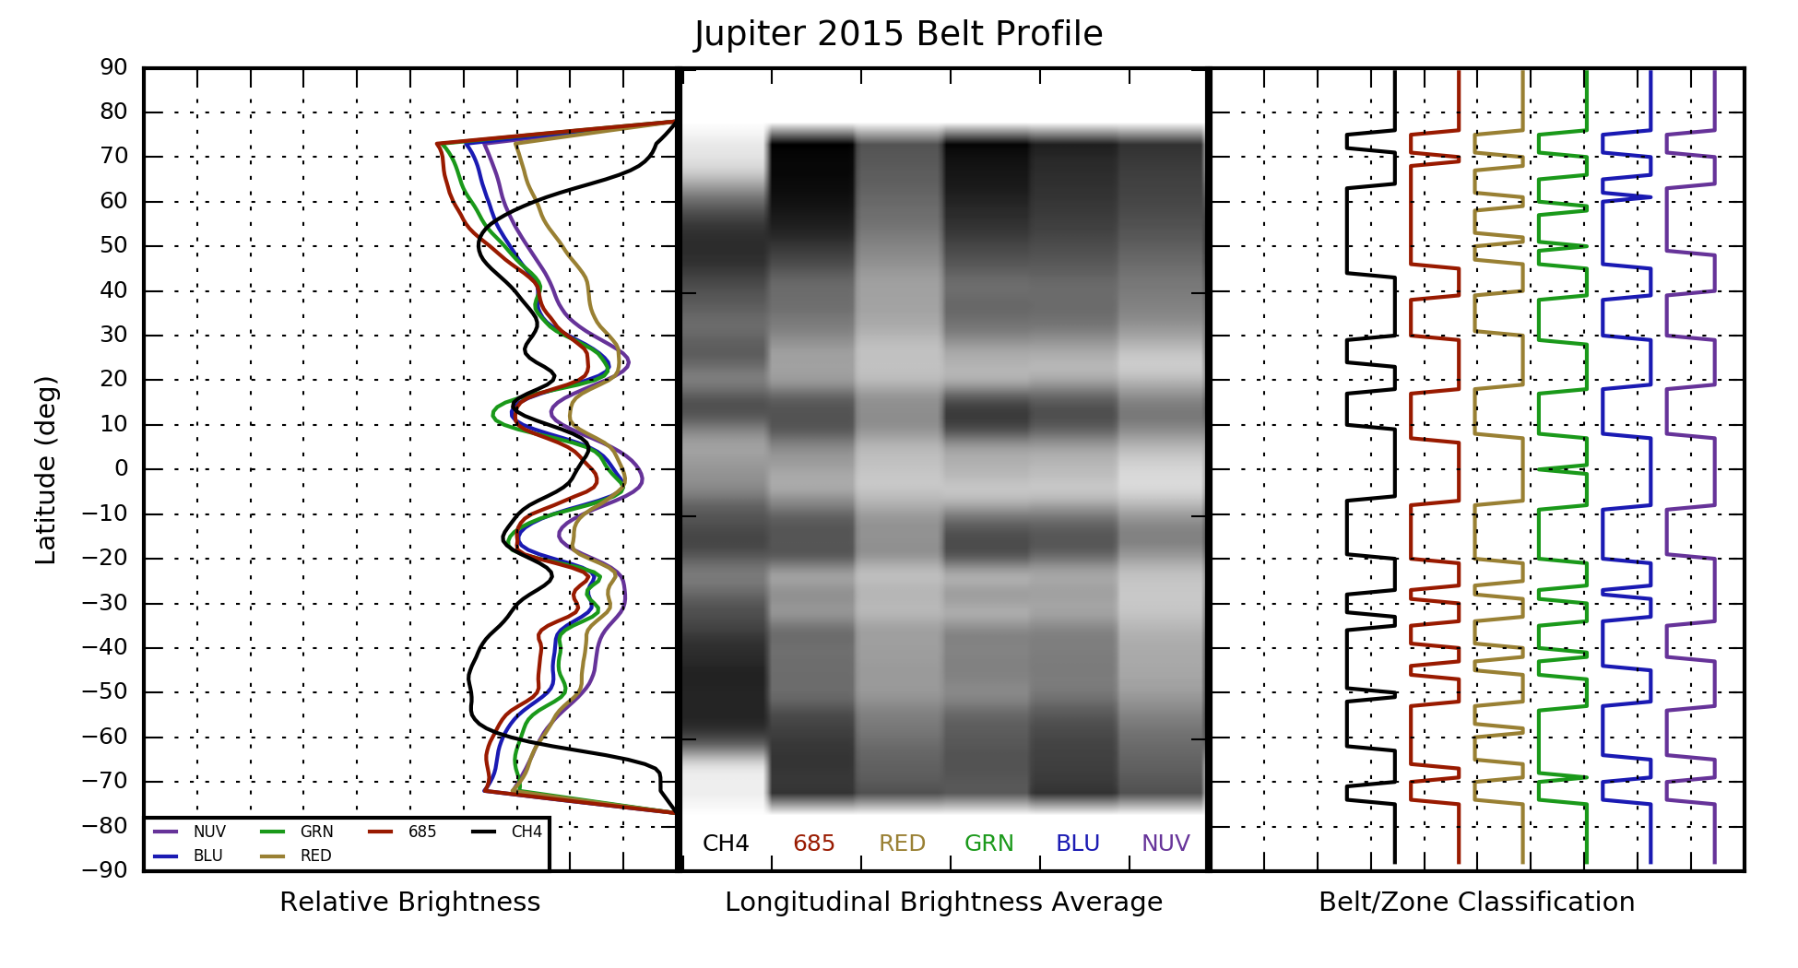

Jupiter2015BeltProfile.png from BeltProfiles2.py

So this brings be to the point where I have to question the value of establishing latitudes of belts and zones with any level of accuracy. Basically I have available two approaches the first is the simple point-and-click interface of WinJUPOS and the second is the longitudinally integrated method (LIM) I’ve coded in Python. The WinJUPOS method has the advantage of being able to make multiple, time and longitude resolved measurements of belt locations. It has the disadvantage of relying on human judgment to determine band boundaries often under low signal-to-noise ratio conditions. It is also user intensive.

The LIM has several advantages including: greater automation, repeatability and consistency across data sets and better extraction of band boundaries under low signal-to-noise ratio conditions. However, it tends to blur longitudinal structure in high quality data and can create band artifacts due to individual image artifacts. And, to get the most uniform quality across latitudes, I’ve been applying limb darkening correction in WinJUPOS. Along with the fact that the WinJUPOS outputs are uncalibrated 256 bit images, this really removes all semblance of photometric accuracy.

Ultimately however, the question is: What is the value of band latitudes to the study of Jupiter or Saturn? The physical processes of the atmosphere of principle interest are circulation, vertical structure and chemistry. What do band latitudes reveal about any of these? Qualitatively band strength (including width and “intensity”) may reveal long-term atmospheric cycles in circulation, vertical structure and chemistry. However, neither of the band width techniques uncovers anything about the intensity of the bands. To do this, one would have to use photometric data to establish broad band spectra of belts and zones under similar lighting conditions. Of course spatially resolved spectra would reveal the most about local chemistry and vertical structure.

For circulation, the frequent tracking of longitudinal features (barges, ovals, festoons) at the jets between belts and zones would be the most useful. I’m only beginning to have this capability with the ASI120MM camera. This also does not require photometric data.

My conclusion is the two specific contributions that latitude measurements of bands provides are: Information on band extent important to things like SEB re-emergence and the latitudes between which broad band photometric measurements should be taken for regional spectra.

All of this would be very labor intensive to do manually, so figuring a way to automate it in Python would be very useful. Probably the starting input to Python would be a centered, photometric FITS image (photometric to the limits interpolation for centering allows). If adequate metadata is provided in the FITS header, no additional information may be needed. The idea would be for the code to identify zonal structures and then automatically extract the spectra, including background subtraction. It is not exactly clear how to deal with limb darkening.

Alternatively, the Python code could use either an annual map created in WinJUPOS to establish the zonal structure or a simple input file indicating the zonal structure.

Here are a few further thoughts on next steps. It would be valuable to run the Python code with different size smoothing boxes. With the largest boxes, the largest belt structures would be clear, without the ‘noise’ created by multiple sub-band structures. Then smaller boxes could be used down to the level of image/map noise to refine smaller sub-band structures. All the data on transitions should be output to a file for each level of smoothing. Given that there are not major changes during a single apparition, this analysis should be conducted once a year on the annual master map of the planet. The results of this annual analysis could/should be entered into WinJUPOS as measurements.

Okay, here goes the detailed analysis of the math…

The input array is a set of 180 numbered pairs. The first column is an *index* of colatitude that ranges from 0 to 179. Thus, the colatitude representing the pixel levels runs from +89.5 degrees to -89.5 degrees.

$$I_{i}=I(ϕ_{i})$$

where

$$ϕ_{i}=89.5°-i$$

To find the finite difference at a given latitude we take:

$$\frac{∆I}{∆ϕ}\left(\frac{ϕ_{i}-ϕ_{i-1}}{2}\right)=\frac{I_{i}-I_{i-1}}{ϕ_{i}-ϕ_{i-1}}$$

Alternatively – with some implicit smoothing – we can retain the original indexing:

$$\dot{I_{i}}=\frac{∆I}{∆ϕ}\left(ϕ_{i}\right)={\left[\frac{∆I}{∆ϕ}\right]}_{i}=\frac{1}{2}\left[\frac{I_{i+1}-I_{i}}{ϕ_{i+1}-ϕ_{i}}+\frac{I_{i}-I_{i-1}}{ϕ_{i}-ϕ_{i-1}}\right]$$

Similarly, to get the second fixed difference:

$$\ddot{I_{i}}=\frac{∆^{2}I}{∆ϕ^{2}}\left(ϕ_{i}\right)=\frac{1}{2}\left[\frac{{\dot{I}}_{i+1}-{\dot{I}}_{i}}{ϕ_{i+1}-ϕ_{i}}+\frac{{\dot{I}}_{i}-{\dot{I}}_{i-1}}{ϕ_{i}-ϕ_{i-1}}\right]$$

Now, to determine whether a band is a zone or belt, we look for the sign of the second derivative. The latitudes at which the sign changes, indicates a change from belt to zone and visa versa.

NOTE: The use of 360x180 pixel maps may need to be reconsidered if I improve my spatial resolution. Right now, 1 degree of latitude subtends ~0.38 arc seconds. My sampling with the ASI120MM and the ST2000 (with the 2x barlow lens) give spatial sampling of ~0.16 arc seconds. Measurements in WinJUPOS on the best >685nm images suggest the smallest features to be seen subtend 1.2-1.6 degrees in latitude (near the equator). More typically, the smallest clear features are 2-3 degrees of latitude (also near the equator). Moving toward the pole the latitude resolution degrades due to the projection effect.

**NOTE: DID I FINISH GETTING THE MATH RIGHT AND FIXING THE CODE (8/16/2016)???**

+---Jupiter

| +---Spectroscopy

| | \---Data

| | +---20150123UT

| | | \---Calibration

| | +---20150209UT

| | | \---Calibration

| | +---20150210UT

| | +---20140309UT

| | | +---03bMoonsAligned

| | | \---03aJupiterAligned

| | +---20131217UT

| | +---20130117UT

| | | +---Calibrated

| | | \---calibrations

| | +---20150318UT

| | +---20150322UT

| | \---20150331UT

| +---Imaging

| | +---Data

| | | +---20150310UT

| | | +---20150311UT

| | | +---COMMENTS

| | | \---20150623UT

| | +---Scans to be filed

| | \---Mapping

| | +---COMMENTS

| | \---JupiterRotationRendition2008

| +---References

| \---Reports

+---Jupiter Project 2013-14

| +---Spectroscopy

| | +---Data

| | | +---20140309UT

| | | | +---03bMoonsAligned

| | | | \---03aJupiterAligned

| | | \---20131217UT

| | \---ReferenceData

| \---Imaging

| \---Source Data

| +---20140313UT

| | +---Video

| | | \---Aligned

| | \---CCD

| \---20131213UT

+---Jupiter Project 2012-13

| +---Imaging

| | \---Source Data

| | +---20121222Local

| | | +---Blue

| | | +---Methane

| | | +---NUV

| | | \---Video

| | +---20140117Local

| | +---20130105Local

| | | +---Video

| | | \---CCD

| | \---20121221Local

| | +---Blue

| | +---Halpha

| | +---Methane

| | +---NIR

| | +---NUV

| | \---Video

| \---Spectroscopy

| \---Source Data

| +---20130109UT

| \---20130117UT

| +---Calibrated

| \---calibrations

+---Jupiter Project 2011-12

| \---Source Data

| +---20111210Local

| | \---RotatedCropped

| \---20120308Local

### Saturn Analysis 2015 Apparition

Last Updated 1/18/2015

+---Saturn Project 2015

| +---Imaging

| | +---20150623UT

| | +---20140528UT

| | | +---RGB

| | | +---Blu

| | | +---CH4

| | | +---Grn

| | | +---Hal

| | | +---NIR

| | | +---NUV

| | | \---Red

| | +---20140529UT

| | | +---RGB

| | | +---CH4

| | | \---NIR

| | +---20140610UT

| | | +---NIR

| | | +---CH4

| | | \---RGB

| | +---Mapping

| | \---Photometry

| +---Spectral Data

| | +---20140629UT

| | +---References

| | +---Karkoschka

| | \---Data

| +---PROJECT

| | \---7250

| +---References

| \---Reports

### Uranus Analysis 2015 Apparition

Last Updated 1/18/2015

\---Uranus

+---Spectral Data

| +---20150129UT

| \---20131201UT

+---References

+---Imaging Data

| \---20151115UT

| \---Calibration

+---Photometry

| \---20131110

\---Reports

### Neptune Analysis 2015 Apparition

Last Updated 2/2/2016

This year I attempted to track rotational modulation of methane absorption at Neptune due to longitudinally constrained NIR bright storms. Due to poor weather and a busy schedule I didn’t get much coverage. In addition, some of the work has been more experimental in order to exploit what I can in terms of aperture and spectral resolution. To this end I’ve used the StarAnalyzer 200 grating (200 lines/mm) with the C8 at a focal length of 1260mm.

The grating spacing gives a dispersion of about 0.5 nm per pixel. Given the plate scale of approximately 1.1 arc seconds per pixel and that Neptune subtends 2.5 arc seconds the effective dispersion is really about 1.14 nm. Applying the Nyquist sampling criterion, the smallest resolvable spectral features should be about 2.3 nm. Of course, contrast and depth are important to the resolution problem as well.

The basic parameters of this configuration in terms of light gathering and dispersion seem very favorable to analyzing methane absorption, especially compared to the alternative objective grating using the 135mm lens with an aperture of just 25 mm. However, there is a major complication. Due to the larger dispersion of the 200 line/mm grating, there is significant wavelength dependence for focus.

While the dispersion is similar to the 100 line/mm grating on the 135 mm lens, the wavelength dependence is greater because the dispersion angle is twice as large. Thus, the important question is how severely this affects calibration and repeatability of EW measurements. (Some work on the variations in focus with wavelength *may* be covered in the Vega spectrum section of this document.) This also makes merging VIS and NIR spectra more difficult. Thus, I want to use bands only in the VIS range, possibly extending to the 725nm band.

I only took a Vega spectrum as an absolute reference on 2015-10-15UT to link with Sig Aqr and Neptune. For the November observations I’ll have to use that as a reference. I did not take any G2V reference star spectra either to use as a solar proxy. Thus, I’ll have to use a model solar spectrum convolved with a response function generated from Vega and Sig Aqr.

I am working on a significant reimplementation (along with documentation) of my spectral and EW analysis software. The original branches derive from the Jupiter-related codes developed for the 2015 SAS conference. I want to extend the codes to work easily with all outer planets and Titan, as well as for other targets such as stars and nebulae. The Appendix on Python Spectral Codes should document many of these upgrades.

In addition, I will am collaborate with Richard Schmude, Tony Mallma, and Hristo Pavlov and using their spectra from the summer/early fall of 2015. I’ll need to establish the ephemeris of the storm(s) from the work done by Marc Delacroix and presented on the ALPO Japan website.

Finally, I attempted to get a NIR resolved observation of the storm. This seemed possible since it’s been achieved with the same camera (ASI120MM) and filters (>685nm) that I use, though I don’t think I’ve seen the storm resolved with apertures less than 0.28m (11 in). Unfortunately conditions were unfavorable and **I’m not even sure I targeted Neptune correctly** when imaging. However, I did manage to get my first spatially resolved images of Uranus this year.

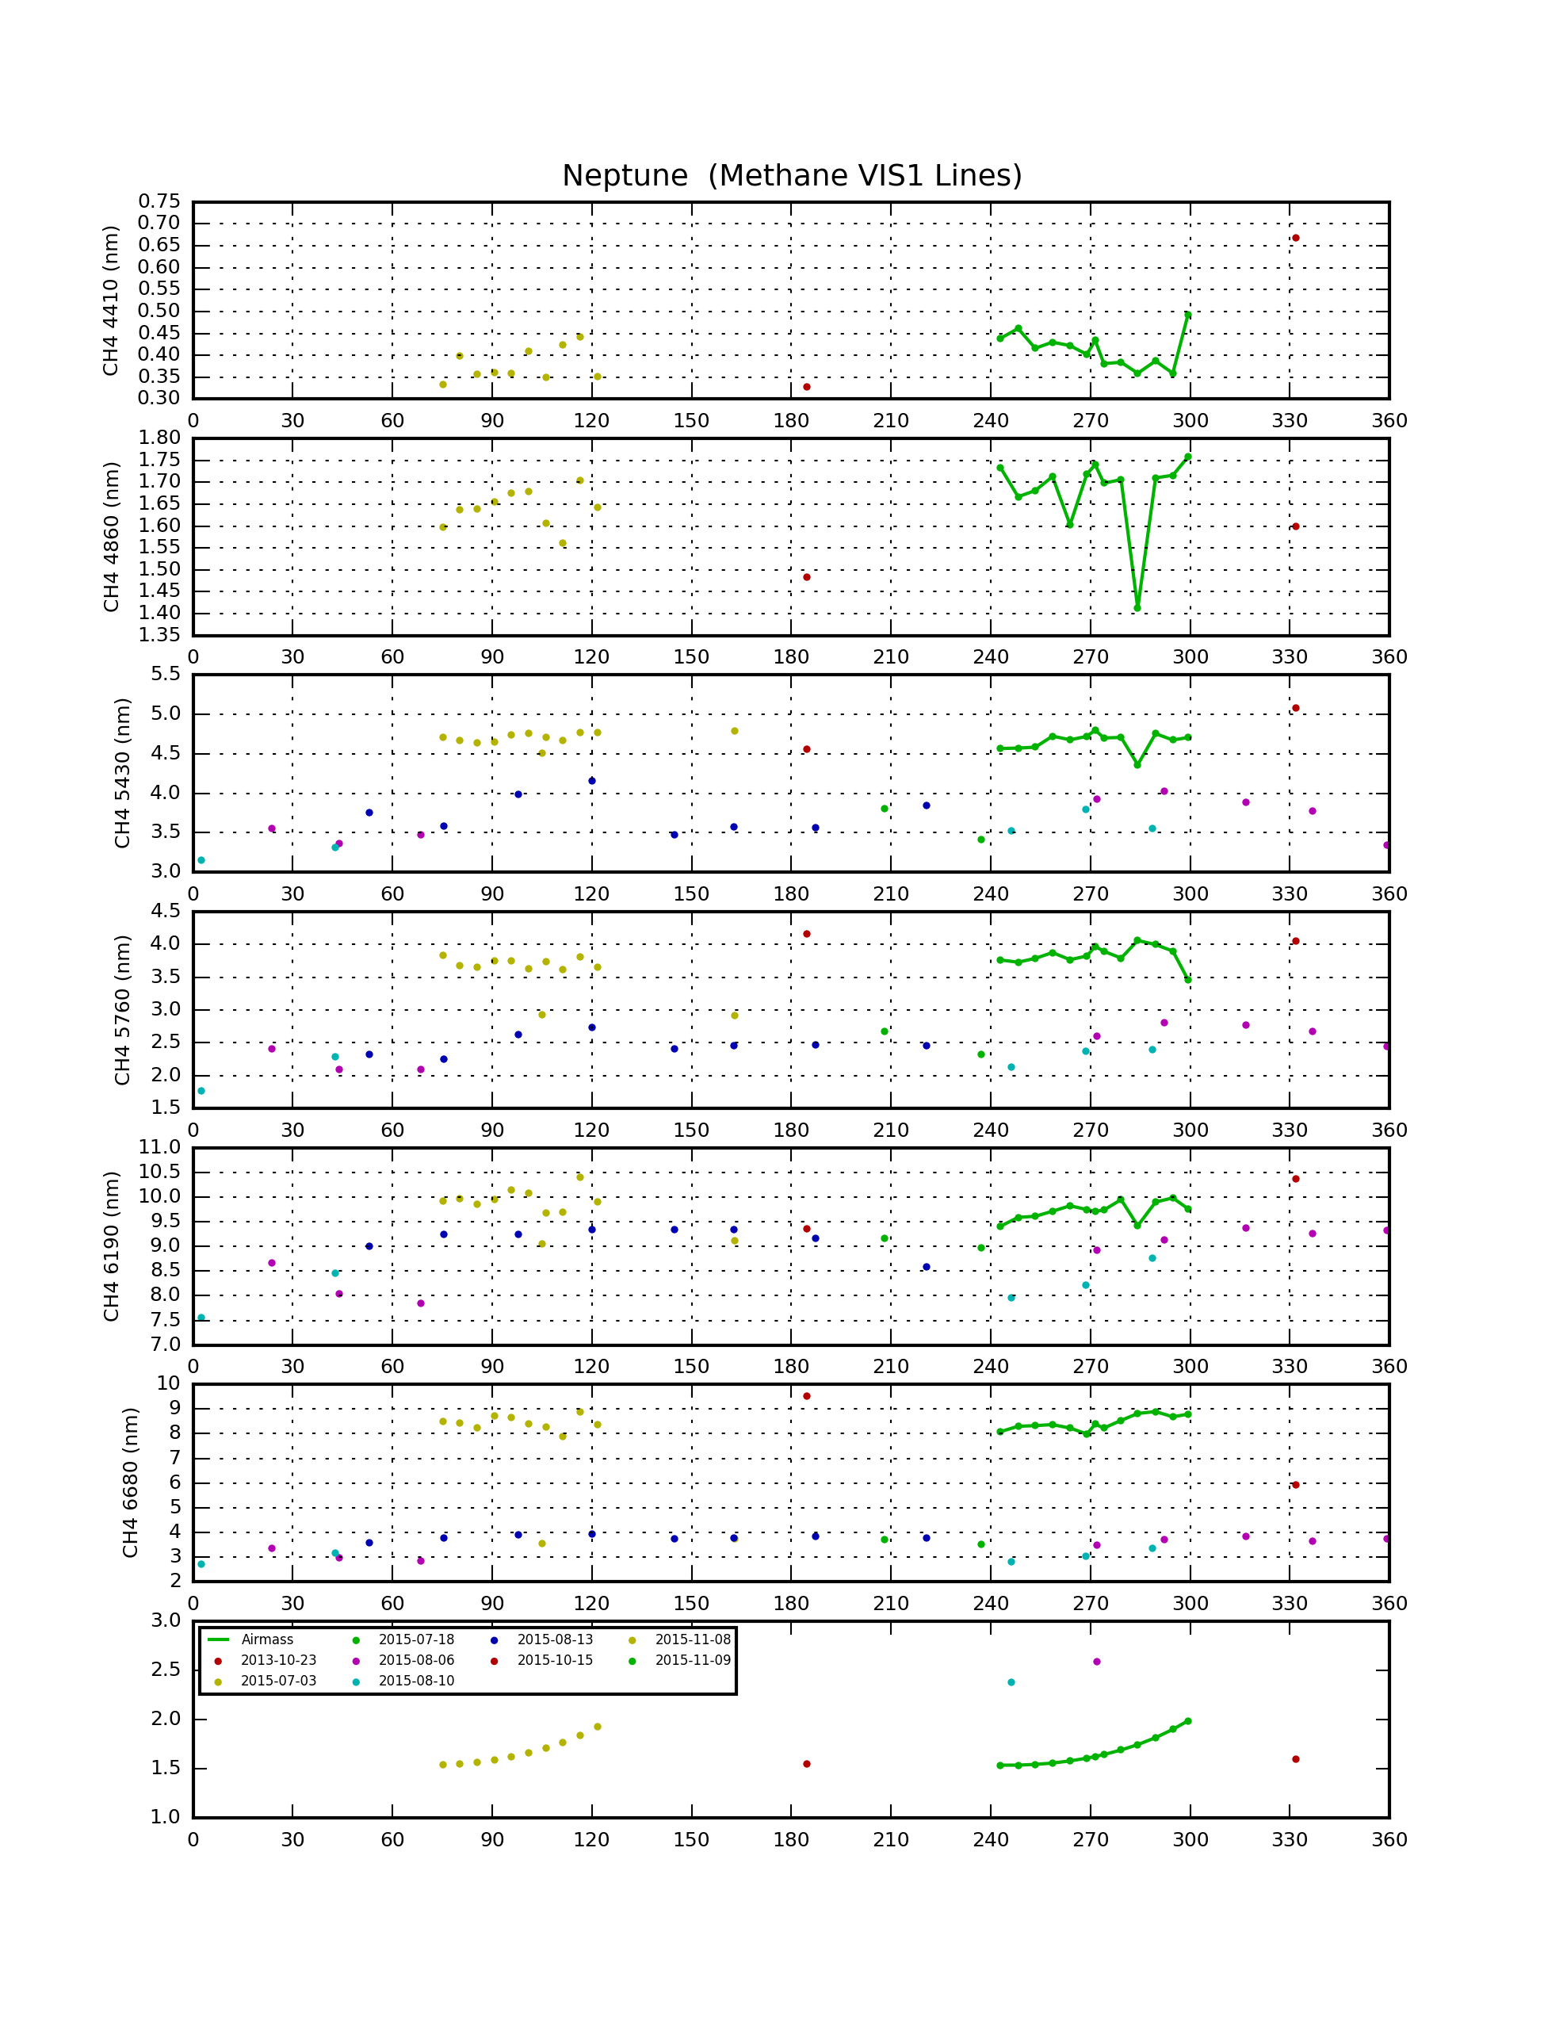

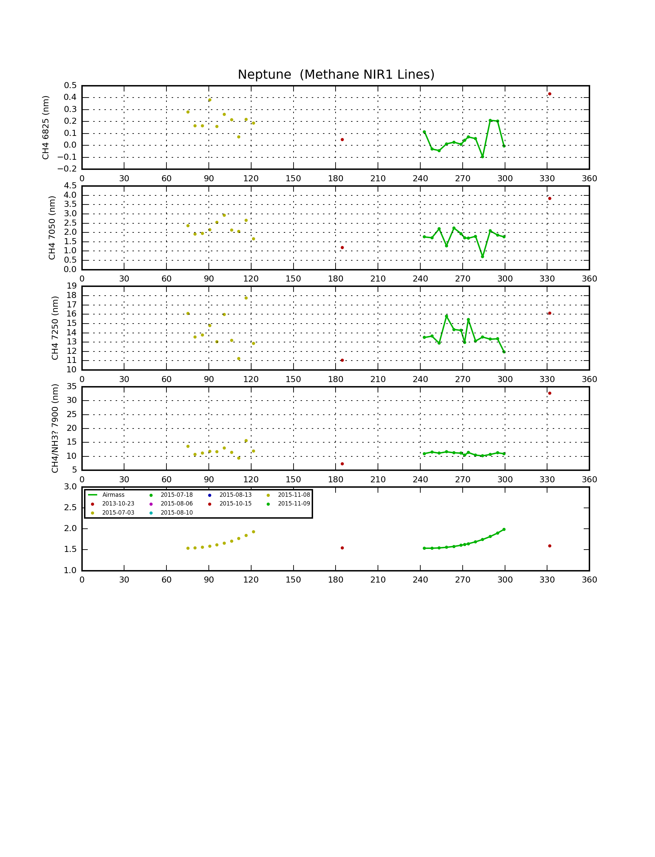

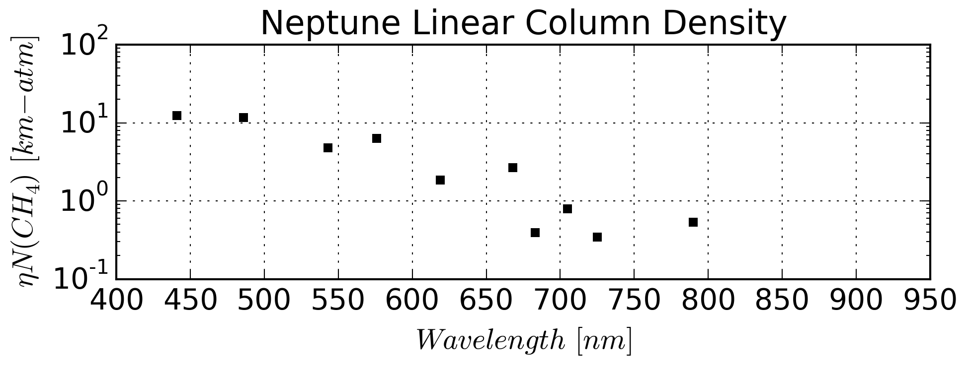

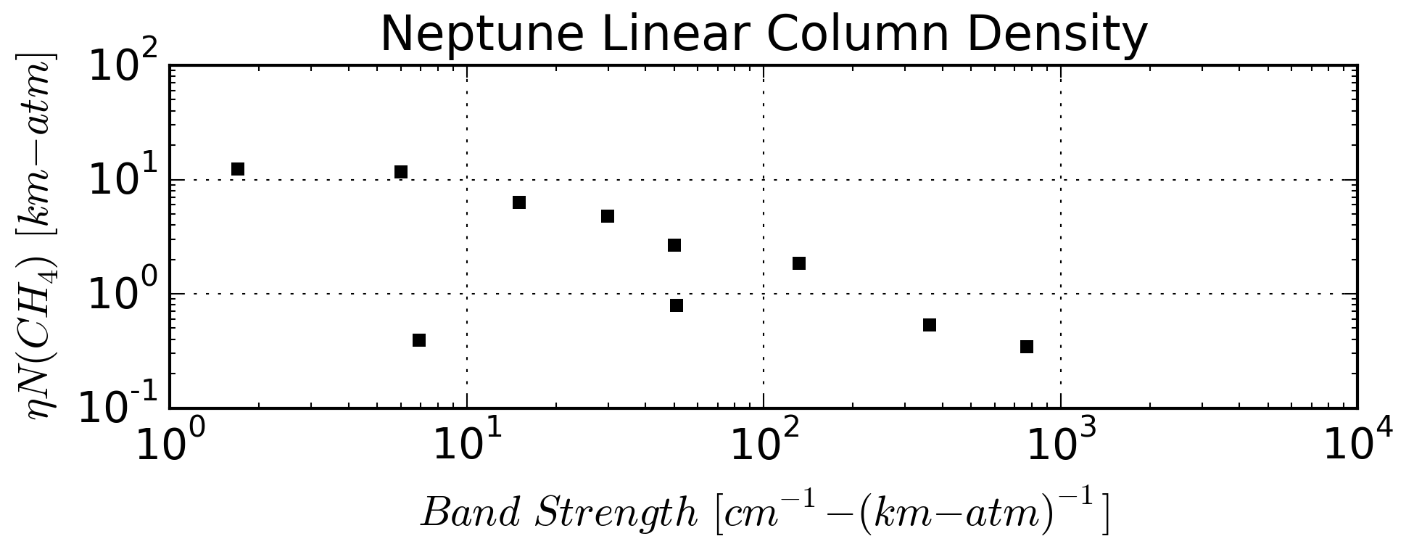

12/3/2015:

Checklist of stuff to do:

* Analysis Code and Schmude data
  + Finish rotational ephemeris code with corrections for perspective and inclination according to **Astronomical Algorithms** book by Jean Meeus.
  + Create (manually) EW tables for published Schmude *et al.*, 2015 data
  + Update EW plotter software to integrate correct rotational ephemeris code and Schmude *et al*., 2015 EW data.
  + **Document and refactor EW code to reduce complexity and increase flexibility – in progress 2/2/16**
* My Neptune Observations
  + Finish processing my Neptune spectrum images from 2015
  + Run “generic” FITS-to-1D spectral code against all my Neptune spectra (not just 2015).
  + Iterate to establish consistent EW parameters for all my spectral observations. This includes reconciling EW parameters from different instrument configurations as best as possible.
  + For fun and reference, tabulate the EWs for the Sig Aqr reference spectra
  + Integrate Schmude spectra and compute my own EWs from that data set
* Complementary Observations
  + Contact collaborators, e.g., Mark Delcroix, on cloud ephemerides for this rotation
  + Review public images (ALPO, ALPO-Japan, PVOL) to confirm and/or establish cloud longitudes and drift rates
  + Derive my own EWs from Hristo spectra
* Period Analysis
  + I tried some simple phase folding on the Schmude data to see if rotational modulation clearly popped out with different drift rates. The spreadsheet (Schmude2015-EW-Analysis.xlsx) showed nothing conclusive, though many drift rates seemed to show some periodicity.
  + Investigate Python Lomb-Scargale periodogram analysis for cloud structures. Can also apply to Jupiter GRS work from last year

11/19/2015:



**Fig. 1** Reference system used to define orientation of the planets and their satellites

Neptune rotational ephemeris from

*α0* = 299.36 + 0.70 sin *N*

*δ0* = 43.46 − 0.51 cos *N*

*W* = 253.18 + 536.3128492*d* − 0.48 sin *N*

*N* = 357.85 + 52.316*T*

where:

The direction of the north pole is specified by the value of its right ascension *α*0 and declination *δ*0.

The angle *W* specifies the ephemeris position of the prime meridian.

*T* = interval in Julian centuries (of 36525 days) from the standard epoch

*d* = interval in days from the standard epoch.

The standard epoch is JD 2451545.0, i.e. 2000 January 1 12 hours TDB

*α*0, *δ*0 are ICRF equatorial coordinates at epoch J2000.0.

Approximate coordinates of the north pole of the invariable plane are *α*0 = 273◦.85, *δ*0 = 66◦.99.

**Advanced Data Processing:**

For data processing of FITS files, I think I have the steps to account for flat field correction, at least approximately:

1. Compute the flat-field and background corrections together using the BKG keyword rows
   1. Subtract pedestal (keyword) from the BKG data rows
   2. Find (smoothed) maximum in BKG data rows – this is the background level
   3. Normalize BKG rows to maximum – this is the flat reference
2. Apply corrections
   1. Subtract pedestal from FITS data
   2. Divide FITS data by flat field
   3. Subtract background level
   4. Reapply pedestal if desired

Finally, I need to figure out how to improve my wavelength calibration and make sure it is stable across observations. This may mean going to a second or third order fit.

Neptune storm ephemeris from ALPO-Japan:

<http://alpo-j.asahikawa-med.ac.jp/Latest/N_obstxt.htm>

* Drift data
  + L(T0)=273.8 deg
  + Drift=25.9898 deg/day
  + Ref. Date=2015-08-16 UT (2015-08-16.5)

Richard W. Schmude, Jr. (ALPO)

Gordon College

Division of Natural

Sciences and Nursing

419 College Drive

Barnesville, GA 30204

Email: [Schmude@gordonstate.edu](mailto:Schmude@gordonstate.edu)

Tony Mallma

Hristo Pavlov

**Data Sets:**

I’ve received spectral data from Hristo Pavlov from the summer of 2015. I think the three main data sets I need to work with are:

1. Hill 2015 spectra (EWs only, *maybe* fluxes if I can work out the calibration)
2. Pavlov 2015 spectra (EWs – his, mine, raw and flux calibrated)
3. Delacroix imaging and spot ephemeris

Goals of publication should be placing professional storm/atmosphere observations in a longer-term context. Fitting Schmude *et al.*, 2015 photometry context into shorter term spectral context. Basically, nesting contexts here. In addition, determine if simple 1-D atmosphere models can be used to retrieve stronger, more physically meaningful environmental data records/metrics/indices.

Computed linearly from nearest storm C.M. transit using a throw-away MS Excel sheet.

|  |  |  |  |
| --- | --- | --- | --- |
| Date-Time | CM | Storm Long | Delta Long |
| 2015-10-15 03:34:47 | 180.1 | 24 | 156 |
| 2015-11-08 02:40:47 | 70.7 | 287 | 143 |
| 2015-11-08 04:45:42 | 117.3 | 289 | 172 |
| 2015-11-09 ~02:30:00 | 243.0 | 312 | 70 |
| 2015-11-09 ~04:30:00 | 287.7 | 315 | 27 |
| 2015-11-10 ~04:10:00 | 96.5 | 341 | 116 |
| 2015-11-10 ~04:50:00 | 111.4 | 341 | 130 |

Nice reference on time systems:

<https://www.cv.nrao.edu/~rfisher/Ephemerides/times.html>

Python article on time systems:

<http://docs.astropy.org/en/stable/time/>

JPL Horizons interface:

<http://ssd.jpl.nasa.gov/horizons.cgi>

Spot ephemeris and discussion from Marc Delcroix

<http://www.cloudynights.com/topic/506373-neptune-triton-20150720-with-bright-spot/>

Useful article on Uranus and Neptune conditions this year at the Planetary Society:

<http://www.planetary.org/blogs/emily-lakdawalla/2015/09221120-checking-in-on-uranus-and-neptune.html>

**The above link contains another link to ephemerides for *three* spots:**

[**http://www.pvol.ehu.es/pvol/neptune\_2015.html**](http://www.pvol.ehu.es/pvol/neptune_2015.html)

+---Neptune

| +---Imaging Data

| | +---20141021UT

| | +---20141015UT

| | +---20131102

| | +---20131110

| | +---Photometry

| | \---20151115UT

| +---Spectral Data

| | +---20141028UT

| | | \---Calibration

| | +---20141029UT

| | | \---Calibration

| | +---References

| | +---20151015UT

| | +---20131023UT

| | +---20151108UT

| | | \---OriginalFiles

| | +---20151109UT

| | | \---NoHeaderUpdates

| | +---20151110UT

| | | \---NoHeaderUpdates

| | +---for Steven Hill

| | +---1D Spectra

| | +---EWs

| | +---Configuration Files

| | \---Analysis

| \---Reports

## Analyses: Stars

Last Updated 8/14/2014

TBD

Very good links:

<http://zuserver2.star.ucl.ac.uk/~msw/lines.html>

<http://stsdas.stsci.edu/elcat/>

Balmer ratios!!! <http://ned.ipac.caltech.edu/level5/Glossary/Jaschek/H.html>

### Vega (Spectroscopy)

Moved to 2016 Notes and updated there.

### Beta Lyrae (Spectroscopy)

**Observing Log**

|  |  |  |
| --- | --- | --- |
| **Date** | **Comments** | **Update** |
| 2015 Sep 09 | Spectra: Took spectra using Star Analyzer 200/mm grating, ST2000, and C8 at f/6.3 (1260mm). Used CLR filter. | 2015-Oct-29 |
| 2015 Sep 20 | Spectra: Took spectra using Star Analyzer 200/mm grating, ST2000, and C8 at f/6.3 (1260mm). Used CLR filter. Unfortunately I discovered that there was icing on the detector at -10C. This ruined the spectra for any quantitative purposes. I’ve permanently deleted the data files. | 2015-Oct-29 |
| 2015 Sep 24 | Spectra: Took spectra using Star Analyzer 200/mm grating, ST2000, and C8 at f/6.3 (1260mm). Used CLR and NIR742 filters for order separation. | 2015-Oct-29 |
| 2015 Oct 13 | Spectra: Took spectra using Star Analyzer 200/mm grating, ST2000, and C8 at f/6.3 (1260mm). Used CLR and NIR742 filters for order separation. | 2015-Oct-29 |
| 2015 Oct 14 | Spectra: Took spectra using Star Analyzer 200/mm grating, ST2000, and C8 at f/6.3 (1260mm). Used CLR and NIR742 filters for order separation. | 2015-Oct-29 |

FOCUSING ISSUE using 200/mm grating with C8…

Good amateur article on Be Stars, like Beta Lyrae:

<http://www.shelyak.com/dossier.php?id_dossier=24&lang=2>

Reference that looks good for Landolt stars, but is a book for sale that has lots of other stuff in it: <https://books.google.com/books?id=tJCceLB84Z8C&pg=PA79&dq=landolt+reference+stars&hl=en&sa=X&ved=0CCIQ6AEwAWoVChMIpoOU7uqByAIVzDqICh3jTAbR#v=onepage&q=landolt%20reference%20stars&f=false>

Captured from AAVSO on 2015-10-27

|  |  |  |  |  |  |  |  |  |  |  |  |  |  |  |  |  |  |  |  |  |  |  |  |  |  |  |  |  |  |  |  |  |  |  |  |  |  |  |  |  |  |  |  |  |  |  |  |  |  |  |  |  |  |  |  |  |  |  |  |  |
| --- | --- | --- | --- | --- | --- | --- | --- | --- | --- | --- | --- | --- | --- | --- | --- | --- | --- | --- | --- | --- | --- | --- | --- | --- | --- | --- | --- | --- | --- | --- | --- | --- | --- | --- | --- | --- | --- | --- | --- | --- | --- | --- | --- | --- | --- | --- | --- | --- | --- | --- | --- | --- | --- | --- | --- | --- | --- | --- | --- | --- |
| |  |  |  |  | | --- | --- | --- | --- | | **Name** | |  |  | | --- | --- | | https://www.aavso.org/vsx/_images/0.gif   **bet Lyr** |  | | | **AAVSO UID** | |  |  | | --- | --- | | 000-BCW-361 (27455 observations) |  | | | **Constellation** | |  |  | | --- | --- | | Lyra | https://www.aavso.org/vsx/_images/raquo.gif [**Sequence**](javascript:showCharts(18631)) | | | **J2000.0** | |  |  | | --- | --- | | 18 50 04.79 +33 21 45.6  (282.51996 +33.36267) | https://www.aavso.org/vsx/_images/raquo.gif[**Search nearby**](https://www.aavso.org/vsx/index.php?view=results.nearby&oid=18631) | | | **B1950.0** | 18 48 14.00 +33 18 12.3 | | **Galactic coord.** | 63.188 +14.783 | | **Other names https://www.aavso.org/vsx/_images/spacer.gif** (Internal only) | |  |  |  | | --- | --- | --- | | 10 Lyr | AAVSO 1846+33 | ADS 11745 A | | BD+33 3223 | HD 174638 | HD 174639 | | HIP 92420 | HR 7106 | IRC +30343 | | MWC 306 | RAFGL 5305S | SAO 67451 | |  |  |  |   (Not logged in)  https://www.aavso.org/vsx/_images/raquodim.gif**Add name** | | **Variability type** | |  |  | | --- | --- | | EB | **[https://www.aavso.org/vsx/_images/help.gif](javascript:varTypeHelp('EB'))** | | | **Spectral type** | B8II-IIIep | | **Mag. range** | |  |  | | --- | --- | | 3.30 - 4.35 V | **[https://www.aavso.org/vsx/_images/help.gif](javascript:passbandHelp('V','',''))** | | | **Discoverer** | -- | | **Epoch** | |  |  | | --- | --- | | 26 Aug 2010 (HJD 2455434.87020) | https://www.aavso.org/vsx/_images/raquo.gif [**Ephemeris**](javascript:showEphemeris(18631)) | | | **Outburst** | -- | | **Period** | 12.94061713 d | | **Rise/eclipse dur.** | -- | | |
|  | |
| **Remarks** | **[https://www.aavso.org/vsx/_images/barhelp.gif](https://www.aavso.org/vsx/index.php?view=detail.top&oid=18631)** |
| Some references may be clicked to view in new window. Roll over index number to view submission details. | |
|  | |
| |  |  |  | | --- | --- | --- | | **1** | [**Otero, Sebastian Alberto**](mailto:sebastian@aavso.org) | HJD 2455434.8702 +12.94061713 \* E is a linear ephemeris. | | |

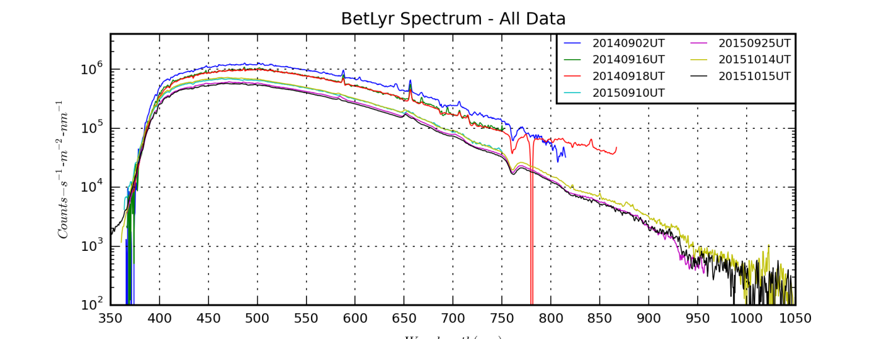

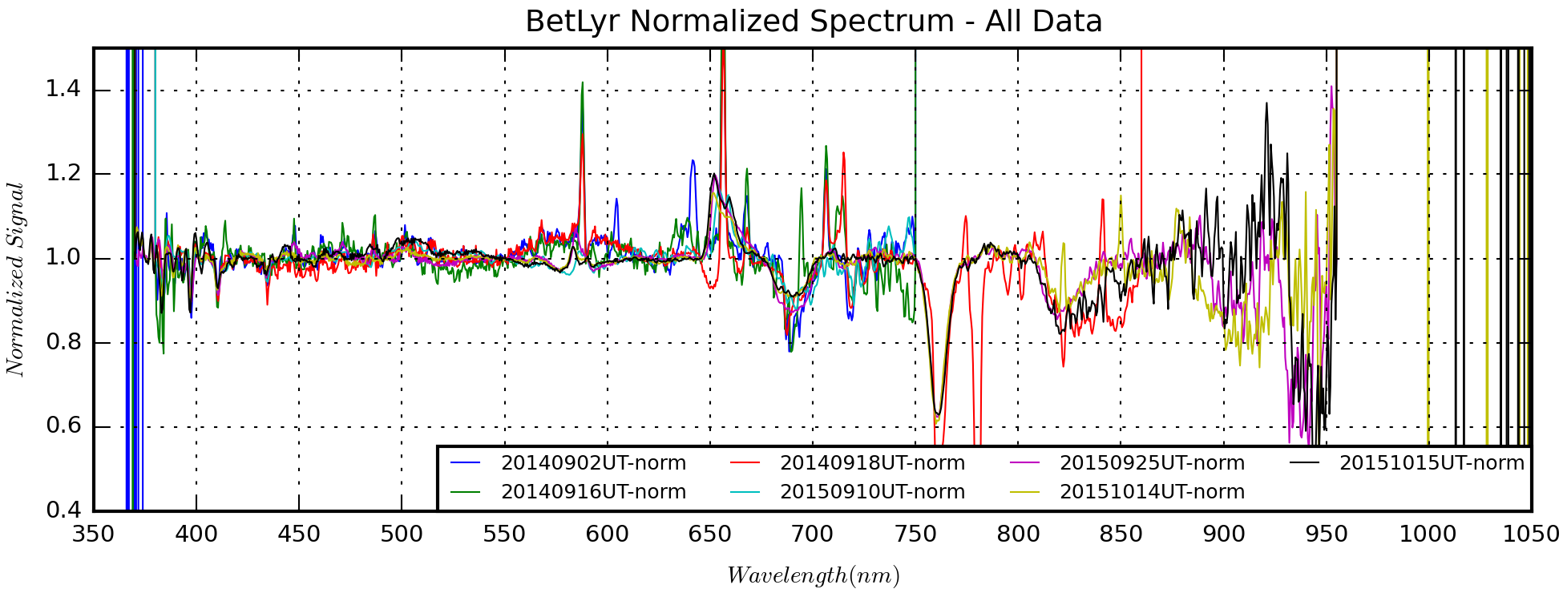

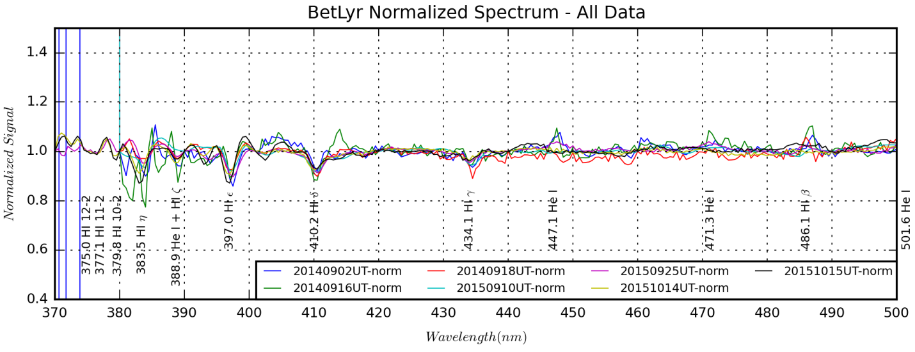

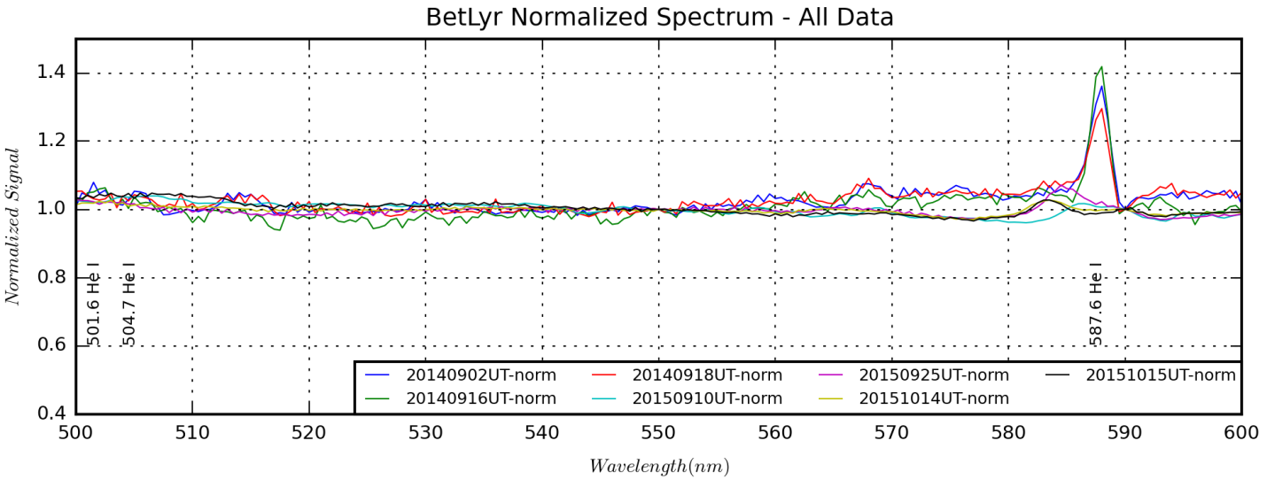

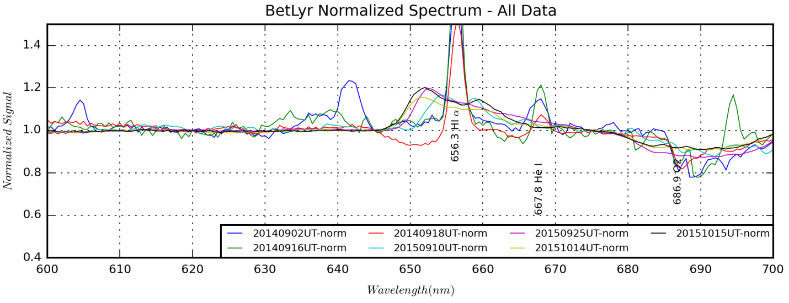

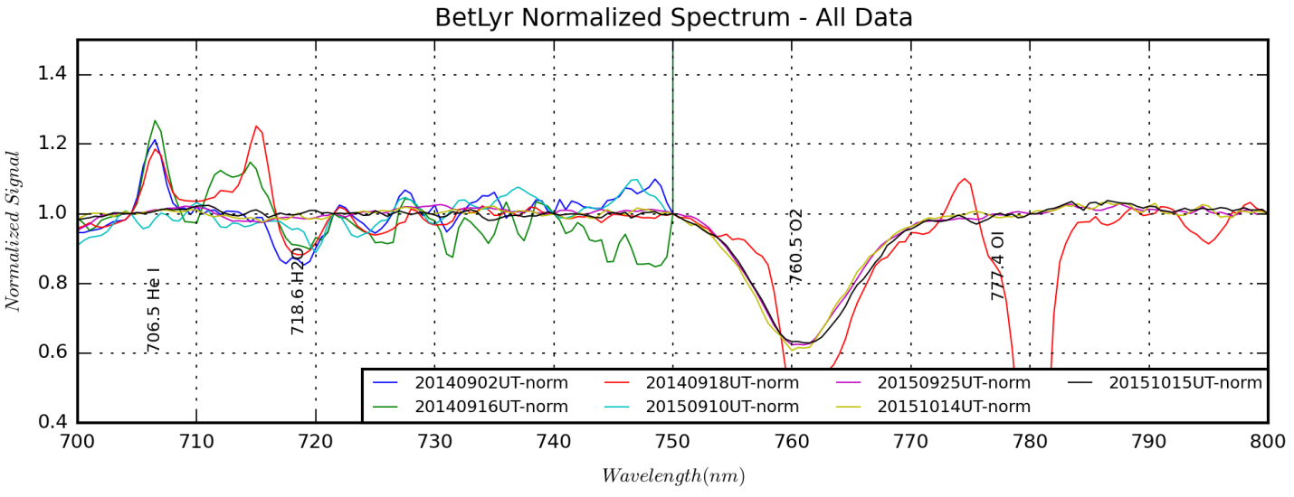

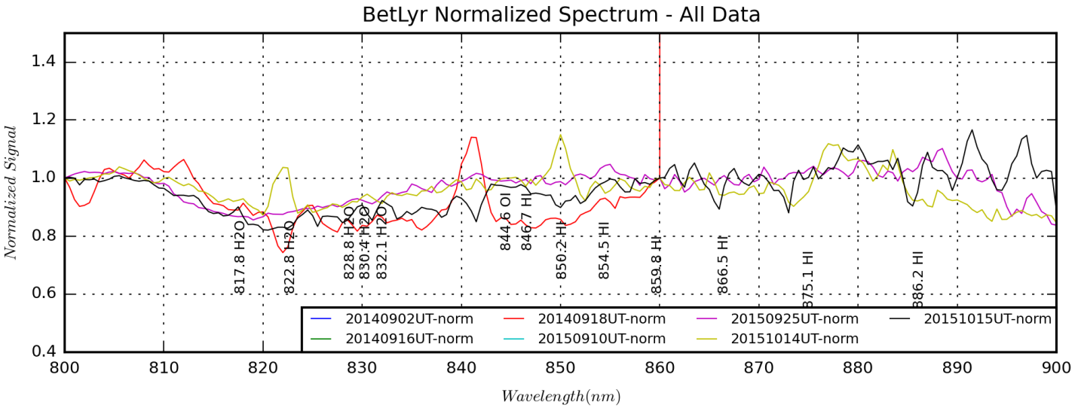

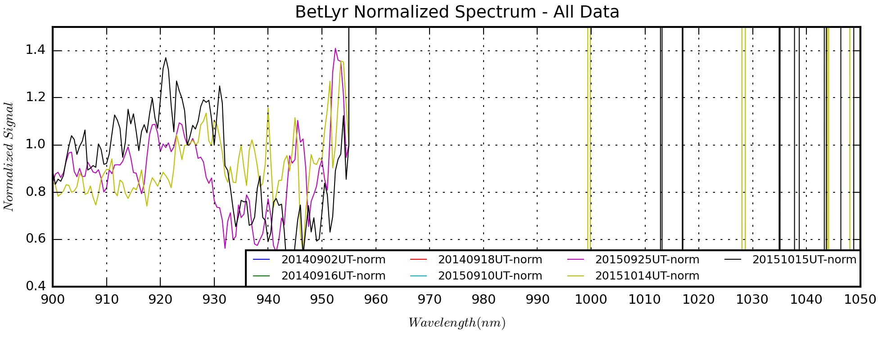

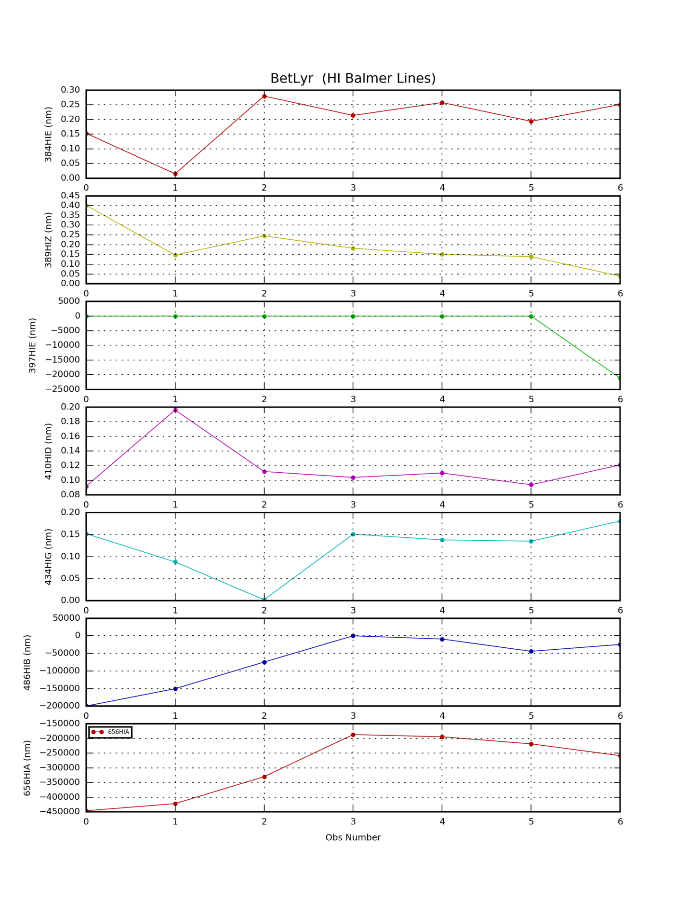

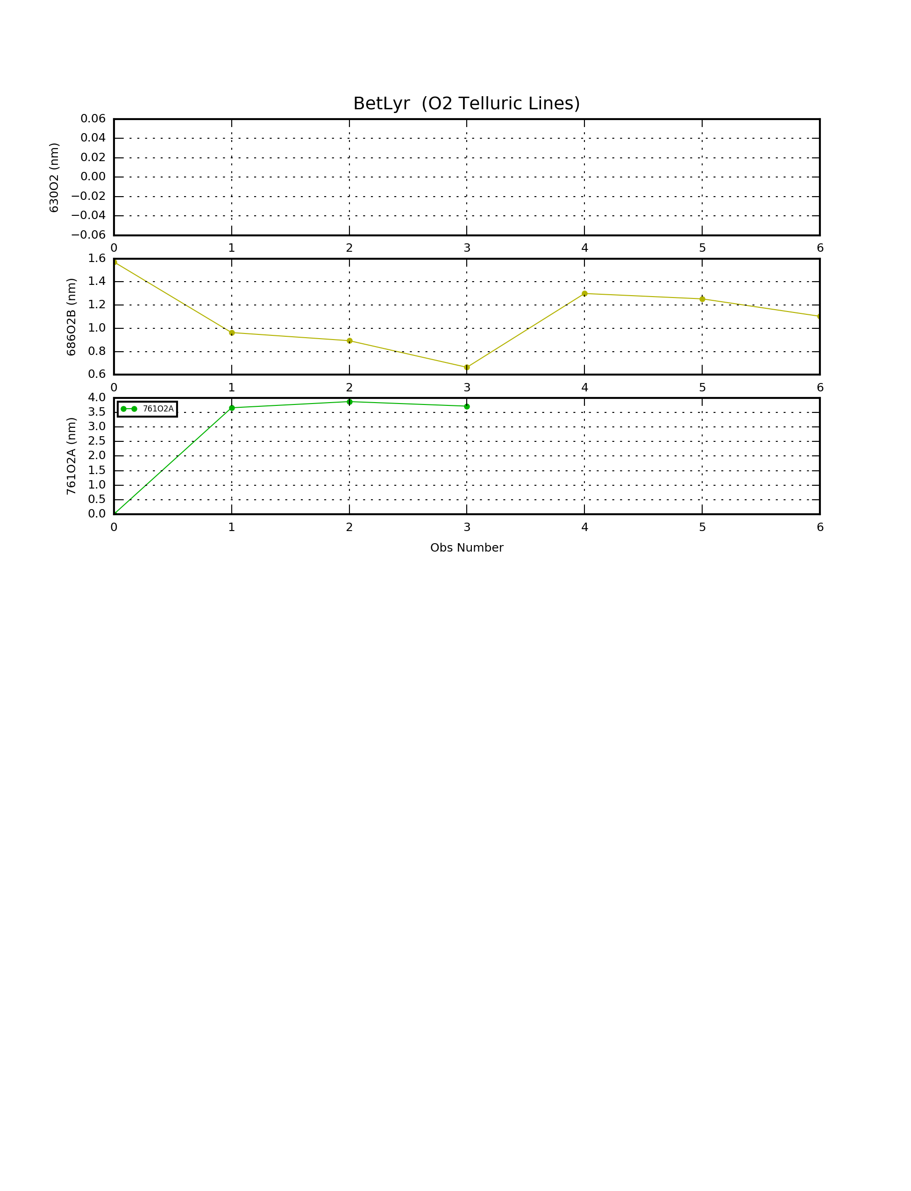

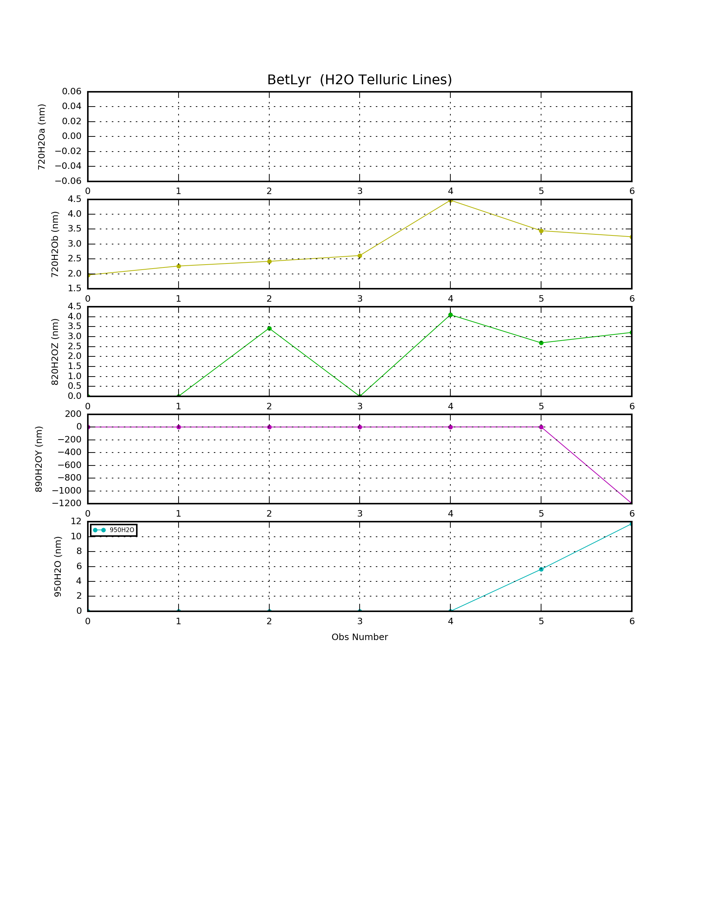

+---BetLyr

| \---Spectral Data

| +---20150910UT

| +---20151014UT

| +---20151015UT

| +---20140918UT

| +---20140916UT

| +---20140902UT

| +---20150925UT

| +---1D Spectra

| +---EWs

| \---Configuration Files

## Planetary Nebulae Analysis

### Saturn Nebula (NGC7009) Analysis

Last Updated 1/18/2015

I have several images of spectra in the CLR and NIR>742nm. The questions are: What is the difference between the CLR images and should I use the flattened versus the un-flattened images?

|  |  |  |  |
| --- | --- | --- | --- |
| **Filename** | **Spec. Range** | **Background** | **Peak O III** |
| NGC6543-RedFocus-20150921UT-742-sum01m40s-Rotated-Cropped-Flattened.fit |  |  |  |
| NGC6543-RedFocus-20150921UT-CLRa-sum04m00s-Rotated-Cropped-Flattened.fit |  |  |  |
| NGC6543-20150921UT-CLR-sum04m00s-Rotated-Cropped-Flattened.fit |  |  |  |
| NGC6543-RedFocus-20150921UT-CLR-sum04m00s-Rotated-Cropped-Flattened.fit |  |  |  |

APERTURE = 3.510000000000E-002

DATAROW1 = 90

DATAROW2 = 110

BKG1ROW1 = 35

BKG1ROW2 = 55

BKG2ROW1 = 133

BKG2ROW2 = 153

PIXEL1 = 270.00000000000000

WAVE1 = 434.00000000000000

PIXEL2 = 694.00000000000000

WAVE2 = 656.29999999999995

XPIX1 = 155

XPIX2 = 1180

HISTORY Filter Kernel

ANM00000 = '"<Measurements version=%221%22></Measurements>"'

+---NGC7009 Project

| +---Data

| | \---Imaging

| | +---20140924UT

| | +---20140928UT

| | \---RGB

| \---Spectral Data

| +---20141003UT

| | \---Calibration

| +---20150921UT

| | \---Calibration

| +---EWs

| +---1D Spectra

| \---Configuration Files

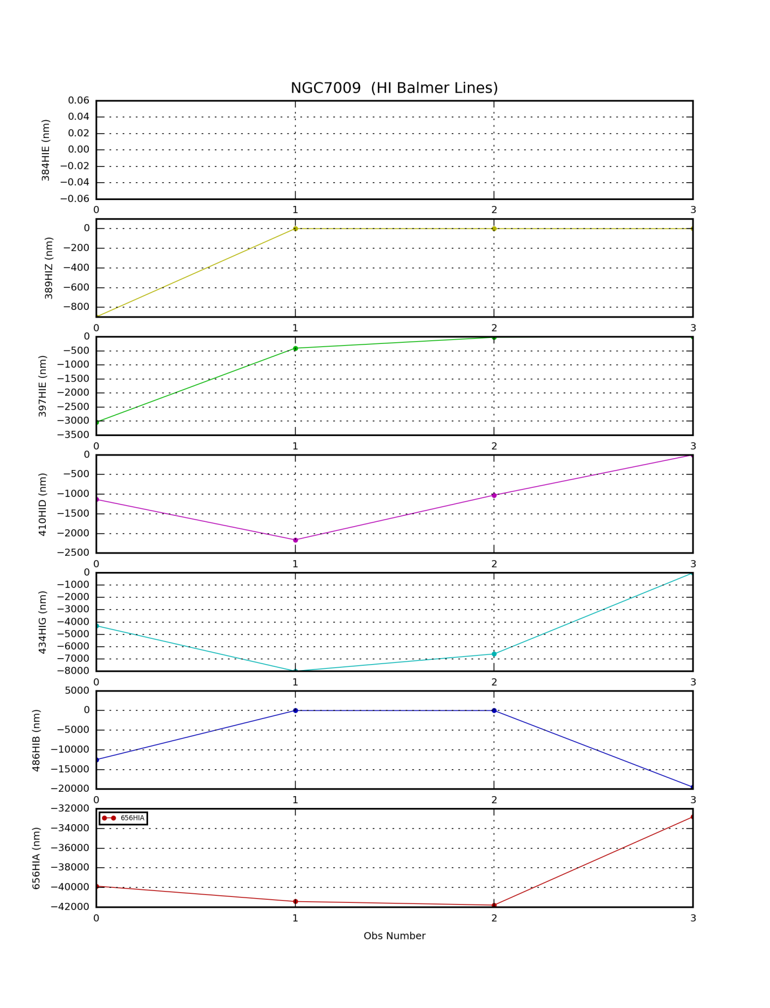

### Ring Nebula (M57) Analysis

Last Updated 1/18/2015

dasf

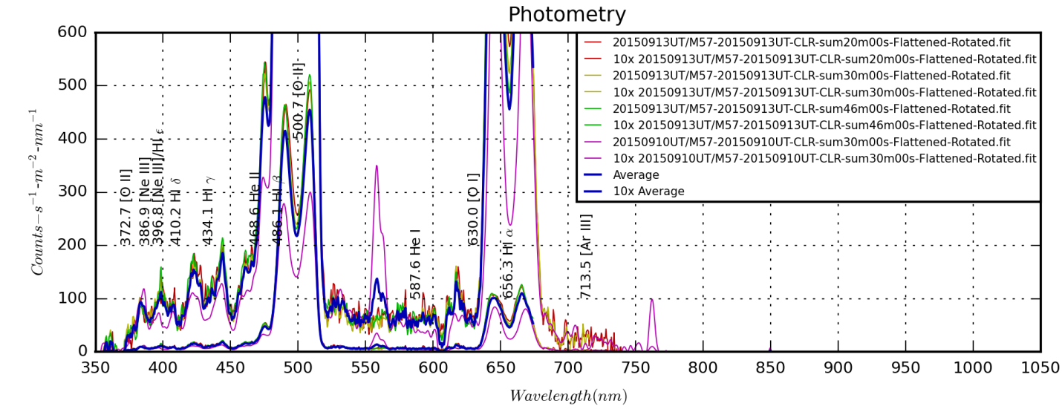

M57\_20150913UT.png

+---M57

| +---Image Data

| | +---20140630UT

| | +---20140706UT

| | +---from201008-M57Proj

| | +---20140817UT

| | +---20140903UT

| | +---20140904UT

| | +---20140901UT

| | \---20140829UT

| +---References

| +---MasterFilterImages

| \---Spectral Data

| +---20140902UT - Copy

| +---20140916UT - Copy

| +---20140919UT - Copy

| +---20150910UT

| +---20150913UT

| +---Configuration Files

| +---EWs

| +---1D Spectra

| \---20130921UT

| \---5ExpNorm

## Nebulae

### Orion Wide Field – M42 and Sword Region

Last Updated 7/6/2015

This summarizes work with the 135mm lens (at f/2.5) done from 2008 through 2015. The initial work was done in 2008 and was a simple RGB wide field image of modest exposure. No clear images are possible with the 135mm lens because the chromatic aberration makes sharp focus with that broad a wavelength range impossible. The result of the RGB images is a simple, classical view of the Orion nebula and the star clusters TBD.

In 2011 I obtained both near ultraviolet (NUV) and near infrared (NIR, >685nm) filters and added exposures in those filters. In particular the NUV images revealed the incredible temperatures of TBD Orionis. The NIR images revealed the presence of TBD Orionis, a very bright AGB star along with a large number of smaller infrared-bright stars. My 2011 Observing Notes provides a description of this analysis.

In 2014 I obtained both H I (656 nm, a.k.a. Hα ) and CH4 (889 nm) narrow band filters. The 889 filter was to be used predominantly for outer planet imaging; however it also provided my most extreme near infrared window into deep sky objects as well. The Hα images of course revealed the incredible extend of emission nebulosity. The CH4 images had very low signal by nature of the low detector response at that wavelength and the narrowness of the pass band (7(TBC?) nm FWHM).

Finally, in 2015 I used filters I had purchased in 2014 including narrow band O III (501 nm) and S II (6?? nm) and long pass NIR filters >742 nm and >807 nm. The narrow band filters permit a crude estimate of ionization temperature (TBD), typically as a function of distance from the ionizing source. The NIR images permit discrimination of different temperature IR-bright stars along with different levels of dust penetration.

The tables below, taken from the file *OrionWideFieldObservingLog.xlsx*, show the total exposures taken up to the present time for each filter.

|  |  |  |  |  |  |  |  |  |  |  |  |  |
| --- | --- | --- | --- | --- | --- | --- | --- | --- | --- | --- | --- | --- |
| **Date (UT)** | **CH4 889** | **>807nm** | **>742nm** | **>685nm** | **SII** | **H I** | **Red** | **Green** | **O III** | **Blue** | **UV** | **Total** |
| **2008-02-06** |  |  |  |  |  |  | 40.0 | 20.0 |  | 20.0 |  | 80.0 |
| **2011-02-23** |  |  |  |  |  |  | 12.5 | 6.3 |  | 6.3 | 50.0 | 75.0 |
| **2011-03-14** |  |  |  | 27.5 |  |  |  |  |  |  |  | 27.5 |
| **2014-01-19** | 156.0 |  |  |  |  | 62.9 |  |  |  |  |  | 218.9 |
| **2015-01-26** |  |  |  |  |  |  |  |  | 153.0 |  |  | 153.0 |
| **2015-01-29** |  |  |  |  | 85.7 |  |  |  |  |  |  | 85.7 |
| **2015-02-12** |  |  | 41.3 |  |  |  |  |  |  |  |  | 41.3 |
| **2015-02-19** |  | 58.0 |  |  | 50.7 |  |  |  |  |  |  | 108.7 |
| **Total** | 156.0 | 58.0 | 41.3 | 27.5 | 136.4 | 62.9 | 52.5 | 26.3 | 153.0 | 26.3 | 50.0 | 790.1 |
| **Goal** | 180.0 | 120.0 | 90.0 | 60.0 | 180.0 | 90.0 | 60.0 | 30.0 | 90.0 | 30.0 | 180.0 | 1110.0 |

|  |  |  |  |  |  |  |  |  |  |  |  |  |
| --- | --- | --- | --- | --- | --- | --- | --- | --- | --- | --- | --- | --- |
| **Date** | **CH4 889** | **>807nm** | **>742nm** | **>685nm** | **SII** | **H I** | **Red** | **Green** | **O III** | **Blue** | **UV** | **Total** |
| **2008-02-06** | 00h00m | 00h00m | 00h00m | 00h00m | 00h00m | 00h00m | 00h40m | 00h20m | 00h00m | 00h20m | 00h00m | 01h20m |
| **2011-02-23** | 00h00m | 00h00m | 00h00m | 00h00m | 00h00m | 00h00m | 00h52m | 00h26m | 00h00m | 00h26m | 00h50m | 02h35m |
| **2011-03-14** | 00h00m | 00h00m | 00h00m | 00h27m | 00h00m | 00h00m | 00h52m | 00h26m | 00h00m | 00h26m | 00h50m | 03h02m |
| **2014-01-19** | 02h36m | 00h00m | 00h00m | 00h27m | 00h00m | 01h02m | 00h52m | 00h26m | 00h00m | 00h26m | 00h50m | 06h41m |
| **2015-01-26** | 02h36m | 00h00m | 00h00m | 00h27m | 00h00m | 01h02m | 00h52m | 00h26m | 02h33m | 00h26m | 00h50m | 09h14m |
| **2015-01-29** | 02h36m | 00h00m | 00h00m | 00h27m | 01h25m | 01h02m | 00h52m | 00h26m | 02h33m | 00h26m | 00h50m | 10h40m |
| **2015-02-12** | 02h36m | 00h00m | 00h41m | 00h27m | 01h25m | 01h02m | 00h52m | 00h26m | 02h33m | 00h26m | 00h50m | 11h21m |
| **2015-02-19** | 02h36m | 00h58m | 00h41m | 00h27m | 02h16m | 01h02m | 00h52m | 00h26m | 02h33m | 00h26m | 00h50m | 13h10m |
| **Total** | 02h36m | 00h58m | 00h41m | 00h27m | 02h16m | 01h02m | 00h52m | 00h26m | 02h33m | 00h26m | 00h50m | 13h10m |
| **Goal** | 03h00m | 02h00m | 01h30m | 01h00m | 03h00m | 01h30m | 01h00m | 00h30m | 01h30m | 00h30m | 03h00m | 18h30m |

Color composite images to be produced:

* Classic RGB
* RGB with added narrow band information into G/B (OIII) and R (HI and SII) channels
* SHO image rendered as RGB
* NIR color composite(s) using 889, >807, >742 and >685
* NIR color composite differences using >807 or 889, (>742 - >807), (>685 - >742)
  + There may be issues here with obtaining similarly sharp focus in each of these channels for the image arithmetic.
* Five-color rendering for IRGBU – picking the best (sharpest, strongest SNR) NIR channel
* Five-color rendering summing narrow band signal with RGB signal and possibly summing NIR signals if similarly sharp focus in each of the NIR bands is obtained.

Potential Analyses:

* Extend photometric analysis of S Orionis further into NIR and with narrow band filters
* Photometric analysis of sections of M42 nebulosity
* Identification of other “interesting” stars for photometric study
* Difference images – many combinations and permutations are possible. What make the most sense?
* Image segmentation into temperature/ionization regions and dust reflection?

+---OrionWideFieldProject2015

| \---Data

| +---20080206UT-RGB-Belt

| | \---Adobe

| | \---New Folder

| +---20110223UT-RGBU-Sword

| | +---Adobe

| | | \---New folder

| | \---processed

| | +---UV

| | \---UVALIGNED

| +---20110314UT-NIR-Sword

| | +---Adobe

| | | \---New folder

| | \---processed

| +---20150126UT-OIII-Sword

| | \---Calibration

| +---20140120UT-HI-Dagger

| +---20140119UT-HI-CH4-Sword

| +---20150129UT-SII-Sword

| +---20150219UT-807+SII-Sword

| | \---Calibration

| \---20150212UT-742-Sword

## Galaxies

### M31 Wide Field and Multispectral

Last Updated 12/7/2015

Prior reports and summaries in 2013 (very short), 2012 (mostly plannung and image lists), 2011 (images in each band, some color composites and ratios).

Figure X, below, shows images in each of five broadband channels representing the total integration time taken between 2011 and 2015. The bands are centered on >685, 650, 550, 450 and 380 nm (TBC more exact numbers and cite with filter parameters reference, not yet done.) The images were taken with a 135 mm focal length lens (f/2.5, giving a clear aperture of 54 mm). The SBIG ST-2000XM camera was used. Plate scale is approximately 11 arcsec-pixel-1. The general purpose of the broadband images is to reveal the distribution of stellar populations. Shorter wavelengths should highlight the spiral arms and areas of recent star formation. Longer wavelengths highlight the older halo and core population.

Each image will now be discussed, highlighting features revealed along with artifacts that impact analysis and comparison.

The NIR image is through a >685 nm long pass filter. Given that the detector is sensitive out to 1000 nm, the chromatic aberration is severe across more than 300 nm bandwidth. This is probably compounded by the fact that the lens is not designed for NIR. The result is 'soft' star images due to wide angle scattering. (Maybe measure The FWHM for each filter and with this lens.)

The RED image shows a more conventional view of M31, which includes H I regions and dust lanes. The image is much sharper due to the narrower band width.

The GRN image again is conventional, beginning to show spiral arms more clearly. It also has a sharp focus.

The BLU image bears similarities to the NIR image in terms of wide angle scattering. This is due to the intrusion of NUV flux into the band pass. While the band width is smaller in absolute terms than the NIR band pass, the relative width is still substantial (put relative band widths here? Back of the envelope suggests that this relative width may not explain the whole variation. The problem may be due more to variation of slope of the lens’ refractive index on wavelength).

|  |  |
| --- | --- |
|  |  |
| M31 807-NIR | M31 742-NIR |
| F:\Astronomy\Projects\M31 Multispectral Project\Source Files\685-NIR\M31-2012-2011-NIR-sum2h02m-LogLog-HalfSize.jpg | F:\Astronomy\Projects\M31 Multispectral Project\Source Files\650-RED\M31-2011-2013-Red-sum2h10m-MASTER-LogLog.jpg |
| M31 685-NIR  M31-2012-2011-NIR-sum2h02m-LogLog-HalfSize.jpg | M31 650-RED  M31-2011-2013-Red-sum2h10m-MASTER-LogLog-HalfSize.jpg |
| F:\Astronomy\Projects\M31 Multispectral Project\Source Files\550-GRN\M31-2011-2013-Green-sum1h59m-MASTER-LogLog.jpg | F:\Astronomy\Projects\M31 Multispectral Project\Source Files\450-BLU\M31-2011-2013-Blue-sum1h45m-MASTER-LogLog-HalfSize.jpg |
| M31 550-GRN  M31-2011-2013-Green-sum1h59m-MASTER-LogLog-HalfSize.jpg | M31 450-BLU  M31-2011-2013-Blue-sum1h45m-MASTER-LogLog-HalfSize.jpg |
| F:\Astronomy\Projects\M31 Multispectral Project\Source Files\380-NUV\Cumulatives\M31_NUV-20121219-Cumulative-sum40h05m-LogLog-HalfSize.jpg | |
| M31 380-NUV  M31\_NUV-20121219-Cumulative-sum40h05m-LogLog-HalfSize.jpg | |

|  |  |
| --- | --- |
| F:\Astronomy\Projects\M31 Multispectral Project\Source Files\889-CH4\M31_Methan-20121219-Cumulative-sum10h00m-LogLog-HalfSize.jpg | F:\Astronomy\Projects\M31 Multispectral Project\Source Files\672-SII\20151206UT\M31-20151206UT-SII-sum01h30m-Flattened-LogLog-HalfSize.jpg |
| M31 889-CH4  M31\_Methan-20121219-Cumulative-sum10h00m-LogLog-HalfSize.jpg | M31 672-SII  M31-20151206UT-SII-sum01h30m-Flattened-LogLog-HalfSize.jpg |
| F:\Astronomy\Projects\M31 Multispectral Project\Source Files\656-HAL\M31-2011-2012-Halpha-sum3h34m-LogLog-HalfSize.jpg | F:\Astronomy\Projects\M31 Multispectral Project\Source Files\501-OIII\20151206UT\M31-20151206UT-OIII-sum01h14m-Flattened-LogLog-HalfSize.jpg |
| M31 656-HAL  M31-2011-2012-Halpha-sum3h34m-LogLog-HalfSize.jpg | M31 501-OIII  M31-20151206UT-OIII-sum01h14m-Flattened-LogLog-HalfSize.jpg |

Note that in differences between OIII and GRN or BLU, there was no easy visual detection of HI regions, possibly no detection at all. However, in SII minus 685 differences, it was clear that faint SII emission followed HI emission.

|  |  |  |  |  |  |  |  |  |  |  |  |  |
| --- | --- | --- | --- | --- | --- | --- | --- | --- | --- | --- | --- | --- |
| **Date (Local)** | **889-CH4** | **807-NIR** | **742-NIR** | **685-NIR** | **672-SII** | **656-HI** | **650-RED** | **550-GRN** | **501-OIII** | **450-BLU** | **380-NUV** | **Total** |
| 2011 Jan 05 | 0 | 0 | 0 | 0 | 0 | 0 | 50 | 15 | 0 | 25 | 0 | **90** |
| 2011 Jan 22 | 0 | 0 | 0 | 0 | 0 | 0 | 0 | 10 | 0 | 0 | 15 | **25** |
| 2011 Nov 26 | 0 | 0 | 0 | 0 | 0 | 0 | 0 | 0 | 0 | 0 | 215 | **215** |
| 2011 Nov 27 | 0 | 0 | 0 | 50 | 0 | 0 | 0 | 0 | 0 | 0 | 150 | **200** |
| 2011 Dec 20 | 0 | 0 | 0 | 0 | 0 | 70 | 0 | 0 | 0 | 0 | 0 | **70** |
| 2011 Dec 23 | 0 | 0 | 0 | 0 | 0 | 0 | 0 | 0 | 0 | 0 | 189 | **189** |
| 2011 Dec 24 | 0 | 0 | 0 | 0 | 0 | 0 | 0 | 0 | 0 | 0 | 198 | **198** |
| 2011 Dec 25 | 0 | 0 | 0 | 0 | 0 | 0 | 0 | 0 | 0 | 0 | 60 | **60** |
| 2011 Dec 27 | 0 | 0 | 0 | 0 | 0 | 0 | 0 | 0 | 0 | 0 | 206 | **206** |
| 2011 Dec 31 | 0 | 0 | 0 | 0 | 0 | 0 | 0 | 0 | 0 | 0 | 190 | **190** |
| 2012 Nov 06 | 156 | 0 | 0 | 0 | 0 | 0 | 0 | 0 | 0 | 0 | 0 | **156** |
| 2012 Nov 07 | 164 | 0 | 0 | 0 | 0 | 0 | 0 | 0 | 0 | 0 | 0 | **164** |
| 2012 Nov 08 | 212 | 0 | 0 | 0 | 0 | 0 | 0 | 0 | 0 | 0 | 0 | **212** |
| 2012 Nov 11 | 0 | 0 | 0 | 0 | 0 | 0 | 0 | 0 | 0 | 0 | 206 | **206** |
| 2012 Nov 13 | 0 | 0 | 0 | 0 | 0 | 0 | 0 | 0 | 0 | 0 | 116 | **116** |
| 2012 Nov 15 | 0 | 0 | 0 | 0 | 0 | 0 | 0 | 0 | 0 | 0 | 206 | **206** |
| 2012 Nov 18 | 0 | 0 | 0 | 0 | 0 | 0 | 0 | 0 | 0 | 0 | 198 | **198** |
| 2012 Nov 19 | 0 | 0 | 0 | 0 | 0 | 0 | 0 | 0 | 0 | 0 | 198 | **198** |
| 2012 Dec 12 | 0 | 0 | 0 | 0 | 0 | 0 | 0 | 0 | 0 | 0 | 200 | **200** |
| 2012 Dec 19 | 68 | 0 | 0 | 0 | 0 | 0 | 0 | 0 | 0 | 0 | 60 | **128** |
| 2012 Dec 28 | 0 | 0 | 0 | 72 | 0 | 144 | 0 | 0 | 0 | 0 | 0 | **216** |
| 2013 Jan 01 | 0 | 0 | 0 | 0 | 0 | 0 | 80 | 50 | 0 | 56 | 0 | **186** |
| 2013 Jan 02 | 0 | 0 | 0 | 0 | 0 | 0 | 0 | 44 | 0 | 30 | 0 | **74** |
| 2015 Dec 05 | 0 | 0 | 0 | 0 | 90 | 0 | 0 | 0 | 74 | 0 | 0 | **164** |
| **Total** | **600** | **0** | **0** | **122** | **90** | **214** | **130** | **119** | **74** | **111** | **2407** | **3867** |
| **Goal** | **600** | **300** | **300** | **120** | **180** | **180** | **180** | **90** | **180** | **90** | **2400** | **4620** |

|  |  |  |  |  |  |  |  |  |  |  |  |  |
| --- | --- | --- | --- | --- | --- | --- | --- | --- | --- | --- | --- | --- |
| **Date (Local)** | **889-CH4** | **807-NIR** | **742-NIR** | **685-NIR** | **672-SII** | **656-HI** | **650-RED** | **550-GRN** | **501-OIII** | **450-BLU** | **380-NUV** | **Total** |
| 2011 Jan 05 | 00h00m | 00h00m | 00h00m | 00h00m | 00h00m | 00h00m | 00h50m | 00h15m | 00h00m | 00h25m | 00h00m | 01h30m |
| 2011 Jan 22 | 00h00m | 00h00m | 00h00m | 00h00m | 00h00m | 00h00m | 00h50m | 00h25m | 00h00m | 00h25m | 00h15m | 01h55m |
| 2011 Nov 26 | 00h00m | 00h00m | 00h00m | 00h00m | 00h00m | 00h00m | 00h50m | 00h25m | 00h00m | 00h25m | 03h50m | 05h30m |
| 2011 Nov 27 | 00h00m | 00h00m | 00h00m | 00h50m | 00h00m | 00h00m | 00h50m | 00h25m | 00h00m | 00h25m | 06h20m | 08h50m |
| 2011 Dec 20 | 00h00m | 00h00m | 00h00m | 00h50m | 00h00m | 01h10m | 00h50m | 00h25m | 00h00m | 00h25m | 06h20m | 10h00m |
| 2011 Dec 23 | 00h00m | 00h00m | 00h00m | 00h50m | 00h00m | 01h10m | 00h50m | 00h25m | 00h00m | 00h25m | 09h29m | 13h09m |
| 2011 Dec 24 | 00h00m | 00h00m | 00h00m | 00h50m | 00h00m | 01h10m | 00h50m | 00h25m | 00h00m | 00h25m | 12h47m | 16h27m |
| 2011 Dec 25 | 00h00m | 00h00m | 00h00m | 00h50m | 00h00m | 01h10m | 00h50m | 00h25m | 00h00m | 00h25m | 13h47m | 17h27m |
| 2011 Dec 27 | 00h00m | 00h00m | 00h00m | 00h50m | 00h00m | 01h10m | 00h50m | 00h25m | 00h00m | 00h25m | 17h13m | 20h53m |
| 2011 Dec 31 | 00h00m | 00h00m | 00h00m | 00h50m | 00h00m | 01h10m | 00h50m | 00h25m | 00h00m | 00h25m | 20h23m | 1d00h03m |
| 2012 Nov 06 | 02h36m | 00h00m | 00h00m | 00h50m | 00h00m | 01h10m | 00h50m | 00h25m | 00h00m | 00h25m | 20h23m | 1d02h39m |
| 2012 Nov 07 | 05h20m | 00h00m | 00h00m | 00h50m | 00h00m | 01h10m | 00h50m | 00h25m | 00h00m | 00h25m | 20h23m | 1d05h23m |
| 2012 Nov 08 | 08h52m | 00h00m | 00h00m | 00h50m | 00h00m | 01h10m | 00h50m | 00h25m | 00h00m | 00h25m | 20h23m | 1d08h55m |
| 2012 Nov 11 | 08h52m | 00h00m | 00h00m | 00h50m | 00h00m | 01h10m | 00h50m | 00h25m | 00h00m | 00h25m | 23h49m | 1d12h21m |
| 2012 Nov 13 | 08h52m | 00h00m | 00h00m | 00h50m | 00h00m | 01h10m | 00h50m | 00h25m | 00h00m | 00h25m | 1d01h45m | 1d14h17m |
| 2012 Nov 15 | 08h52m | 00h00m | 00h00m | 00h50m | 00h00m | 01h10m | 00h50m | 00h25m | 00h00m | 00h25m | 1d05h11m | 1d17h43m |
| 2012 Nov 18 | 08h52m | 00h00m | 00h00m | 00h50m | 00h00m | 01h10m | 00h50m | 00h25m | 00h00m | 00h25m | 1d08h29m | 1d21h01m |
| 2012 Nov 19 | 08h52m | 00h00m | 00h00m | 00h50m | 00h00m | 01h10m | 00h50m | 00h25m | 00h00m | 00h25m | 1d11h47m | 2d00h19m |
| 2012 Dec 12 | 08h52m | 00h00m | 00h00m | 00h50m | 00h00m | 01h10m | 00h50m | 00h25m | 00h00m | 00h25m | 1d15h07m | 2d03h39m |
| 2012 Dec 19 | 10h00m | 00h00m | 00h00m | 00h50m | 00h00m | 01h10m | 00h50m | 00h25m | 00h00m | 00h25m | 1d16h07m | 2d05h47m |
| 2012 Dec 28 | 10h00m | 00h00m | 00h00m | 02h02m | 00h00m | 03h34m | 00h50m | 00h25m | 00h00m | 00h25m | 1d16h07m | 2d09h23m |
| 2013 Jan 01 | 10h00m | 00h00m | 00h00m | 02h02m | 00h00m | 03h34m | 02h10m | 01h15m | 00h00m | 01h21m | 1d16h07m | 2d12h29m |
| 2013 Jan 02 | 10h00m | 00h00m | 00h00m | 02h02m | 00h00m | 03h34m | 02h10m | 01h59m | 00h00m | 01h51m | 1d16h07m | 2d13h43m |
| 2015 Dec 05 | 10h00m | 00h00m | 00h00m | 02h02m | 01h30m | 03h34m | 02h10m | 01h59m | 01h14m | 01h51m | 1d16h07m | 2d16h27m |
| **Total** | **10h00m** | **00h00m** | **00h00m** | **02h02m** | **01h30m** | **03h34m** | **02h10m** | **01h59m** | **01h14m** | **01h51m** | **1d16h07m** | **2d16h27m** |
| **Goal** | **10h00m** | **5h00m** | **5h00m** | **2h00m** | **3h00m** | **3h00m** | **3h00m** | **1h30m** | **3h00m** | **1h30m** | **40h00m** | **61h00m** |

+---M31 Multispectral Project

| +---Source Files

| | +---685-NIR

| | | +---20111128UT

| | | \---20121229UT

| | +---380-NUV

| | | +---20111128UT

| | | +---20111127UT

| | | +---20111225UT

| | | +---20111224UT

| | | +---20111226UT

| | | +---20111228UT

| | | +---20120101UT

| | | +---20121112UT

| | | +---Cumulatives

| | | +---20121114UT

| | | +---20121116UT

| | | +---20121119UT

| | | +---20121120UT

| | | +---20121213UT

| | | \---20121220UT

| | +---501-OIII

| | | \---20151206UT

| | +---672-SII

| | | \---20151206UT

| | +---889-CH4

| | | +---20121107UT

| | | +---20121108UT

| | | +---20121109UT

| | | \---20121220UT

| | +---656-HAL

| | | +---20111221UT

| | | \---20121229UT

| | +---550-GRN

| | | +---20111006UT

| | | +---20130102UT

| | | \---20130103UT

| | +---650-RED

| | | +---20111006UT

| | | \---20130102UT

| | \---450-BLU

| | +---20111006UT

| | +---20130102UT

| | \---20130103UT

| \---Analysis

## Techniques and Planning

### Data Model for Projects

Last Updated 2/1/2016

Primary organizing principal: Organize around target astrophysical type rather than constellation. Thus, constellation becomes a secondary index or attribute for some kinds of reporting. The second organizing principal: Architect the processed data and results of analysis within a directory structure that facilitates use by software.

Note: Three classes of targets:

1. Faint static or quasi-static: For these targets, data directory may be FilterBand.
2. Bright and variable: For these targets, data directory is DateUT.
3. Moon: Same structure as 2.

There needs tobe a “roll-up” strategy for analysis and reports by target astrophysical type. This may be as simple as creating master MS Word documents that include reports on individual objects (targets) and then classes of objects (target types).

The directory structure shown below is replacing existing “Notes” structure.

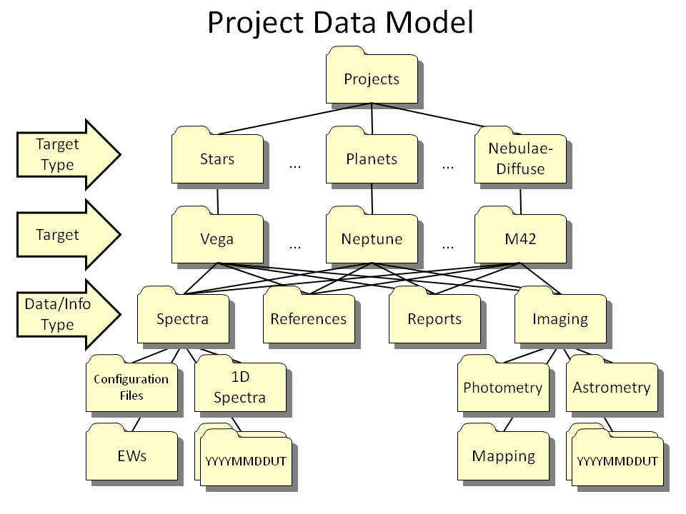

### Python Resources

Last Updated 1/18/2015

Environment: Anaconda

To Update (<http://conda.pydata.org/docs/intro.html>)

$ conda update conda

# Now you are ready to update Anaconda

$ conda update anaconda

Editor: Spyder

Adding new packages and libraries: PIP

Packages hosted on Astronomy Laptop:

[PyEphem](http://rhodesmill.org/pyephem/)

photutils

pyneb

pyspeckit (https://media.readthedocs.org/pdf/pyspeckit/latest/pyspeckit.pdf)

Issues with string literals, e.g., embedded CR/LF in text input files. This reference doesn’t solve the problem, but does provide some potential insight.

<https://docs.python.org/2.0/ref/strings.html>

Packages hosted on Work Computer:

General Links for ephem 2/16/2015:

<http://stackoverflow.com/questions/12266176/python-pyephem-calculation-of-azimuth-and-altitude>

<http://rhodesmill.org/pyephem/CHANGELOG#version-3-7-5-3-2014-may-29>

<http://www.hs.uni-hamburg.de/DE/Ins/Per/Czesla/PyA/PyA/pyaslDoc/aslDoc/eq2hor.html>

<http://www.astro.washington.edu/users/rowen/AstroPy.html>

<http://docs.astropy.org/en/stable/>

<http://www.hs.uni-hamburg.de/DE/Ins/Per/Czesla/PyA/PyA/index.html>

2/17/2015 Big Problems on Astronomy Laptop!!!! IPython keeps looking for the kernal. Need to close the window and manually start IPython console with

Also need to start Spyder from the Anaconda command prompt “spyder” Not sure exactly what executable is running.

2/18/2015 Seem to have resolved problems, but should install next upgrade to Anaconda and Spyder as soon as they’re available.

Astrophysics Source Code Library, ASCL.net, Python Search: <http://ascl.net/code/search/python>

### Python Spectral Calibration, Plotting and EW Measurement

Last Updated 3/10/2016

For stellar absorption lines I’ll need to work out the detailed balance, not just look at absorption coefficients.

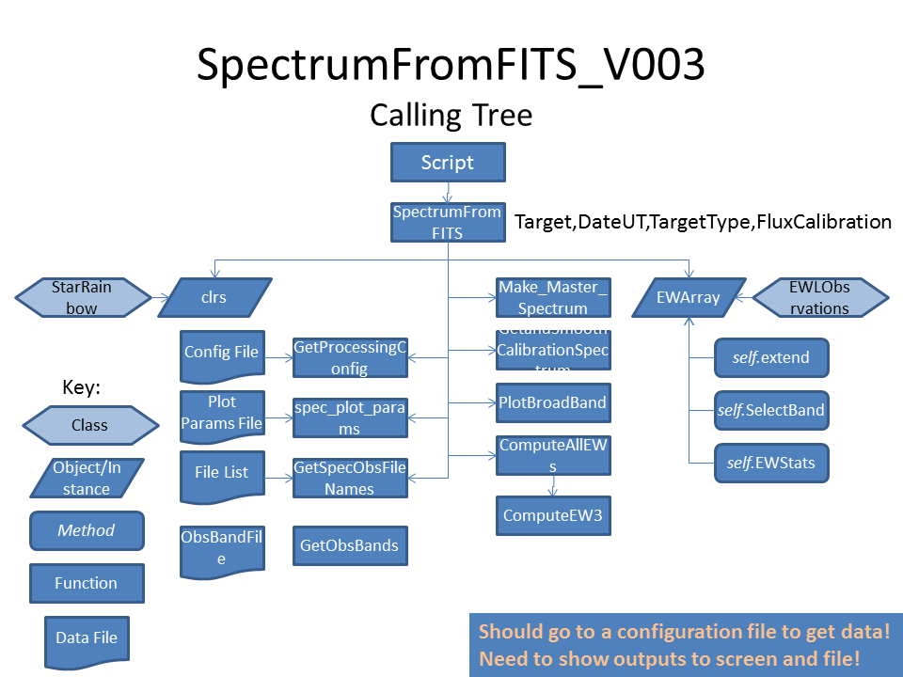

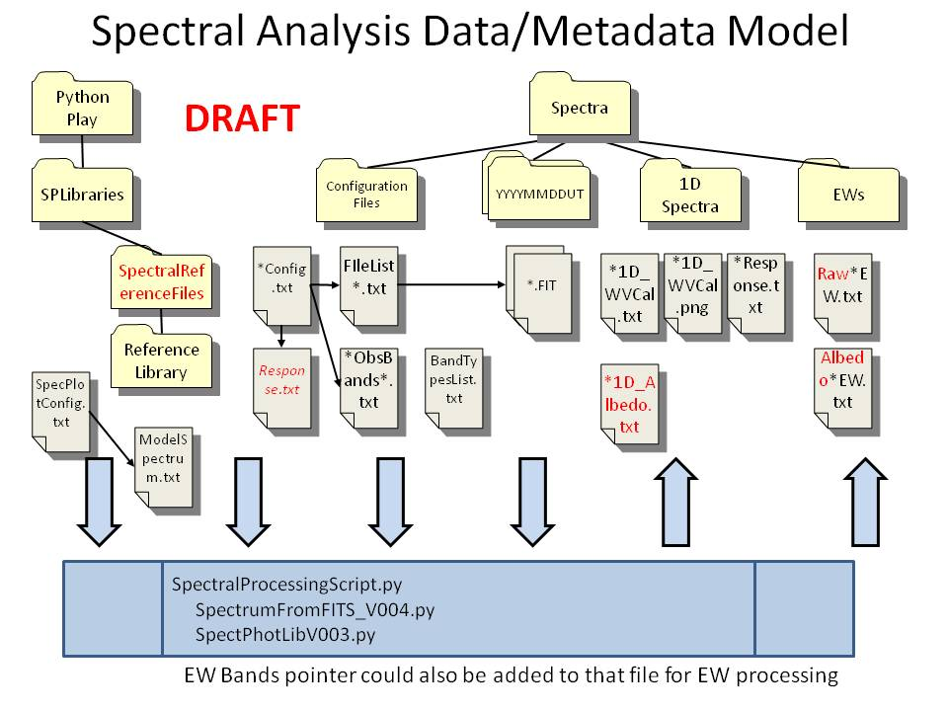

**SpecPlotConfig.txt:**

Target,TType,X0,X1,NX,Y0,Y1,NY,Ytype,OpsType,Model,

M57,PN,350.,850.,11,0.,6000.,7,lin,spectrum,Null,

NGC7009,PN,350.,850.,11,0.,100000.,7,lin,spectrum,Null,

Vega,ST,350.,1050.,15,1000.,30000000.,7,log,spectrum,a0v.txt,

BetLyr,ST,350.,1050.,15,300.,3000000.,7,log,spectrum,b8.txt,

GamLyr,ST,350.,1050.,15,300.,3000000.,7,log,spectrum,b9iii.txt,

SigAqr,ST,350.,1050.,15,300.,3000000.,7,log,spectrum,a0iv.txt,

Neptune,ST,350.,1050.,15,10.,30000.,7,log,spectrum,g2v.txt,

Venus,PL,350.,1100.,16,1.0e6,1.0e10,7,log,spectrum,g2v.txt,

Jovian Moons CH4,PL,840.,940.,11,0,2000,7,lin,spectrum,g2v.txt,

**Vega20151015UT\_Config.txt**

FileList\_Vega\_Spectra-20151015UT.txt,

a0iii.dat,

CreateResponse,

Vega\_ObsBands\_1500mm200lpm.txt,

**FileList\_Vega\_Spectra-20151015UT.txt**

Vega-20151015UT-CLR-sum1500ms-Rot-Crop.fit,Vega-20151015UT-NIR-sum01m40s-Rot-Crop.fit,

**Vega\_ObsBands\_1500mm200lpm.txt**

Name,Start(nm),End(nm),ContWdth(nm),Label Height,

380HI10,378.0,381.5,1.0,100.,

384HIE,382.0,386.0,1.0,100.,

389HIZ,386.0,392.0,1.0,100.,

397HIE,394.0,401.0,1.0,100.,

410HID,405.0,415.0,1.0,100.,

434HIG,428.0,441.0,1.0,100.,

486HIB,480.0,494.0,1.0,100.,

656HIA,645.0,672.0,1.0,100.,

686O2B,678.0,700.0,1.0,100.,

761O2A,750.0,772.0,1.0,100.,

720H2Ob,703.0,744.0,1.0,100.,

820H2OZ,804.0,840.0,1.0,100.,

890H2OY,890.0,910.0,1.0,100.,

950H2O,920.0,970.0,1.0,100.,

**SAS Spectral Codes**

***Relevant Code files and Contents***

* *Python “L1” codes – many, many codes*
* *Python “All Years” codes, including both ‘raw’ and ‘albedo’ spectra*
* *Python EW analysis codes, including StevesEWPlotterV003.py (under the Jupiter 2015 directory) and the StevesCH4PlotterV000.py*
* *Python EW libraries: Two versions (at least), ComputeEW and ComputeEW1. It appears that the second version is the newer version and provides output files with all necessary parameters (adding target and date-time) that are needed by the EW analysis codes. There may be a third version that incorporates the ability to look at band ratios in addition to EWs.*
* *Python Spectral Libraries: EWLibV003.py and CH4V000.py. It appears that EWLibV003 is the more recent. However, it appears there are two copies, one under the Jupiter 2015 directory and one in the Python Play directory. In addition, there is the new library I’ve begun working on that SpecPhotLibV001.py that sits under the Python Play directory. The intention is to have a unified direct-from-FITS-file approach in a single library for both photometry and spectroscopy.*
* *NOTE: It appears that from the codes (StevesEWPlotterV0003.py), the SAS CH4 number densities were determined from the albedo spectrum EWs as opposed to the raw spectrum EWs.*
* *Level-1 codes, e.g., JupiterSpectrum20150322UT-742.py or NeptuneSpectrum20141029UT.py*
  + *Purpose:*
    - *To take ‘raw’ spectral data (counts vs pixel) and produce various higher level products on a standard 0.5nm interval wavelength grid. Because there are individual codes for each day and target, there has been much copying and pasting. In addition, there are different versions of libraries in use. Downstream codes use the outputs to produce summary plots as well as perform EW analysis on band absorption.*
  + *Principle Libraries*
    - *ComputeEW* or *ComputeEW1*
  + *Inputs/Configuration:* 
    - *Reads hard-coded list of wavelength-calibrated, ASCII files of spectra generated by RSPEC*
    - *Reads hard-coded Karkoschka reference file for plotting purposes*
    - *Reads hard-coded relative spectral response ASCII file for relative flux calibration*
    - *Reads hard-coded G2V reference ASCII file for computation of albedo spectra*
  + *Computes:*
    - *Merges filters if needed, e.g., VIS and NIR*
    - *Applies smoothing to portions of the spectra (OLD BOXCAR method, should be updated to remove potential wavelength shift side effects)*
    - *Top of Atmosphere relative flux*
    - *Albedo spectrum*
    - *Equivalent widths of (hard-coded) absorption features*
  + *Outputs:*
    - *Plot of raw spectra, merged spectra (“Master”), ToA spectrum, solar reference spectrum (G2V), normalized and scaled Albedo spectrum*
    - *ASCII file of relative response calibrated spectrum???*
    - *ASCII file of albedo spectrum*
    - *ASCII file of equivalent widths calculated from Master spectrum*
    - *ASCII file of equivalent widths calculated from albedo spectrum*

**Code Updates and Generalizations**

This code will address meta-data and class structure for code to plot spectra. It will help reduce the myriad of code copies I’ve created for plotting individual spectra. The data model will be similar to that used for plotting photometric data (see 2011 Observing Notes).

Generally, I’ve begun to realize the overlap in function of the double star plotting, photometry and spectral plotting software libraries. In fact, I’m beginning to see a fairly strong case for the first time for base classes and inheritance. Some of the possible base classes and derived classes are listed below.

* Object Info – this is information on the target object only. It could be things such as distance, type of object, or other astrophysical parameters
  + Double stars – Common name, catalog, distance
  + Photometry
  + Spectroscopy – bands to label and or compute band parameters for – this could be under plotting info but using object as a key
* Plotting Info – this would be tied to the object itself since the parameters I’m trying to observe and plot are bounded by the actual values for the object
  + Double stars – Wide, narrow and trend metadata
  + Photometry – single plots or multiple plots including both ‘raw’ and response calibrated data
  + Spectroscopy – single plots or multiple plots including both ‘raw’ and response calibrated data
* Catalog of observations
* Catalog of official data
* Observing info – date (and time?) tagged metadata about an observation: instrument, camera, filter, exposure. Some may be from a separate metadata file, some may be from a FITS header
  + Double stars - ?
  + Photometry – FITS file list(s), centroids and radii for photometry, reference calibration file(s)
  + Spectroscopy – FITS file lists(s), rows for data and backgrounds, wavelength calibration parameters, contamination regions, reference calibration file(s)
* Plotting itself...
* Filter Parameters
* Reading and/or (pre-)processing data

**Band Group and Line/Band Naming Conventions:**

* HI; HI.txt
  + H Bet (EWLibV004); **486HIB (FITS file filter type) – Adopted!**
* O2 Telluric

### Python Aggregated Spectral Plotting

Last Updated 3/10/2016

Is this supposed to be the “plot\_all\_years” functionality?

### Python EW Analysis and Plotting

Last Updated 3/10/2016

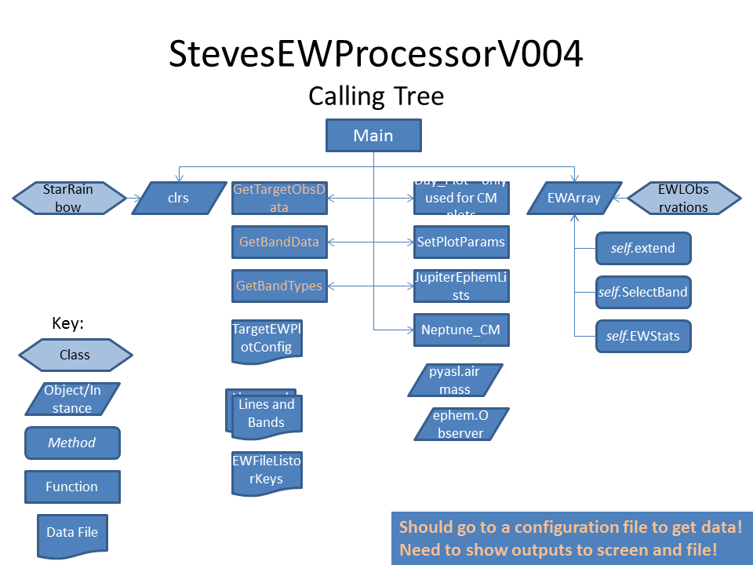

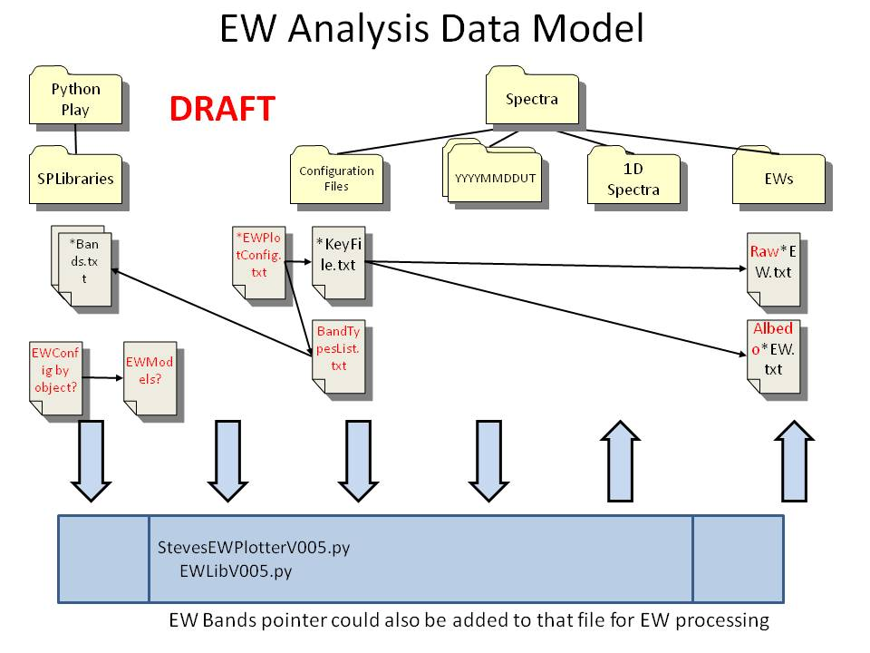

* *StevesEWPlotterV003:*
  + *Inputs/Configuration:*
    - *Hard coded options include:* 
      * *Plot type: EW or EW variance*
      * *X-axis type: time, air mass, CMII, or GRS angle*
      * *Target: Jupiter, Titan, Uranus or Neptune*
      * *(Input) spectrum type: raw flux or albedo*
    - *Reads EW files according to hardcoded paths and “keys” in EWLibV003*
    - *“Keys” provide target and date-time meta data*
  + *Computes/Calls:*
    - *EWL.StarRainbow()*
    - *EWL.GetTargetObsData(Target)*
    - *EWL.GetBandTypes(Target,SpectrumType)*
    - *EWL.EWObservations()*
    - *EWL.GetBandData(BandType)*
    - *EWL.Day\_Plot() Several times!*
  + *Outputs:*
    - *Multi-plot PNG files showing equivalent widths of absorption bands grouped by species as a function of the chosen X-axis (time, air mass, CMII, or GRS angle)*
    - *PNG plots of CH4 number density as a function of wavelength*
    - *PNG plots of CH4 number density as a function of band strength*
    - *ASCII data files of “EW Statistics” that aggregate data from all available EW measurements and also provide estimated number densities and variances.*

### Python Astrophysics Analysis of Spectra

Last Updated 1/18/2015

### SWIR Camera Resources

Last Updated 1/18/2015

<http://www.infraredlaboratories.com/TriWave_Camera.shtml>

<http://www.photonic-science.com/products/swir-ingaas-cameras.html>

[http://www.xenics.com/en/products/cameras?f[0]=field\_spectrum\_term%3A618&f[1]=field\_technology\_term%3A624&f[2]=field\_thermography\_term%3A631&f[3]=field\_interface\_term%3A653&f[4]=field\_resolution\_term%3A640&f[5]=field\_max\_frame\_term%3A634&f[6]=field\_cooled\_term%3A632](http://www.xenics.com/en/products/cameras?f%5b0%5d=field_spectrum_term%3A618&f%5b1%5d=field_technology_term%3A624&f%5b2%5d=field_thermography_term%3A631&f%5b3%5d=field_interface_term%3A653&f%5b4%5d=field_resolution_term%3A640&f%5b5%5d=field_max_frame_term%3A634&f%5b6%5d=field_cooled_term%3A632)

<http://www.pembrokeinstruments.com/_download_pdf_897/_Pembroke-PDF-Downloads/SWIR-InGaAs-640U-Pembroke.pdf>

<http://www.raptorphotonics.com/product/ninox-640-50>; <http://www.raptorphotonics.com/cms/uploads/Ninox-White-Paper-Dec-2014.pdf>

<http://www.edmundoptics.com/imaging/cameras/near-ir-nir-ultraviolet-uv-cameras/>

<http://www.ebay.com/itm/Alpha-NIR-Near-Infrared-InGaAs-Thermal-Imager-Camera-indigo-systems-w-cable-/151559595297?pt=LH_DefaultDomain_0&hash=item2349a7e521>

### Some Thoughts on Additional Narrow-Band Imaging Filters and Spectroscopes

Last Updated 7/10/2015

So now I have HI, OIII and SI filters. A general ability to discriminate the ionization energy shows as a general rule OIII is the “hottest” and closest to the illuminating star followed by HI then SII. However, nothing quantitative regarding intensities can be done because of interstellar reddening and the fact that the HI filter is 7nm wide and includes both neighboring NII lines.

Current Filters:

|  |  |  |  |  |  |
| --- | --- | --- | --- | --- | --- |
| Band/Name | Lines | Center | FWHM | Manufacturer | Notes |
| HIα | 656.3 | ? | 7.0? | ? |  |
| OIII | 495.9, 500.7 | ? | 8.5 | Baader | Manufacturer data |
| SII | 671.7, 673.1 |  | 8.5 | Baader | Manufacturer data |
| **Proposed** | | | | | |
| ***HIβ*** | ***486.1*** |  | ***8.5*** | ***Baader*** | ***Cost $132*** |
| ***NII*** | ***658.3*** | ***658.3*** | ***3.5*** | ***AstroDon*** | ***Doesn’t include 654.8 nm line on other side of HIα. Cost is $490!*** |
| ***He II*** | ***468.6*** | ***470.0*** | ***10.0*** | ***Edmund Optics*** | ***Multipurpose: Good for relatively bright component of PNs, but also good for C2 Swan Δv=+1 band at ~470nm.$185.*** |
| ***[O I]*** | ***630.0*** | ***632.0*** | ***10.0*** | ***Edmund Optics*** | ***Multipurpose: PNs (faint line) and comets. $185.*** |
| ***He I*** | ***587.6*** | ***589.0*** | ***10.0*** | ***Edmund Optics*** | ***Multipurpose: PNs, comet continuum(?) and Na doublet (where?). $185.*** |

Adding both HIβ and NII would in principle permit spatially resolved, quantitative measurement of interstellar reddening by comparing HIβ/HIα to the predicted Balmer decrement. This is predicated on the assumption that the NII 658.3 and 654.8 nm lines are populated by the same upper state and related only by a well-known branching ratio.

A user in Poland has done work with “exotic” narrow band imaging, including identifying sources for filter components. His main site is <http://www.rkblog.rk.edu.pl/w/p/helium-argon-and-neon-narrowband-imaging/>. The site with Edmund Optics components is <http://www.rkblog.rk.edu.pl/w/p/choosing-edmund-optics-filters-helium-oxygen-and-argon-narrowband-imaging/>.

The He II, He I and [O I] filters seem like nice additions to my set and some have multiple purposes. Note that it is possible to complement the 470nm filter’s ability to measure the C2 Δv=+1 band with a filter at 515nm to measure the Δv=0 band at 514nm.

Finally, I should not forget the use of NIR 10nm FWHM filters to look at methane band centers and wings of the outer planets.

Note that the user in Poland had an astronomical equipment vendor mount the EO filters in standard 1.25” filter mounts.

Spectrograph Slit sources (look for high-powered air slits for gold reflectivity):

<http://www.edmundoptics.com/optomechanics/irises-apertures/pinholes-slits/precision-air-slits/1845/>

<http://www.nationalaperture.com/reflective.htm>

<http://www.shelyak.com/recherche.php> (search “slit”)

Many spectrograph designs including a reflective needle slit:

<http://www.eyes-on-the-skies.org/shs/needle1.htm>

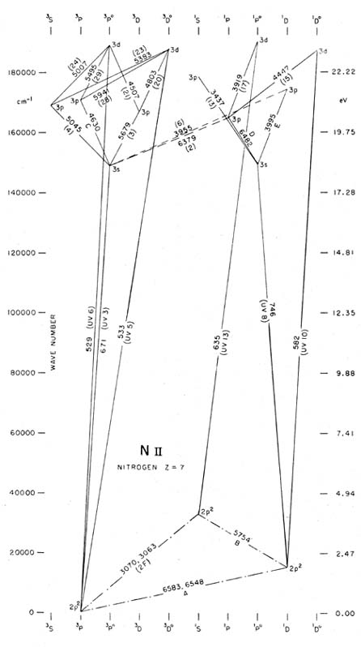

From: <https://ned.ipac.caltech.edu/level5/Ewald/Grotrian/n2.jpg>

Here it is assumed that the two lines of these doublets have relative strengths proportional to their Einstein A coefficients, or in this case 3:1. Thus Ι(λ6548 -l· λ 6583) = 4/3 Ι(λ 6583) and /(λ 6300 -h λ 6363) = 4/3 /(λ 6300). λ 3726 and λ 3729 of 0+ are measured as one line, the λ 3727 line.

**Above is from 1968PASP\_\_\_80\_\_689C.pdf in PN project references.**

Same value (3:1) can be found in <http://www.nist.gov/srd/upload/jpcrd3620071287p.pdf> on page 1342 in the ratio of the A values

Nice units conversion page: <http://halas.rice.edu/conversions>

### Some Thoughts on Mounts

Last Updated 9/3/2015

A good mount review site: <http://lambermont.dyndns.org/astro/pe.html>

**Python Equivalent Width Software Documentation:**

**EWLibV001.py:**

This library contains the five functions and classes needed by the main program, StevesBinaryPlotterV03.py. The program generates plots of predicted and observed orbital positions of binary stars. The functions and classes are listed below:

* **Class EW\_plot\_params**
  + Purpose: Read a single record from an ASCII configuration file based on the desired binary star to be plotted and the view to be presented by that plot
  + Initialization Parameters:
    - StarIdentifierDD: A string value corresponding to a specific binary star. The identifier also corresponds to that used in the WDS6 catalog.
    - View: A string value representing one of three different plot views:
      * “Wide” is a plane-of-sky orbital plot with the origin fixed at the primary’s location and having sufficient extent on the sky to include the entire orbit and annotations.
      * “Zoom” is a plane-of-sky orbital plot with the origin fixed at the primary’s location. However, this plot’s extend is limited to include only a region of interest, usually correlating to the extent of my observations.
  + Attributes:
    - T0 is the start time of the plot period
    - T1 is the end time of the plot period
    - dTF is the fine time increment for the plot period
    - dTC is the coarse time increment for the plot period
    - X0 is the eastern-most X (R.A.) coordinate value
    - X1 is the western-most X (R.A.) coordinate value
    - NX is the number of X-axis grid increments
    - Y0 is the southern-most Y(Dec.) coordinate value
    - Y1 is the northern-most Y(Dec.) coordinate value
    - NY is the number of Y-axis grid increments
    - ANSCL is a scale factor for radial placement of annotations the four digit year on the plot
    - DIST is the distance in parsec to the binary star and is used to compute the secondary axes in AU rather than in arc seconds
  + Methods:
    - TimeGridFine creates a numpy array of time using T0, T1 and DTF
    - TimeGridCoarse creates a numpy array of time using T0, T1 and DTC
* **Class StarOrbitObservations**
  + Purpose: Read *all* records from an ASCII data file of (my) observations of a selected binary star for subsequent plotting and analysis.
  + Initialization Parameters:
    - StarIdentifierDD: A string value corresponding to a specific binary star. The identifier also corresponds to that used in the WDS6 catalog.
  + Internal(?) Variables:
  + Attributes:
    - TObs
    - XObs
    - YObs
    - PAObs
    - SepObs
    - PAErr
    - SepErr
    - NObs
    - FirstTime
  + Methods
    - ObsStats computes statistics regarding the observations along with a weighted least squares linear fit to position angle as a function of time and separation as a function of time.
* Class StarOrbitPrediction
* Function DrawOrbitPlotV0
* Class StarRainbow

### Object Lists

29(!) Globular clusters that I’ve observed as of 7/14/2015. None in

| **NGC** | **Other ID** | **Size1/Mag1** | **Size2/Mag2** | **Mag/Sep** | **mag/am2** | **MA\*** | **Const.** | **Obs** | **Photo** | **Comments** | **Update** |
| --- | --- | --- | --- | --- | --- | --- | --- | --- | --- | --- | --- |
| 6981 | M72 | 5.9 | 5.9 | 9.4 | 13.3 | ### | Aqu | 0 | 1 | General: Good 8.29m star to the NNE for self guiding for 1260mm. | 2006 Oct 24 |
| 7089 | M2 | 11.7 | 11.7 | 6.5 | 11.8 | ### | Aqu | 1 | 2 | General: Fair 9.75m star for self guiding for 1260mm. | 2005 May 12 |
| 7099 | M30 | 12.0 | 12.0 | 7.2 | 12.6 | 11.0 | Cap | 0 | 2 | General: Good(!) 5.24m star to the E for self guiding for 1260mm. | 2006 Oct 24 |
| 6934 |  | 5.9 | 5.9 | 8.9 | 12.8 |  | Del | 0 | 0 |  | 2004 Oct 08 |
| 7078 | M15 | 12.3 | 12.3 | 6.4 | 11.9 | 11.0 | Peg | 0 | 3 | General: Good(!) 6.08m star to the E for self guiding for 1260mm. | 2005 May 12 |
| 288 |  | 13.8 | 13.8 | 8.1 | 13.8 | 13.5 | Scu | 0 | 0 | General: Good 6.1mV star to the SE for self-guiding at 430mm. | 2008 Dec 08 |
| 5139 | Omega Centauri | 36.3 | 36.3 | 3.7 | 11.5 | 11.2 | Cen | 0 | 1 | General: Largest and brightest globular cluster visible from Earth. Too low from Boulder, but visible from Houston/Brazos Bend. Good 6.38mV star for guiding to the SSW at 400mm FL. Should take RGB image at 400mm, binned 1x1 for 20-45min. | 2006-Jun-09 |
| 6205 | M13 | 23.2 | 23.2 | 5.9 | 12.7 | 12 | Her | 14 | 11 | General: Good 7.3m star to the SSW for self guiding for 1260mm. Good 7.08mV star to the WSW for self guiding at 400mm. | 2010-Aug-25 |
| 6341 | M92 | 11.2 | 11.2 | 6.5 | 11.7 | 11 | Her | 1 | 1 | General: Good 8.6m star for self guiding for 1260mm. | 2006-May-30 |
| 5987 |  |  |  |  |  |  | Lib | 0 | 0 |  | 2006-May-30 |
| 6779 | M56 | 5.0 | 5.0 | 8.3 | 11.8 | 12.0 | Lyr | 2 | 1 | General: Good! 5.85m star for self guiding at 1260mm. | 2006-May-30 |
| 6171 | M107 | 3.3 | 3.3 | 8.1 | 10.7 | 12.0 | Oph | 1 | 2 | General: Good 7.63mV star to the NE for self guiding at 1260mm. | 2006-Jun-28 |
| 6218 | M12 | 14.5 | 14.5 | 6.6 | 12.4 | 12 | Oph | 0 | 2 | General: Good 9.34mV star to the ENE for self guiding for 1260mm. A good 135mm FL group includes M10 and M12. | 2006-Jun-28 |
| 6254 | M10 | 12.2 | 12.2 | 6.6 | 12 | 12 | Oph | 0 | 1 | General: Good 8.32m star to the SE for self guiding for 1260mm. Good 4.82m star to the E for selfguiding at 400mm. A good 135mm FL group includes M10 and M12. | 2006-Jun-28 |
| 6266 | M62 | 14.1 | 14.1 | 6.6 | 12.3 | 11.0 | Oph | 1 | 1 | General: Good 7.48mV star to the N for self guiding at 1260mm. Requires slight offpointing. | 2008-Aug-27 |
| 6273 | M19 | 5.3 | 5.3 | 7.2 | 10.8 | 11 | Oph | 2 | 2 | General: Good 8.12mV star to the SW for self guiding for 1260mm. REQUIRES slight offpointing. | 2006-Jun-28 |
| 6333 | M9 | 5.5 | 5.5 | 7.9 | 11.6 | Oph | Oph | 0 | 2 | General: Good 7.83mV star to the S for self guiding for 1260mm. REQUIRES slight offpointing. Good 6.52mV star to the SE for self guiding at 400mm, with FOV centered between M9 and B64. Would be nice to have new long exposure with B64. | 2009-Jul-27 |
| 6402 | M14 | 6.7 | 6.7 | 7.6 | 11.7 | 12 | Oph | 1 | 1 | General: Good 7.44mV star to the N for self guiding for 1260mm. | 2006-Jun-28 |
| 6093 | M80 | 5.1 | 5.1 | 7.2 | 10.7 | 11 | Sco | 3 | 1 | General: Good 9.05mV star to SSE for self guiding for 1260mm. | 2006-Jun-28 |
| 6121 | M4 | 26.3 | 26.3 | 5.9 | 13.0 | 12 | Sco | 7 | 4 | General: Good 8.40mV star to SE for self guiding for 1260mm. Good 2.89mV star to the NW for self guiding at 400mm with FOV centered between M4 and NGC6144. | 2006-Jun-28 |
| 6144 |  | 6.2 | 6.2 | 9.1 | 13.1 | 12.8 | Sco | 0 | 1 |  | 2006-Jun-30 |
| 6712 |  | 4.3 | 4.3 | 8.2 | 11.4 | 11.11 | Sct | 0 | 2 |  | 2006-Sep-22 |
| 5904 | M5 | 19.9 | 19.9 | 5.8 | 12.3 | 11 | Ser | 0 | 3 | General: Good 5m (!) star for self guiding to the SSE for 1260mm. | 2006-Jun-02 |
| 6838 | M71 | 6.1 | 6.1 | 8.3 | 12.2 | 12 | Sge | 0 | 2 | General: Good 6.23mV (!) star to the WSW for self guiding for 1260mm. | 2006-May-30 |
| 6522 |  | 5.6 | 5.6 | 8.6 | 12.3 | 12.08 | Sgr | 0 | 1 | General: Nice paring with NGC 6528 GC to the east in 430mm FOV. Good background Milky Way and dark nebulae. | 2009-Aug-25 |
| 6544 |  | 8.4 | 8.4 | 8.3 | 12.9 | 12.66 | Sgr | 0 | 1 |  | 2006-Jun-30 |
| 6626 | M28 | 15 | 15 | 6.9 | 12.8 | 11 | Sgr | 2 | 1 | General: Good 9.45mV star to the NW for self guiding for 1260mm. A good 135mm FL grouping includes four globular clusters: M22, M28, NGC6642, and NGC6638. | 2005-Jul-14 |
| 6637 | M69 | 7.1 | 7.1 | 7.7 | 12.0 | 11 | Sgr | 0 | 1 | General: A good 135mm FL grouping includes three globular clusters: M69, M70, and NGC6652 | 2005-Jun-14 |
| 6638 |  | 2.2 | 2.2 | 9.2 | 10.9 | 10.65 | Sgr | 0 | 0 | General: A good 135mm FL grouping includes four globular clusters: M22, M28, NGC6642, and NGC6638. | 2005-Jul-14 |
| 6642 |  | 0.8 | 0.8 | 8.8 | 8.3 | 8.06 | Sgr | 0 | 0 | General: A good 135mm FL grouping includes four globular clusters: M22, M28, NGC6642, and NGC6638. | 2005-Jul-14 |
| 6652 |  | 3.5 | 3.5 | 8.9 | 11.6 | 11.36 | Sgr | 0 | 0 | General: A good 135mm FL grouping includes three globular clusters: M69, M70, and NGC6652 | 2005-Jun-14 |
| 6656 | M22 | 24 | 24 | 5.1 | 12.0 | 11 | Sgr | 12 | 3 | General: Good 9.3m star for self guiding for 1260mm. A good 135mm FL grouping includes four globular clusters: M22, M28, NGC6642, and NGC6638. | 2006-Jun-30 |
| 6681 | M70 | 7.8 | 7.8 | 8.1 | 12.6 | 11 | Sgr | 0 | 1 | General: A good 135mm FL grouping includes three globular clusters: M69, M70, and NGC6652 | 2005-Jun-14 |
| 6715 | M54 | 9.1 | 9.1 | 7.7 | 12.5 | 11 | Sgr | 0 | 2 |  | 2005-Jul-14 |
| 6809 | M55 | 19 | 19 | 7 | 13.4 | 13 | Sgr | 0 | 1 | General: Much larger than I thought it would be! | 2005-Jul-14 |
| 6864 | M75 | 6 | 6 | 8.6 | 12.5 | 11 | Sgr | 0 | 0 | General: Good 8.0mV star to the NNE for self-guiding at 1260mm FL - requires slight offpoint. | 2006-May-30 |
| 1904 | M79 | 9.6 | 9.6 | 7.7 | 12.6 |  | Lep | 0 | 0 | Good 9.2m star to the ESE for self-guiding at 1260mm. | 2009-Mar-16 |
| 2419 |  | 6.2 | 6.2 | 10.4 | 14.4 | 14.1 | Lyn | 0 | 0 | General: Most distant globular. Brightest stars are 17m. Good 8.69mV star to the ESE for self guiding at 1260mm. | 2009-Mar-19 |